ESG AND ASSET PRICING IN CHINA: POLICY-CONTINGENT RETURNS AND RISK MITIGATION

Abstract
This paper examines whether environmental, social, and governance (ESG) performance generates excess returns or mitigates downside risk in China’s A-share market. Using a comprehensive panel of 65,000 firm-year observations from the CNRDS ESG Rating Database (2007–2022), I construct ESG-based long–short portfolios and estimate Fama–French five-factor regressions. The results reveal a consistent negative ESG–return relation, mainly driven by the governance (G) pillar, while high-ESG portfolios exhibit lower volatility and downside deviation. Dynamic tests show that ESG effects are policy-contingent and episodic, turning positive only during government promotion periods. Robustness checks using alternative data sources and fixed-effects models confirm that these findings are not driven by data or portfolio design. Overall, ESG in China functions primarily as a risk-mitigation and policy-alignment signal, rather than a structural source of abnormal returns.

Introduction
Environmental, social, and governance (ESG) investing has become one of the most influential developments in global capital markets. Institutional investors and regulators now routinely treat ESG performance as a key dimension of corporate value, long-term sustainability, and risk management. Yet the financial implications of ESG remain debated. While some studies document higher risk-adjusted returns or lower cost of capital for high-ESG firms (Lins et al., 2017; Albuquerque et al., 2020; Derwall et al., 2005), others find little or no effect of ESG on financial performance (Hoepner et al., 2019; Gillan et al., 2021; Whelan et al., 2021). These mixed findings raise a fundamental question: does ESG generate excess returns, or does it primarily mitigate downside risk?
Most existing evidence is drawn from developed markets where disclosure standards and governance frameworks are mature (Khan et al., 2016; Krüger, 2015; Gibson et al., 2023). In contrast, evidence from emerging markets—particularly China—remains limited and theoretically underdeveloped. Prior literature suggests that ESG’s financial effects depend critically on institutional features such as regulatory enforcement, information asymmetry, and state-led oversight (Friede et al., 2015; Broadstock et al., 2021; Albuquerque & Shen, 2020). In China, where disclosure is heterogeneous and policy intervention is frequent, ESG ratings may capture not only firm-level sustainability practices but also compliance, transparency, and alignment with government priorities. This creates a distinct environment in which the meaning and pricing of ESG differ from those in developed economies.
China provides a policy-driven institutional environment for examining ESG pricing. Unlike developed markets where ESG reflects voluntary disclosure and market-driven sustainability preferences, China’s ESG system is shaped by administrative mandates, state-ownership governance, and heterogeneous enforcement intensity. As a result, ESG scores embed not only sustainability practices but also regulatory compliance. Within this institutional structure, governance scores (G scores) play a disproportionately important role: governance quality is directly monitored by regulators, tightly linked to credit allocation and SOE oversight, and far less susceptible to information asymmetry than environmental (E) or social (S) metrics. These features imply that ESG in China behaves less like a stable priced characteristic and more like a state-contingent beta whose valuation depends on policy stance. A simple conditional-pricing framework illustrates this mechanism:
$$R_{i,t+1}=α+β_{ESG,t} ESG_{i}+ε_{i,t+1},$$
where the ESG-beta $β_{ESG,t}$evolves with policy intensity:
$$β_{ESG,t}=\{\begin{matrix}β^{(H)}, & \text{if policy stance is strict or supportive of green governance}, \\ β^{(L)}, & \text{if policy stance is weak or neutral}.\end{matrix}$$
Under this state-dependent structure, ESG characteristics command stronger pricing power during periods of regulatory tightening, reflecting heightened investor attention and policy-driven capital reallocation. Importantly, this mechanism predicts that the governance (G) pillar should dominate ESG pricing in China. Governance scores (G scores) are more tightly monitored by regulators, respond more directly to government directives—especially for state-owned enterprises—and reduce information asymmetry and financing frictions in a market where disclosure on environmental and social metrics remains limited. This reduction in information asymmetry arises through several concrete channels. High-governance firms must disclose detailed board reports, internal-control evaluations, and related-party transactions under CSRC and SASAC regulations, providing standardized and verifiable information to outside investors. They also undergo more rigorous audits and financial reporting procedures, which increase financial transparency and lower uncertainty faced by lenders in China’s bank-centered financial system. These institutional features make governance the most informative and policy-sensitive pillar, enabling governance attributes to transmit regulatory shocks into asset prices more effectively than the environmental or social dimensions.
I use China’s A-share market as a distinctive empirical setting. As the world’s second-largest capital market, China has undergone rapid ESG institutionalization through increased disclosure requirements and state-driven sustainability initiatives (Luo, Tang & Lan, 2013; Broadstock & Zhang, 2023). I draw on the CNRDS ESG Rating Database, which covers all listed firms from 2007 to 2022 across 11 industries and provides the most comprehensive longitudinal ESG dataset available in China. This setting allows me to evaluate both market-driven and policy-driven effects. The coexistence of expanding disclosure and heterogeneous enforcement creates a quasi-natural environment to observe whether ESG scores predict financial returns or primarily serve as a risk buffer during policy cycles.
I conduct a multi-step empirical analysis. First, I examine ESG coverage ratios and rating trends across industries from 2007 to 2022. Second, I analyse score distributions, rank stability, and coverage bias using a logit regression of ESG participation on firm characteristics. Third, following Fama and French (1993) and Lins, Servaes, and Tamayo (2017), I construct decile-based high–low (H–L) portfolios for ESG, E, S, and G scores to evaluate excess returns, volatility, Sharpe ratios, and turnover rates, capturing both profitability and stability of ESG-based strategies. Fourth, I examine ESG’s relation to downside risk by comparing high- and low-ESG portfolios’ volatility and drawdowns relative to major indices (CSI 300, SSE, SZSE), in line with Albuquerque et al. (2020) and Hoepner et al. (2019). Finally, I evaluate dynamic and policy-driven effects, testing whether ESG pricing patterns vary systematically with regulatory cycles and macroeconomic stress periods.
I find that ESG coverage expanded rapidly. All industries show upward trends, with Information Technology growing fastest and Real Estate slowest. The average ESG rating rose at an annualized rate of 3.6 percent, while Consumer Staples, Health Care, and Utilities consistently outperformed across the E, S, and G dimensions.
I document substantial structural heterogeneity in ESG ratings. The rank correlation between Environmental (E) and Social (S) dimensions is positive, while that between Environmental (E) and Governance (G) dimension is negative. Firms covered by ESG ratings tend to be larger and more valuable, indicating a coverage bias confirmed by logit regression results (p < 0.01). Industry-level ranking stability varies significantly; Energy and Telecommunications show the highest volatility, consistent with sectoral differences in regulatory intensity and environmental exposure (Broadstock et al., 2021).
I further show that ESG factor performance exhibits cyclical patterns aligned with policy interventions. From 2010 to 2015, ESG and E-factor returns declined sharply, rebounded during 2016–2020, and fell again after 2021—mirroring major policy cycles in green finance and sustainability governance. Firms with higher ESG scores exhibit lower downside volatility, especially during periods of market turbulence or regulatory tightening, indicating that ESG acts primarily as a defensive, risk-mitigating exposure rather than a return-enhancing driver in China’s transitional market.
Based on the conceptual framework and the institutional characteristics of China’s policy-driven ESG environment, I propose the following testable hypotheses: H1. ESG performance is negatively related to subsequent stock returns. High-ESG firms earn lower future returns, consistent with ESG functioning as a priced characteristic whose premium is compressed in a transitional, policy-sensitive market. H2. The governance (G) pillar exhibits the strongest return predictability among the ESG components. Governance scores are more tightly linked to regulatory oversight, information asymmetry, and state-led capital reallocation, leading to stronger pricing effects relative to environmental or social dimensions. H3. ESG return differentials are state-contingent and strengthen during periods of regulatory tightening or high policy intensity. ESG’s pricing power varies with policy cycles, increasing when government sustainability initiatives or green finance policies intensify. H4. High-ESG firms have lower downside risk, particularly during market stress or policy tightening episodes. ESG operates primarily as a defensive characteristic, reducing volatility, drawdowns, and tail losses relative to low-ESG firms.
The remainder of the paper is organized as follows. Section 2 describes the data, variable construction, and methodology. Section 3 presents empirical results on ESG coverage, rating dynamics, and pricing tests, followed by a dynamic analysis of time-varying and policy-contingent ESG effects. Section 4 discusses robustness tests and policy implications. Section 5 concludes.
This study makes three contributions. First, it integrates ESG into an asset-pricing framework for an emerging market and provides the first comprehensive long-span evidence using CNRDS ESG ratings. Second, it bridges the ESG–return and ESG–risk literatures by showing that ESG’s value in China lies in downside protection rather than premium generation. Third, it demonstrates the policy-dependent nature of ESG development in transitional economies, offering implications for regulators and investors regarding the stability and efficiency of ESG-driven capital allocation.

2. Data and Methodology

2.1 Data Description
I construct the dataset using the CNRDS ESG Rating Database, which provides the most comprehensive panel of ESG ratings for all listed firms in China’s A-share market from 2007 to 2022. Each firm-year observation includes an overall ESG rating as well as three sub-scores for the environmental (E), social (S), and governance (G) dimensions. The CNRDS evaluation framework is developed based on international disclosure standards—ISO 26000, GRI Standards, and SASB Standards—and adapted to China’s domestic regulatory context. Each firm’s ESG performance is evaluated using a three-tier structure consisting of 3 primary, 14 secondary, and 39 tertiary indicators.
ESG information is manually collected and verified from publicly available information, including annual reports, CSR/ESG reports, regulatory filings, and verified media sources. Qualitative indicators are assigned binary (0–1) values, while quantitative indicators are standardized and aggregated from 0 to 100 and then composite into ESG ratings. This methodology ensures cross-firm and intertemporal comparability of ESG ratings. I follow the official documentation of the CNRDS platform for data citation and verification procedures (CNRDS, 2024).
Following prior studies on ESG performance and financial outcomes (e.g., Lins, Servaes, and Tamayo, 2017; Khan, Serafeim, and Yoon, 2016; Broadstock et al., 2021), I focus on firm-level ESG ratings and their dynamic interactions with corporate financial characteristics. Compared with international databases such as MSCI or Refinitiv, which provide limited coverage of Chinese firms, the CNRDS database offers complete coverage of all A-share listed firms and integrates local disclosure rules into its rating system, making it the most representative and policy-aligned ESG rating system in China market.
To maintain cross-sectoral comparability, I retain financial firms and include 11 CSRC industry categories in the final sample. To complement the ESG information, I merge firm-level financial data from CSMAR and Wind, including market capitalization, price-to-book ratio, and daily stock returns, which are used for portfolio construction and factor-based regressions.
After merging and filtering, the final balanced panel consists of approximately 65,000 firm-year observations. I winsorize all continuous variables at the 1st and 99th percentiles to mitigate the influence of outliers. The number of observations expands from 5,076 in 2007 to 5,084 in 2022, reflecting the rapid institutionalization of ESG disclosure in China over the past decade. I report summary statistics by year and industry in Table 1 and present the distribution of ESG coverage and average scores across the E, S, and G dimensions in Table 2.
I choose 2007 to 2022 as sample period because 2007 marks the first year with full ESG coverage for A-share firms in the CNRDS rating database, while 2022 represents the latest year before the CSRC’s 2023 ESG disclosure reform, ensuring data consistency and comparability across years. Firm-level variables include standardized ESG, E, S, and G scores, market capitalization, price-to-book ratio, and daily return. At the portfolio level, I construct performance and risk measures, including monthly and excess returns, Sharpe ratios, turnover, and downside risk indicators, derived from firm-level data to assess the financial implications of ESG performance.
For robustness analyses, I further complement the CNRDS data with the ESG ratings sourced from the CSMAR–SynTao Green Finance database, which provides an independent ESG evaluation framework covering all A-share firms since 2015. The SynTao system adopts a 14-issue, 200-indicator structure with 51 industry models, focusing on ESG management performance and risk exposure. This enables a direct cross-database comparison of rating consistency and mitigates potential measurement bias from a single data provider (see Appendix B).
To ensure the robustness of the empirical results, all continuous variables—including ESG scores, financial ratios, and stock returns—are winsorized at the 1st and 99th percentiles on an annual basis to mitigate the influence of extreme outliers. This procedure is consistently applied across portfolio sorts and regression analyses. Having established the construction and characteristics of the dataset, I proceed to analyze industry-level heterogeneity and temporal trends in ESG performance, which provide the foundation for subsequent pricing tests.

2.2 Industry Heterogeneity and Temporal Trends in ESG Performance
Our sample covers all listed firms in China’s A-share market from 2007 to 2022, encompassing 11 CSRC industry categories and approximately 65 000 firm-year observations. Both financial and non-financial firms are retained to preserve cross-sector comparability. ESG coverage rates expand steadily from 27.5 percent in 2007 to 95.4 percent in 2022, indicating the institutionalization of sustainability disclosure and the progressive integration of ESG principles into corporate governance. The mean ESG score increases at an annualized rate of about 3.6 percent, with sharp upturns following major regulatory initiatives—particularly the Green Finance Guidelines (2015) and the Revised ESG Disclosure Mandates (2020)—underscoring the strong policy-driven nature of China’s ESG landscape.
To assess cross-sectional heterogeneity, I compare ESG ratings across 11 industries. Firms in consumer staples, health care, and materials consistently outperform the market average, whereas telecommunication, and real estate trail behind—reflecting structural differences in environmental intensity and regulatory exposure. Among the three dimensions, the environmental (E) score exhibits the largest dispersion, implying heterogeneous responses to pollution control and energy-transition policies. Among the three ESG dimensions, the environmental (E) score exhibits the greatest dispersion, reflecting substantial heterogeneity in firms’ responses to pollution control measures and energy-transition policies. The social (S) dimension appears more homogeneous across sectors, suggesting a relatively consistent approach to social responsibility practices. In contrast, the governance (G) dimension clusters around mid-range values, consistent with the standardized governance frameworks imposed by State-owned Assets Supervision and Administration Commission (SASAC).
From a temporal perspective, ESG coverage displays two distinct acceleration phases: (1) 2015–2017, coinciding with the national rollout of the Green Finance Strategy; and (2) 2020–2022, when sustainability disclosure was incorporated into mandatory reporting frameworks. Both episodes occur during periods of regulatory tightening and policy reinforcement, underscoring that China’s ESG coverage evolution is predominantly policy-induced rather than purely market-driven.
Taken together, these descriptive results reveal a dual process of policy induction and market adaptation. Industries with high regulatory visibility and stakeholder scrutiny converge faster toward higher ESG standards, whereas energy-intensive sectors exhibit persistent underperformance. This evidence establishes the empirical foundation for the return- and risk-based analyses that are followed in Section 3. These cross-sectional and temporal insights motivate the next step of the analysis, where I formalize the construction of ESG variables and portfolio strategies for empirical asset-pricing tests.

2.3 Variable Construction and Description statistics

2.3.1 ESG Portfolio Construction
To examine how ESG ratings relates to firms’ return dynamics, I construct decile-based portfolios following the methodology of Fama and French (1993) and Lins, Servaes, and Tamayo (2017). Each year from 2007 to 2022, all firms in the sample are ranked according to their overall ESG rating as well as their Environmental (E), Social (S), and Governance (G) dimension ratings. Firms are first sorted into ten decile portfolios (Deciles 1–10) based on their respective scores. To verify the robustness of the portfolio construction to grouping granularity, I also replicate the analysis using five quintile portfolios (Quintiles 1–5). The qualitative similarity between decile- and quintile-based results confirms that the documented ESG-return relationships are not artifacts of arbitrary sorting thresholds.
For each dimension, I compute the monthly high–low (H–L) factor, which measures the return differential between the top and bottom deciles. The portfolio return differential captures whether firms with superior ESG performance earn systematically higher or lower returns relative to their peers. Specifically, the high–low return spread is defined as:
$$\begin{matrix} & H \text{-}L_{t}=R_{t}^{High}-R_{t}^{Low} & & \text{(1)}\end{matrix}$$
where $R_{t}^{High}$and $R_{t}^{Low}$represent the value-weighted average monthly returns of firms in the top and bottom ESG deciles, respectively.
Portfolio returns are computed using both value-weighted and equal-weighted approaches. Value-weighted returns assign weights based on firms’ market capitalization at the end of the previous month, while equal-weighted returns treat all firms uniformly. Following Fama and French (2015), I measure excess returns as the difference between portfolio returns and the one-month risk-free rate derived from the PBoC Treasury bill yield.
Volatility for each portfolio is calculated as the standard deviation of monthly returns. To assess risk-adjusted performance, I compute Sharpe ratios as the mean excess return divided by its standard deviation:
$$\begin{matrix} & Sharpe_{i}=\frac{\overset{‾}{R_{i}-R_{f}}}{σ_{i}} & & \text{(2)}\end{matrix}$$
where $R_{i}$denotes the monthly return of portfolio $i$, $R_{f}$is the monthly risk-free rate, and $σ_{i}$is the standard deviation of excess returns.
Portfolio stability is evaluated using turnover rates, defined as the fraction of portfolio constituents replaced each year during rebalancing. High turnover signals unstable ESG rankings or transitory investor attention, both of which can erode implement-ability.
To ensure that the ESG–return relationship is not sensitive to portfolio design, I verify robustness under multiple alternative specifications—including quintile sorts, value-weighted versus equal-weighted portfolios, and winsorization at the 1st–99th percentiles. These robustness checks are presented in Section 4.2. Building on the portfolio-based return analysis, I now extend the framework to evaluate the downside risk and crash sensitivity of ESG portfolios.

2.3.2 Downside Risk and Crash Sensitivity Measurement
To capture the asymmetric risk characteristics associated with ESG rating, I construct three complementary downside risk indicators: volatility, downside deviation, and crash sensitivity. These measures jointly assess the stability and tail-risk exposure of ESG-based portfolios relative to major market benchmarks.
The volatility of each portfolio is calculated as the standard deviation of monthly excess returns:
$$\begin{matrix} & σ_{i}=\sqrt{\frac{1}{T-1}\sum_{t=1}^{T}{(R_{i,t}-\overset{ˉ}{R_{i}})^{2}}} & & \text{(3)}\end{matrix}$$
where $R_{i,t}$denotes the monthly excess return of portfolio $i$, and $\overset{‾}{R_{i}}$represents its mean.
To quantify risk conditional on losses, I also compute the lower semi-deviation (LSD) following Ang, Chen, and Xing (2006):
$$\begin{matrix} & LSD_{i}=\sqrt{\frac{1}{T}\sum_{t=1}^{T}{[min⁡(0,R_{i,t}-\overset{ˉ}{R_{i}})]^{2}}} & & \text{(4)}\end{matrix}$$A smaller $LSD_{i}$indicates lower downside volatility and greater resilience under adverse market conditions. For risk-adjusted performance, I use the Sortino ratio, which isolates downside risk from total volatility:
$$\begin{matrix} & Sortino_{i}=\frac{\overset{ˉ}{R_{i}}-R_{f}}{LSD_{i}} & & \text{(5)}\end{matrix}$$
where $R_{f}$is the risk-free rate (proxied by the one-month PBoC Treasury yield).
In addition, I calculate the Value-at-Risk (VaR) at the 5% confidence level to assess the potential maximum portfolio loss under extreme market conditions (Jorion, 2006):
$$\begin{matrix} & VaR_{i,0.05}=-{Quantile}_{0.05}(R_{i,t}) & & \text{(6)}\end{matrix}$$
This statistic provides a distribution-based measure of tail risk and complements the volatility-based approach.
To capture systematic downside asymmetry, I examine the crash sensitivity of ESG portfolios, defined as their conditional return behavior during large market drawdowns. Following Kim, Li, and Zhang (2011), the crash sensitivity is estimated by regressing ESG portfolio returns on market returns interacted with a crash indicator:
$$\begin{matrix} & R_{i,t}-R_{f,t}=α_{i}+β_{i}^{c}(R_{m,t}-R_{f,t})D_{t}^{-}+ε_{i,t} & & \text{(7)}\end{matrix}$$
where $D_{t}^{-}=1$if $(R_{m,t}-R_{f,t})<\text{Threshold}$ (e.g., -5%, -8%, -10%), and 0 otherwise. Negative or insignificant $β_{i}^{c}$indicates that ESG portfolios are less sensitive to extreme market downturns, consistent with partial hedging effects.
These three measures—volatility, downside deviation, and crash sensitivity—jointly characterize the multi-dimensional downside risk profile of ESG-based portfolios. In subsequent analyses, I compare these metrics across ESG, E, S, and G dimension-sorted portfolios and benchmark indices (CSI300, SSE, SZSE) to assess whether ESG performance systematically reduces exposure to tail risk.
Beyond the cross-sectional and risk-based specifications, I further incorporate an event-study framework to examine how ESG portfolios react to major policy shocks and regulatory announcements in China’s evolving sustainability landscape.

2.3.3 Dynamic ESG Performance Framework
To investigate whether the pricing of ESG factors is time-varying and sensitive to institutional and policy conditions, I develop a dynamic ESG performance framework that integrates event segmentation with multi-period factor regressions. Before implementing the dynamic segmentation, I first estimate the baseline Fama–French five-factor model for the full sample period (2007–2022) to assess whether ESG-related long–short (H–L) portfolios generate abnormal returns after controlling for standard risk factors. The regression results indicate that the intercept term (αp) is statistically insignificant across all ESG dimensions (ESG, E, S, and G), suggesting that the return differentials associated with ESG performance can be largely explained by conventional market, size, value, profitability, and investment factors. This finding is consistent with recent evidence that ESG characteristics in mature markets are increasingly priced into existing risk factors rather than generating independent alpha (e.g., Blitz et al., 2021; Pedersen et al., 2021). Motivated by this result, I extend the analysis to a dynamic ESG performance framework that examines whether ESG-related pricing effects vary across distinct institutional subperiods, as structural changes in China’s regulatory environment may lead to time-varying sensitivities. This framework evaluates whether the risk-adjusted returns of ESG-based portfolios—particularly the long–short (H–L) portfolios for the E, S, and G dimensions—exhibit significant changes across different macro-policy regimes and market conditions.
Specifically, for each subperiod associated with a distinct institutional or policy phase (e.g., pre-pandemic baseline, regulatory tightening, post-recovery normalization), I re-estimate the Fama–French five-factor model using Newey–West heteroskedasticity and autocorrelation-consistent (HAC) standard errors with 12-month lags:
$R_{p,t}-R_{f,t}=α_{p}+β_{MKT}R_{MKT,t}+β_{SMB}SMB_{t}+β_{HML}HML_{t}+β_{RMW}RMW_{t}+β_{CMA}CMA_{t}+ε_{t}$ (7)
where $R_{p,t}$denotes the monthly excess return of the ESG (or E/S/G) long–short portfolio, and $R_{f,t}$is the one-month Treasury yield. The intercept term $α_{p}$captures the abnormal return that cannot be explained by conventional risk factors, while the Sharpe ratio measures the portfolio’s risk-adjusted efficiency:
$$\begin{matrix} & {\text{Sharpe}}_{p}=\frac{{\overset{ˉ}{R}}_{p}-R_{f}}{σ_{p}} & & \text{(8)}\end{matrix}$$
By comparing the estimated $α_{p}$and Sharpe ratios across multiple periods, this framework enables an empirical assessment of whether ESG-related pricing effects are time-varying and policy-sensitive.
Unlike short-horizon event studies that focus on single shocks, this dynamic design captures broader structural and institutional transitions—such as environmental regulation reforms, financial market cycles, and pandemic disruptions—that may alter investors’ valuation of ESG attributes. A significant and shifting $α_{p}$across subperiods indicates that the performance of ESG factors responds endogenously to evolving regulatory priorities and macroeconomic conditions.
This dynamic segmentation framework also provides the foundation for subsequent robustness checks (Section 4.3), where I re-estimate the model across distinct policy and crisis subperiods—pre-policy (2011–2016), policy-promotion (2017–2019), and COVID/dual-carbon (2020–2022)—to examine whether the ESG–return relation is time-varying and policy-dependent. This framework also serves as the methodological foundation for subsequent analyses of ESG rating initiation and rating revision, which explore whether market reactions to new ESG information are consistent.

2.3.4 Event ESG Performance: Rating Initiations and Revisions
To evaluate the dynamic market response to new ESG information, I implement a calendar-time portfolio regression framework following Fama (1998) and Mitchell and Stafford (2000). This approach examines whether ESG-related information events—such as rating initiations, upgrades, and downgrades—generate statistically significant abnormal returns after controlling for standard risk factors.
Each month, all firms that experience an ESG rating event are assigned to one of three event portfolios based on the event type. Specifically, a rating initiation is defined as the first year in which a firm receives an ESG rating (i.e., Has_ESG changes from 0 to 1). A rating revision occurs when the annual change in a firm’s ESG score exceeds the ±20% quantile threshold, corresponding to an upgrade or downgrade, respectively. Each event portfolio is value-weighted by market capitalization and held for 12 months following the event month to capture medium-term valuation adjustments. For each portfolio $p$, I compute monthly excess returns and estimate the following time-series regression model:
$$\begin{matrix} & R_{p,t}-R_{f,t}=α_{p}+β^{'}{\text{Factors}}_{t}+ε_{t} & & \text{(9)}\end{matrix}$$
where $R_{p,t}$denotes the monthly return of the ESG event portfolio, $R_{f,t}$is the one-month risk-free rate, and ${\text{Factors}}_{t}=(R_{MKT},SMB,HML,RMW,CMA)$represent the standard Fama–French five factors. Newey–West heteroskedasticity and autocorrelation-consistent (HAC) standard errors with 12-month lags are applied to ensure robust inference. The intercept $α_{p}$captures the information-induced abnormal return, reflecting the market’s reaction to ESG-related events after adjusting for systematic risks. The regression framework and portfolio construction procedures described above yield consistent and statistically meaningful estimates,
which are formally presented and discussed in Section 3. Together, these event-level return measures finalize the construction of ESG-related variables and set the stage for the introduction of control variables and summary statistics in Section 2.3.5.

2.3.5 Control Variables and Summary Statistics
To ensure that the observed relationships between ESG ratings and portfolio outcomes are not confounded by market-wide risk factors, I employ several layers of risk-based control mechanisms rather than firm-level covariates.
First, in all portfolio-level regressions, I apply the Fama–French five-factor model (Fama and French, 2015) to control for systematic exposures to market, size, value, profitability, and investment risks. The model isolates the portion of returns attributable to ESG-related characteristics beyond conventional factor risk premia. Second, to benchmark ESG-based portfolios against the overall market, I include three major Chinese equity indices—the CSI300, SSE Composite, and SZSE Component—as reference portfolios. These benchmarks allow for a consistent comparison of volatility, downside risk, and crash sensitivity between ESG portfolios and market-wide aggregates. Third, at the portfolio construction level, I account for asymmetric risk through the inclusion of downside deviation and Sortino ratios, which capture conditional losses during negative-return periods. All return-based variables are winsorized at the 1st and 99th percentiles to mitigate outlier effects.
In later sections, I further address potential endogeneity and unobserved heterogeneity by incorporating lagged ESG specif--ications and firm–year fixed effects models (see Section 4.4 and 4.5). These additional layers ensure that the results are not driven by reverse causality or persistent firm-level traits.
In Table 36, I present descriptive statistics for the portfolio-level returns of ESG-based factors (ESG, E, S, and G) and major market benchmarks (CSI 300, SSE Composite, and SZSE Component). The table reports the time-series characteristics of monthly returns, including the mean, standard deviation, and key percentiles (P25, P50, P75).
Taken together, the empirical tools developed in Section 2.3 directly address the key methodological gaps highlighted in the literature. Prior studies document large cross-database discrepancies in ESG levels, scaling conventions, rating distributions, and pillar-specific reliability—yet provide limited systematic evidence on their statistical sources. The paired-difference tests and year-by-year correlations quantify the magnitude of level and ranking disagreement; ICC and CCC measures assess inter-database rating reliability; normalization experiments evaluate whether divergence is driven by scaling rather than fundamentals; and cross-industry comparisons capture structural differences in sectoral coverage. These empirical components form the basis for Section 3, which applies them to examine whether ESG disagreement in China reflects measurement noise, institutional heterogeneity, or economically meaningful variation.
Taken together, the empirical tools developed in Section 2.3 directly address the core methodological gaps identified in the literature. Prior studies emphasize four unresolved issues in emerging-market ESG research: (1) whether ESG scores contain consistent pricing information; (2) whether governance dominates environmental and social attributes; (3) whether ESG premia are sensitive to policy regimes; and (4) whether ESG functions primarily as a downside-risk buffer rather than a return-enhancing factor. The portfolio-sorting design, FF5 regressions, downside-risk measures, dynamic factor segmentation, and event-study framework map cleanly into these gaps, complementing the paired-comparison tests, ICC/CCC agreement measures, cross-pillar correlation structure, and normalization experiments discussed earlier in Section 2. Together, these methods provide a unified empirical strategy for evaluating the four hypotheses. Section 3 applies this integrated framework to test H1–H4 directly.

Empirical Result
To guide the empirical analysis and clarify how each component of the study links to the paper’s core predictions, Table below provides a concise overview of the hypotheses, empirical tests, and key evidence. This summary serves as a roadmap for the empirical sections that follow and highlights how each hypothesis is evaluated using the available data. Additional details and extended descriptions of the empirical design are provided in Appendix A.

Table A. Summary of Hypothesis, Empirical Tests, and Main Findings
Hypothesis | Empirical Tests | Main Findings
H1. ESG performance is negatively related to subsequent returns. | – Decile/quintile H–L portfolios  – FF5 regressions  – Lagged ESG predictive regressions | – Downside deviation  – VaR (5%)  – Crash-beta regressions  – Benchmark comparison (CSI 300)
H2. Governance (G) exhibits the strongest return predictability among E/S/G | –Decile and quintile H–L governance-sorted portfolios  –FF5 regressions for G, E, S H–L portfolios  –R² comparisons across pillars | – G has the most negative cumulative returns  – Strongest pricing information  – Most policy- and shock-sensitive ESG pillar
H3. ESG return differentials are state-contingent and vary across policy regimes. | – Subperiod analysis (2010–2015, 2016–2020, post-2021)  – Policy-specific FF regressions  – Event-window tests | – ESG/E returns decline, rebound, and weaken with policy cycles  – Alphas vary across regimes  – Short-lived abnormal returns around policy events
H4. High-ESG firms exhibit lower downside risk. | – Downside deviation  – VaR (5%)  – Crash-beta regressions  – Benchmark comparison (CSI 300, SSE, SEZE) | – Lower volatility & VaR  – Muted crash sensitivity  – Downside protection in stress periods

Notes. In this table, I summarize the four hypotheses examined in the paper and maps each hypothesis to the empirical tests and supporting evidence. H–L portfolios refer to long–short portfolios constructed from the highest and lowest ESG deciles. Downside risk metrics include lower semi-deviation, Value-at-Risk (VaR), and crash-beta estimates.

3.1 Overview of ESG Performance in China
Before testing the four hypotheses, this subsection summarizes several structural properties of China’s ESG ratings that directly shape the empirical design. These patterns complement—but do not repeat—the institutional background discussed in the introduction and clarify how the data support the subsequent return and risk analysis.
First, substantial cross-sectional heterogeneity exists across the Environmental (E), Social (S), and Governance (G) dimensions. The E dimension exhibits the greatest dispersion and time-series volatility. G dimensions display the least time-series variation. S dimension is more homogeneous. Correlations across pillars confirm that governance operates independently from E and S, underscoring its distinct institutional origins.
Second, ESG coverage is mechanically tied to financial transparency. Nearly all firms without ESG ratings lack basic financial data in Wind—market capitalization, price-to-book ratios, and return histories—indicating that “non-rated” firms are informationally opaque. As a result, subsequent analyses focus on the ESG-rated universe, which represents the observable, financially transparent segment of the A-share market.
Together, these properties establish the empirical environment for the hypothesis tests that follow. The decoupling of governance from environmental and social dimensions and the data-availability constraints provide the conceptual foundation for evaluating whether ESG attributes in China produce return premia, convey downside protection, or operate as state-contingent risk exposures.
Having established the institutional and data-generating properties of ESG ratings in China, I now examine whether ESG ratings have predictive power for subsequent stock returns. Section 3.2 begins by testing H1 through portfolio sorts and factor regressions, providing direct evidence on whether ESG characteristics command return premia in the cross-section. Taken together, these properties provide the necessary context for evaluating whether ESG ratings carry predictive power for future stock returns, which I examine next in Section 3.2.

3.2 ESG Factor Performance and Return Characteristics

3.2.1 High-ESG Firms Exhibit Lower Average Returns
To test whether firms with superior ESG performance earn different returns from those with weaker ESG profiles, I construct decile-sorted portfolios based on annual ESG scores. Following standard asset-pricing procedures, firms are sorted each year into ten (or five) groups, where Decile 1 contains the highest-ESG firms and Decile 10 the lowest. The monthly return spread between the top and bottom deciles measures the ESG High–Low (H–L) factor:
$$\begin{matrix} & R_{H-L,t}^{ESG}=R_{High,t}^{ESG}-R_{Low,t}^{ESG}. & & \text{(}\text{10}\text{)}\end{matrix}$$
The average of $R_{H-L,t}^{ESG}$across T periods captures the unconditional ESG factor premium:
$$\begin{matrix} & {\overset{‾}{R}}_{H-L}^{ESG}=\frac{1}{T}\sum_{t=1}^{T}{R_{H-L,t}^{ESG}}. & & \text{(1}\text{1}\text{)}\end{matrix}$$
In Panel A of Table 23, I report the equal-weighted 10-decile results. The mean high-minus-low (H–L) return equals −0.0089 with t = −2.09 (p = 0.054), significant at the 10 percent level. This negative coefficient indicates that firms with higher ESG ratings deliver lower realized returns, consistent with an ESG premium interpretation in which investors accept lower financial performance for sustainability attributes.
Panels B and C provide robustness checks using quintile groupings and value-weighted portfolios. The equal-weighted quintile specification yields an insignificant H–L spread. Notably, the value-weighted portfolio based on daily returns remains marginally negative (t = −1.66, p = 0.096), suggesting that the negative ESG-return relation persists among large-cap firms even after controlling for size. The effect is most clear in the equal-weighted decile sort—a common benchmark in asset pricing tests.
Collectively, I show in Table 20 that the Chinese A-share market exhibits a weak but persistent negative ESG–return relation, suggesting that investors value non-financial sustainability attributes and price them as a non-pecuniary preference rather than a risk factor. To identify the source of this return pattern, I begin by testing whether the environmental (E) score exhibits any pricing power.

3.2.2 Environmental Scores Show No Pricing Effect
To examine whether environmental performance alone explains systematic differences in stock returns, I construct decile- and quintile-sorted portfolios based on firms’ Environmental (E) ratings. Following the same procedure as in Equation (10)–(11), the high–low (H–L) portfolio return for the E dimension is computed as:
$$\begin{matrix} & R_{H-L,t}^{E}=R_{High,t}^{E}-R_{Low,t}^{E}, & & \text{(1}\text{2}\text{)}\end{matrix}$$
with its unconditional mean given by:$$\begin{matrix} & {\overset{‾}{R}}_{H-L}^{E}=\frac{1}{T}\sum_{t=1}^{T}{R_{H-L,t}^{E}}. & & \text{(1}\text{3}\text{)}\end{matrix}$$
In Panel A of Table 21, I report the equal-weighted 10-decile results. The mean environmental high minus low return (−0.0089) is statistically insignificant (t = −0.55, p = 0.60), indicating no systematic difference in returns between firms with high and low environmental scores. This finding persists across the 5-decile (equal-weighted) and value-weighted portfolios (Panels B–C), with all t-statistics below 1 in absolute value. The lack of significance across all specifications suggests that environmental performance does not independently contribute to excess returns in the Chinese A-share market.
From an economic perspective, these results imply that investors do not perceive environmental scores as a priced risk attribute or as a persistent source of alpha. Instead, the E pillar appears to capture disclosure heterogeneity rather than return-relevant information. The consistent null results for the environmental dimension stand in contrast to the weak but significant negative premium found for the aggregate ESG score (Section 3.2.1), highlighting that the overall ESG effect is likely driven by the Social and Governance components.
Unlike findings from developed markets, where environmental factors often yield positive excess returns due to stronger investor preference and green asset demand (e.g., Bolton and Kacperczyk, 2021; Pastor, Stambaugh, and Taylor, 2022), the Chinese market shows no statistically significant pricing effect for the E dimension. This contrast underscores the nascent stage of ESG integration and the limited market pricing of environmental externalities in emerging economies. I therefore assess whether the return differential is driven by the Social (S) or Governance (G) dimensions.

3.2.3 Social and Governance Dimensions Drive the Negative Premium
Following the aggregate ESG portfolio analysis, I further decompose the negative premium into its underlying dimension to identify which dimension drives the underperformance.
Decile- and quintile-sorted portfolios are constructed for both the Social (S) and Governance (G) pillars, using annual dimension ratings as sorting variables. For each dimension, the return differential between the highest- and lowest-rated portfolios is calculated as:
$$\begin{matrix} & R_{H-L,t}^{k}=R_{High,t}^{k}-R_{Low,t}^{k},k∈\{S,G\}, & & \text{(1}\text{4}\text{)}\end{matrix} \\ \begin{matrix} & {\overset{‾}{R}}_{H-L}^{k}=\frac{1}{T}\sum_{t=1}^{T}{R_{H-L,t}^{k}}. & & \text{(1}\text{5}\text{)}\end{matrix}$$
As I document in Table 22, firms with stronger social responsibility consistently earn lower subsequent returns. Across all specifications—10-decile, 5-decile, and value-weighted sorts—the high–low (H–L) spreads are negative and marginally significant (t ≈ –1.8, p ≈ 0.09). This implies that investors in high Social (S) ratings firms accept slightly lower financial returns in exchange for exposure to firms with stronger labor, community, and employee-relation practices.
Economically, this pattern is consistent with a mild “social valuation premium”, where socially responsible firms command higher valuations but deliver weaker realized performance.
This finding aligns with behavioral preference theory, suggesting that Chinese investors may increasingly value perceived corporate virtue—particularly after 2015, when social disclosure became a more visible regulatory and reputational benchmark (Blitz et al., 2021; Pedersen et al., 2021).
In contrast, the Governance (G) pillar exhibits the largest and most statistically robust negative factor premium. In Table 23, I document that governance-based H–L spreads reach –0.09 under the 10-decile specification (t = –2.73, p = 0.015) and remain significant at the 1 percent level under the 5-decile and daily value-weighted portfolios (t = –3.12, p = 0.002), although the annual value-weighted spread is insignificant. These results indicate that firms with superior governance ratings—characterized by independent boards, transparent reporting, and low agency conflicts—are priced at a premium ex ante, leading to lower ex-post realized returns.
This “governance premium” interpretation suggests that investors view well-governed firms as safer and are thus willing to accept lower expected returns for reduced idiosyncratic risk.
This “governance valuation premium” mirrors findings in developed markets, where governance characteristics behave like quality traits: reducing risk but compressing excess returns (Gompers, Ishii, and Metrick, 2003; Core, Guay, and Rusticus, 2006).
Taken together, the Social (S) and Governance (G) dimensions account for most of the negative ESG factor premium documented earlier (see Table 22 and Table 23). The environmental pillar shows no pricing power, whereas social and governance performance exhibit consistent inverse relations with returns. In contrast to evidence from developed markets—where strong governance and social performance are often associated with lower risk and slightly higher risk-adjusted returns (e.g., Derwall et al., 2005; Kempf and Osthoff, 2007; Lins, Servaes, and Tamayo, 2017; Gompers, Ishii, and Metrick, 2003; Core, Guay, and Rusticus, 2006)—Chinese firms with superior governance structures or social responsibility appear to trade at valuation appreciation that translate into lower realized returns.
These findings underscore the multidimensional and stage-dependent nature of ESG valuation in China’s capital market: social and governance enhancements are rewarded ex ante through higher valuations but penalized ex post in realized performance, reflecting investors’ preference for non-financial virtues over short-term profitability and the early-stage financialization of ESG investing in emerging markets. I next examine whether this negative premium persists after controlling for systematic risk factors.

3.2.4 ESG Returns Are Episodic Rather than Systematic Risk Factors
Following Equation (7) in Section 2.3.3, I estimate the Fama–French five-factor regressions for the value-weighted High–Low (H–L) factor of ESG rating and its sub-dimensions. The intercept term ($α$) captures abnormal returns unexplained by systematic risk factors.
Across Tables 24–28, I document that ESG-related return premia in China are episodic, sentiment-driven, and lack structural persistence. Across all three ESG dimensions, High–Low (H–L) portfolios produce negative mean return and negative cumulative returns over 2007–2022, with no evidence of sustained abnormal performance. I investigate in Table 25 that the negative Sharpe ratios confirm that, after adjusting for volatility, high-ESG firms underperform their low-ESG counterparts on a risk-adjusted basis.
Governance-based portfolios exhibit the largest cumulative loss (−102%) and highest volatility (24.5%), implying that governance signals are highly sensitive to regulatory cycles and investor sentiment. In contrast, the Environmental (E) and Social (S) pillars show moderate volatility yet similarly negative Sharpe ratios, suggesting that any observed ESG premium is short-lived and linked to temporary “green” or “social responsibility” enthusiasm, particularly during 2016–2021 when policy rhetoric on sustainability intensified.
My analysis of turnover in Table 26 further reveals that ESG portfolios—especially those based on governance, require frequent rebalancing, with annual turnover often approaching or exceeding 1.0 on average. Such high rebalancing intensity indicates unstable firm rankings and rapidly shifting investor expectations, both of which constrain the implement-ability of ESG-based long–short strategies and contribute to performance erosion through transaction costs.
Results from the Fama–French five-factor regressions (Table 27) reinforce these observations. None of the ESG-related factors yield statistically significant alphas, suggesting no independent pricing power after controlling for market, size, value, profitability, and investment factors. Instead, ESG returns are largely explained by exposures to the RMW (profitability) and CMA (investment) factors, consistent with the notion that ESG performance proxies for firm quality and capital intensity rather than a distinct risk source.
Taken together, these findings suggest that ESG factors in China behave more as dynamic sentiment exposures than as priced risk factors. Their return patterns are episodic, responding strongly to policy signals, media attention, and investor mood, rather than to systematic risk compensation. In this sense, ESG integration in the Chinese capital market remains in a transitional stage of financialization, where sustainability attributes influence valuations but have yet to produce consistent, risk-adjusted performance premia.
While Section 3.2 establishes the unconditional pricing patterns of ESG and its E/S/G dimensions, these results do not reveal which pillar carries the strongest cross-sectional predictive power. Because the aggregate ESG premium is primarily driven by the underlying pillars, Section 3.3 isolates the relative contributions of E, S, and G to evaluate H2—namely, whether governance dominates ESG pricing in China.
Economically, the dominance of governance reflects its central role in China’s regulatory and financing environment. Governance scores embed information about board independence, internal controls, related-party transaction transparency, and audit rigor—attributes that directly mitigate information asymmetry in a market where disclosure practices remain heterogeneous. These characteristics are particularly valuable in China’s bank-centered financial system, where lending decisions and credit access depend heavily on perceived governance quality. As a result, well-governed firms attract stronger policy endorsement and lower financing costs, leading investors to bid up their valuations ex ante, which in turn produces lower realized returns ex post.

3.3 Governance Dominance in ESG Pricing

3.3.1 Governance-Based Portfolios Generate the Largest Negative Return Differentials
Governance consistently generates the strongest return differentials among the three ESG pillars. Decile- and quintile-sorted portfolios (Table 23) show that the governance High–Low (H–L) spread reaches −0.09, with a t-statistic of −2.73, making it substantially larger in magnitude and significance than that of the Social pillar and clearly outperforming the environmentally sorted portfolios, which yield no significant premia across any specification.
Value-weighted and daily-based constructions confirm the same pattern. High-governance firms—those with more independent boards, stronger disclosure discipline, and lower agency frictions—consistently trade at valuation premiums. As a result, their realized returns are systematically lower, producing highly persistent and statistically robust negative H–L spreads.
This behavior parallels the “governance premium” documented in U.S. and European markets, but the effect is magnified in China. Because governance quality is closely monitored by regulators and often tied to state-ownership discipline, governance scores carry more institutional content than E or S metrics. This structural role makes governance the most powerful cross-sectional return driver among ESG components. I next examine whether this dominance also appears in standard asset-pricing factor exposures.

Governance Shows the Strongest Sensitivity to Standard Asset-Pricing Factors
Fama–French regressions (Table 27) further reinforce governance’s dominance. The G-sorted factor exhibits the highest R² values, the strongest loadings on profitability (RMW) and investment (CMA), and more stable exposures across subsamples than its E and S counterparts.
These patterns indicate that governance proxies for fundamental firm characteristics—capital intensity, operational discipline, and debt capacity—that directly shape risk and valuation dynamics. The negative and frequently significant alpha associated with the governance H–L portfolio reflects the pricing of “quality-like” traits already embedded in market valuations.
In the Chinese setting, these exposures are amplified by regulatory governance oversight, the influence of state ownership, and governance’s role in credit allocation. These institutional channels strengthen governance’s explanatory power relative to the environmental and social pillars. This motivates analyzing how governance behaves under shifting policy regimes and macroeconomic conditions.

3.3.3 Governance Performance Is Episodic and Highly Sensitive to Policy Cycles
Dynamic segmentation of the sample reveals that Governance (G) factor is not only stronger on average, but more sensitive to policy cycles and macro shocks than Environmental (E) factor or Social (S) factor.
I investigate in Table 29 how the governance factor behaves across all COVID-19 phases—outbreak, containment, recovery, and reopening—and find that it exhibits consistently negative and statistically significant alphas. Unlike the Social (S) dimension, which temporarily generates positive alpha during the initial outbreak, governance never produces positive abnormal returns. This asymmetry suggests that governance-heavy firms face structural rigidity: stricter compliance requirements, slower decision cycles, and less operational flexibility. These features reduce adaptability under crisis conditions, causing governance portfolios to systematically underperform during periods of heightened uncertainty.
The results in Section 3.3 show that governance generates the strongest and most persistent pricing effects among the three pillars. However, these governance-driven premia are not constant over time and appear highly sensitive to institutional conditions. Section 3.4 therefore tests H3 by analysing the state-contingency of ESG returns across major policy cycles, pandemic shocks, and real-estate credit regimes. Accordingly, I extend the analysis to evaluate how ESG returns adjust across policy cycles and macroeconomic regimes.

3.4 ESG Factor Dynamics Across Policy and Market Regimes

3.4.1 Dynamic ESG Performance Framework: Motivation and Design
This section introduces a dynamic framework to investigate whether the pricing of ESG factors in China is time-varying and policy-sensitive, rather than structurally persistent.
The static portfolio and regression results in Section 3.2 reveal no consistent abnormal returns associated with ESG or its sub-dimensions (E, S, G). One plausible explanation is that ESG performance may be rewarded or penalized conditionally, depending on market uncertainty, regulatory stance, and macro-institutional transitions.
Following Pedersen et al. (2021) and Broadstock et al. (2021), I segment the sample by major policy and macro regimes (COVID-19 phases, regulatory tightening cycles, real-estate credit cycles, and green-policy milestones).Within each phase, I re-estimate the monthly High–Low (H–L) portfolio excess returns using the Fama–French five-factor specification:
$$R_{p,t}-R_{f,t}=α_{p}+β_{MKT}(R_{MKT,t}-R_{f,t})+β_{SMB}SMB_{t}+β_{HML}HML_{t}+β_{RMW}RMW_{t}+β_{CMA}CMA_{t}+ε_{t} (7)$$
where $R_{p,t}-R_{f,t}$is the excess return of the ESG-sorted long–short portfolio, and intercept $α_{p}$captures the abnormal return unexplained by systematic risk exposure. To complement the regression evidence, I compute performance diagnostics—annualized return, volatility, Sharpe ratio, and portfolio turnover—to evaluate risk-adjusted performance and strategy implement ability across subperiods.
By comparing $α_{p}$and Sharpe ratios across segmented regimes, this framework tests whether ESG performance in China is structural (stable alpha) or episodic (time-varying alphas). A significant and shifting $α_{p}$across subperiods would imply that ESG pricing reacts endogenously to changing regulatory priorities and macroeconomic conditions rather than representing a stable risk premium. This design thus bridges institutional shocks with asset-pricing dynamics, extending recent work on time-varying ESG payoffs in emerging markets (e.g., Ding et al., 2022; Krueger et al., 2023). I begin by applying this framework to the COVID-19 shock, which provides a natural setting to evaluate episodic ESG repricing.

3.4.2 COVID-19 Shock and ESG Factor Resilience
COVID-19 provides a natural stress test for ESG factors. I examine ESG, S, and G performance across four institutional phases, following the segmentation in Appendix Table 29. Segmenting the sample along these phases enables identification of time-varying ESG premium across heterogeneous uncertainty regimes.
In Panel A of Appendix Table 29, I show that the aggregate ESG factor exhibits a significantly positive alpha during the outbreak phase (α = 1.84, p < 0.001), indicating that high-ESG firms temporarily became a resilience signal under systemic stress. This transitory premium disappears once market volatility normalized, with alphas turning insignificant or negative in subsequent periods. These dynamics suggest that ESG was briefly repriced as a resilience signal during the pandemic, consistent with an episodic repriced rather than structural valuation effect.
In Panel B of Appendix Table 29, I show that the Social (S) factor earns a significantly positive alpha during the outbreak phase (α = 0.99, p = 0.027), indicating that firms with stronger social commitments were temporarily rewarded under crisis conditions. This effect reverses in the recovery (α = –2.21, p < 0.001) and post-reopening (α = –1.10, p = 0.087) periods, as investor preferences shifted back toward higher-growth, risk-tolerant firms once uncertainty eased. These sign reversals highlight that social premia were short-lived and sensitive to changes in market sentiment.
Panel C shows that the Governance (G) factor exhibits negative and statistically significant alphas in all phases, with the strongest decline during the outbreak (α = –2.24, p < 0.001). The persistent underperformance suggests that governance-intensive firms were penalized for reduced operational flexibility during the pandemic, likely reflecting slower decision processes and higher compliance rigidity under crisis constraints. Although the magnitude of the negative alpha moderates after 2021, it remains below zero, indicating sustained investor discounting of governance-heavy firms.
Taken together, the COVID-19 evidence shows that ESG pricing in China was conditional and highly dimension-specific. ESG and Social factors generated short-term abnormal returns only during peak uncertainty, whereas the Governance factor consistently underperformed throughout the pandemic. These patterns indicate that ESG premia in China reflect state-contingent factor loadings rather than stable risk-compensation mechanisms, aligning with the conditional-beta interpretation in Broadstock et al. (2021) and Pedersen et al. (2021).These results suggest that ESG premia in emerging markets represent state-contingent factor loadings that adjust endogenously to policy regimes and macroeconomic shocks, rather than stable risk-compensation mechanisms (Broadstock et al., 2021; Pedersen et al., 2021). I now turn to how these dynamics unfold across policy tightening and real-estate credit cycles.

3.4.3 Policy Tightening, Real Estate Cycles, and the Governance Factor
The governance (G) factor offers a useful lens for examining how regulatory constraints, credit conditions and leverage cycles interact in China’s equity market. Because high-G portfolios are heavily concentrated in property developers and financial institutions, their returns are naturally sensitive to shifts in credit availability and real-estate–linked financing stress.
To isolate these mechanisms, I evaluate the Governance (G) High–Low portfolio under two complementary segmentation schemes: (1) regulatory tightening and easing phases, and (2) real-estate price cycles, as summarized in Appendix Table 30.
Panel A shows that the Governance (G) factor delivers statistically significant alphas across all regulatory regimes, but the sign of α alternates across phases. Positive alphas appear when financing conditions are stable, while negative alphas emerge when firms face binding credit constraints. This nonmonotonic pattern indicates that macro policy alone does not systematically determine governance-related returns. Instead, the Governance (G) factor captures firm-level heterogeneity in leverage exposure: governance-intensive firms—often large, formal, and compliance-heavy—are more vulnerable when liquidity tightens and benefit disproportionately when credit conditions stabilize.
Panel B, which segments the same period by real-estate price cycles rather than regulatory events, yields a similar pattern. The sign of α closely tracks housing-market conditions: positive during price stability and rebounds, and negative during downturns and credit contractions. The consistency across both segmentation schemes suggests that the governance premium is robust but state-contingent, reflecting sensitivity to leverage risk and sectoral liquidity rather than direct responses to specific policy announcements.
Taken together, the evidence shows that the G factor functions as a leverage-sensitive and policy-mediated pricing channel in China’s hybrid financial system. Governance-intensive firms face higher financing costs during credit tightening and limited flexibility to exploit easing conditions, producing alternating positive and negative governance premia across regimes. These dynamics highlight how macro policy shocks and credit-market sentiment jointly shape the valuation of governance characteristics in a policy-driven emerging market. This naturally leads to examining whether environmental premia display comparable sensitivity to green-policy cycles.

3.4.4 Green Policy Milestones and the Environmental Factor
The environmental (E) factor in China reflects how capital markets respond to state-led green-transition cycles and shifts in carbon-policy priorities. Given China’s top-down regulatory structure, environmental valuation is expected to be highly sensitive to policy reinforcement, fiscal subsidies, and shifts in national sustainability agendas.
To evaluate whether Environmental € factor returns are structural or policy-driven, I segment the 2015–2022 sample according to major green-development milestones, following the classification reported in Appendix Table 31. This event-segmented design allows identification of periods in which policy intensity temporarily strengthens or weakens environmental pricing.
I investigate in Appendix Table 31 whether E-factor alphas fluctuate with policy timing. Environmental portfolios earn strongly positive abnormal returns during major policy-promotion phases—such as early ecological-civilization reinforcement and the dual-carbon announcement—but generate negative or insignificant alphas when subsidies are withdrawn or policy momentum slows. These alternations indicate that environmental premia arise primarily when new policy signals increase investor demand for green-aligned firms, but fade once expectations are fully priced or fiscal support diminishes.
Overall, the evidence suggests that environmental premia in China are policy-induced and episodic, rather than non-persistent. Unlike governance or social factors—whose valuation reflects financial constraints or reputational channels—the environmental factor is mediated by industrial policy, fiscal incentives, and political signaling. Consequently, the Environmental (E) factor behaves as a policy-sensitive beta: it delivers transient excess returns when green-policy reinforcement occurs but reverts once subsidy intensity or political attention declines. This pattern is consistent with the policy-beta interpretation proposed by Pedersen et al. (2021) and Ding et al. (2022). These episodic return patterns motivate an analysis of how ESG factors behave under downside risk and crash conditions.

3.5 ESG Factor Downside Risk and Crash Sensitivity
This section examines how ESG-related information and risk characteristics shape market reactions, volatility, and crash resilience in China’s equity market. While earlier analyses show that ESG factors generate limited and transient alpha, understanding ESG’s role in risk mitigation is key to interpreting its pricing implications. Accordingly, this section analyzes the market responses to ESG rating events, compares volatility and downside risk profiles against major stock indices, and evaluates factor behavior during systemic market crashes.
The first analysis focuses on market reactions to ESG rating initiations and revisions. I reports results from monthly calendar-time portfolio regressions that aggregate all firms experiencing an ESG event—initiation, upgrade, or downgrade—within a given month and regress their subsequent portfolio returns on the Fama–French five factors using Newey–West standard errors with twelve lags. The evidence shows that rating initiations produce the strongest and most significant abnormal returns (α = 0.0875, t = 4.54), far exceeding those associated with upgrades (α = 0.0078) or downgrades (α = 0.0086). This pattern suggests that the market perceives first-time ESG coverage as a positive informational signal, reflecting improved disclosure quality, greater analyst visibility, and increased investor recognition. The reaction is reminiscent of the “coverage initiation premium” documented in developed markets (Hong & Kacperczyk 2009), where investor attention itself conveys value.
By contrast, subsequent revisions in ESG scores—either upward or downward—elicit weaker and largely symmetric reactions, implying that investors regard incremental rating changes as less informative. The uniformly positive coefficients for upgrades and downgrades may also indicate a structural optimism bias: firms subject to ESG evaluation already represent higher-quality issuers, and the reputational inertia surrounding ESG classifications tempers the impact of modest score changes.
To assess the risk properties of ESG exposures, I compare the volatility characteristics of the ESG high-minus-low (H–L) factor with those of major Chinese equity indices (CSI 300, SSE Composite, and SZSE Component) in Table 33. The aggregate ESG factor exhibits lower volatility and a smaller Value-at-Risk (VaR 5% = 0.0028) compared with market benchmarks (0.0059–0.0084).This indicates a defensive, low-beta profile, driven by the concentration of ESG portfolios in firms with stable earnings, lower leverage, and stronger stakeholder support.
However, my subsequent analysis in Table 34 shows that lower volatility does not necessarily yield superior risk-adjusted performance: all ESG and sub-pillar portfolios record slightly negative Sortino ratios, indicating that while ESG exposures reduce downside fluctuations, they do not enhance average returns during normal market conditions. Among sub-pillars, the Governance (G) factor displays the highest volatility and downside sensitivity, consistent with its heavy weighting in financially leveraged and policy-regulated sectors, whereas the Environmental (E) and Social (S) factors maintain comparatively stable profiles.
Overall, these results indicate that ESG factors in China act primarily as volatility dampeners rather than sources of persistent alpha, providing risk mitigation without performance enhancement.
I investigate in Table 35 whether ESG factors offer protection during systemic market crashes. Following Chen, Hong, and Stein (2001), I estimate crash-beta regressions conditioning on increasingly severe downside thresholds (–5% to –11%) of market returns. The aggregate ESG H–L factor exhibits consistently small and statistically insignificant crash betas, even under the most extreme cutoffs, confirming its resilience to systemic sell-offs. At the sub-pillar level, the Environmental factor displays mild fragility, with significantly positive crash betas under moderate thresholds (–5% to –7%), implying that investors temporarily de-risk green assets when liquidity tightens. The Social factor remains largely immune to crashes, often generating positive returns in stress periods, consistent with the notion that firms demonstrating strong social responsibility benefit from stakeholder loyalty and reputational insurance (Lins, Servaes & Tamayo 2017). In contrast, the Governance factor is the most vulnerable, showing negative and near-significant crash betas (p ≈ 0.10), reflecting its exposure to financial and real-estate shocks where tight regulation and leverage amplify systemic stress. Taken together, these results suggest that ESG resilience in China is dimension-specific—driven primarily by the Social pillar, mildly supported by Environmental exposure, and offset by Governance fragility.
Synthesizing the evidence across event reactions, volatility diagnostics, and crash behavior reveals a consistent pattern. ESG in China functions less as a priced factor and more as a reputational and stability signal. Rating initiations yield short-term valuation gains through enhanced investor recognition, while long-term ESG holdings reduce volatility and tail risk without generating excess returns. Among the three pillars, social performance offers genuine defensive capacity, whereas governance rigidity and sectoral concentration weaken overall resilience. These findings align with Pedersen et al. (2021) and Broadstock et al. (2021), who document similar downside-hedging but non-alpha effects of ESG integration in global and emerging markets. In China’s transitional institutional setting, ESG thus represents a conditional, policy-sensitive stability mechanism rather than a structural risk premium, reflecting investors’ preference for trust, legitimacy, and continuity amid regulatory and economic uncertainty. These patterns motivate a series of robustness checks to confirm that the documented relationships are not artifacts of data choices or specification design.

Robustness Checks for Concerns and Alternative Explanations

4.1. Data Source Consistency: CNRDS vs. CSMAR Ratings
A key concern is whether the observed negative ESG–return relationship is an artifact of a particular data provider. To address this, we reconstruct the ESG High–Low (H–L) portfolios using an alternative dataset from CSMAR, which sources its ESG ratings from SynTao Green Finance —one of China’s earliest and most established ESG data providers. SynTao launched its proprietary ESG rating system in 2015 and created China’s first comprehensive ESG database covering all A-share listed firms, Hong Kong–listed companies under the Stock Connect program, and major bond issuers. Its framework evaluates firms across 14 key ESG issues and nearly 200 indicators (based on around 700 underlying data points) tailored to 51 industry-specific models. Each company receives a composite ESG score (0–100) and a rating grade (A+ to D), derived from both ESG management performance and risk exposure.
Before presenting the empirical results, it is important to clarify the construction of the firm-year panel used throughout the analysis. All tests are performed on a dataset pre-merged from the CNRDS ESG Rating Database and CSMAR/Wind financial databases at the firm-year level. The merge is based on an exact match of stock code and fiscal year, meaning that a firm-year observation enters the sample only when a valid ESG rating from CNRDS can be paired with return and financial information from CSMAR/Wind in the same year. No imputation is applied; observations with missing data are removed via listwise deletion. For year-by-year cross-database comparisons (e.g., the correlation analysis in Appendix B), I further impose symmetric coverage, restricting the sample to firm-year observations for which both databases report ESG ratings. This ensures that all estimates—portfolio sorts, factor regressions, downside-risk metrics, and rating-divergence statistics—are based on fully comparable and jointly observed firm-year data.
Using this CSMAR–SynTao dataset, we re‐estimate the ESG High–Low (H–L) portfolios for the overlapping years 2015–2020 and compare them with the baseline CNRDS sample. Despite methodological and coverage differences between the two databases, both systems yield qualitatively similar findings: ESG premiums remain weak or negative, with the governance (G) pillar consistently producing significant underperformance. The CNRDS-based results show a pronounced negative governance spread (−18.3%, t = −6.88, p < 0.01), while CSMAR results display small and insignificant coefficients across most dimensions. Notably, the near-zero Spearman correlation (average: 0.08) between CNRDS and CSMAR ESG scores reveals significant inconsistency between the two rating systems, underscoring the impact of their divergent methodologies. The absence of cross-system agreement is further illustrated in Appendix Figure 24: both raw and percentile-normalized ESG scores produce a diffuse, non-monotonic scatter plot with near-zero slope, visually reinforcing the minimal correlations reported above. The stability of the estimated ESG premium across two fundamentally different rating architectures therefore provides strong evidence that our findings are robust to alternative data constructions and generalize beyond a single ESG vendor.
This cross-database comparison confirms that the inverse ESG–return association is not driven by measurement bias from a single data source. Instead, it reflects a structural feature of the Chinese equity market, where ESG attributes are conditionally priced and largely influenced by the orientation of the underlying rating methodology. The detailed regression outputs, mean return tables, and inter-database correlations are reported in Appendix B. These findings motivate a further assessment of whether the documented patterns persist under alternative portfolio groupings and outlier treatments.

4.2. Portfolio Construction and Sorting Granularity
Another potential concern is that the negative ESG premium might be an artifact of the portfolio grouping scheme—e.g., whether portfolios are formed by deciles or quintiles, or whether extreme values distort the distribution of ESG scores and returns. To test this, we re‐estimate the ESG High–Low (H–L) spreads under alternative grouping granularity and outlier treatments.
The results remain remarkably stable across specifications. Whether portfolios are formed using ten deciles or five quintiles, and whether ESG scores and returns are winsorized at the 1st–99th percentile, the direction and magnitude of the ESG premium persist. The overall ESG spread ranges from −2.8% to −3.2% per year (p < 0.05), and the governance (G) pillar consistently drives the underperformance (−7% to −9%, p < 0.01). Similarly, using both equal-weighted and value-weighted portfolio schemes produces nearly identical return spreads, further reinforcing the conclusion that ESG underperformance is independent of weighting design.
These findings demonstrate that the negative ESG–return relation is not a byproduct of portfolio design, sorting granularity, or data extremes. The effect is robust to alternative constructions, indicating structural persistence rather than statistical artifact. Full robustness tables, including decile–quintile comparisons and winsorization tests, are provided in Appendix C and Appendix E. These portfolio-level robustness checks set the stage for examining whether the ESG premium itself varies across policy and macroeconomic regimes.

4.3. Time-Varying and Policy-Dependent ESG Effects
A further concern is that the ESG premium may be time-specific, reflecting temporary policy or macro shocks rather than persistent pricing effects. To explore this, we segment the sample into three policy and crisis subperiods—pre-policy (2011–2016), policy-promotion (2017–2019), and COVID/dual-carbon (2020–2022)—and re‐estimate Fama–French five-factor regressions with Newey–West HAC corrections.
The results show clear time variation: the ESG alpha is negative before 2017 (−0.46, t = −1.81), insignificant during the 2017–2019 green‐finance expansion, and negative again during the 2020–2022 COVID and dual‐carbon period (−0.66). These patterns indicate that ESG pricing in China is policy-contingent—investors reward ESG performance during periods of strong government advocacy but penalize it under regulatory tightening or macro stress.
This dynamic behavior aligns with difference-in-differences logic, where ESG shocks (e.g., policy events or ESG rating initiations) generate short-lived abnormal returns that dissipate once the policy cycle stabilizes. An additional event-window analysis around the 2016 release of Guidelines for Establishing the Green Financial System confirms this pattern, showing a short-term ESG return reversal within six months post-announcement. Thus, ESG valuation effects in China appear episodic and regime-dependent rather than structural or permanent. Full subsample regressions and event-window plots are presented in Appendix D. These regime-dependent patterns motivate a closer examination of dynamic and endogeneity concerns, particularly whether ESG predicts returns or merely reflects prior performance.

4.4. Dynamic and Endogeneity Concerns: Lagged ESG Specifications
One concern is reverse causality—that strong past returns could drive subsequent ESG improvements rather than vice versa. To test directionality, we estimate a lagged ESG specification where ESG scores from year t − 1 predict stock returns in year t.
The OLS results show a consistently negative and highly significant coefficient on lagged ESG (−0.0010, p < 0.001), confirming that firms with higher ESG scores in the previous period earn lower future returns. The same negative relation holds for the environmental (E) and social (S) dimensions, while the governance (G) coefficient turns weakly positive (p ≈ 0.03), suggesting a distinct market interpretation of governance quality.
To further validate this directionality, we also estimate models with firm fixed effects and clustered errors (shown in Appendix G), which confirm the persistence of the lagged ESG effect. These findings indicate that the inverse ESG–return relation is predictive rather than reactive, refuting the hypothesis of reverse causality and reinforcing that ESG overvaluation leads to lower subsequent performance. The complete regression estimates and diagnostics for lagged ESG specifications are summarized in Appendix F. This predictive pattern naturally leads to a fixed-effects specification to rule out unobserved firm and time heterogeneity.

4.5. Controlling for Unobserved Heterogeneity: Firm and Year Fixed Effects
Finally, to ensure that the results are not driven by unobserved firm‐ or time‐specific effects, we estimate a two-way fixed-effects panel regression controlling for both entity and year dummies. The coefficient on lagged ESG remains significantly negative (−0.0021, p < 0.001), even after controlling for firm‐specific characteristics, macro trends, and clustered standard errors at the firm level.
This result confirms that the negative ESG–return relation is not explained by persistent differences in firm size, industry, or time‐specific macro conditions. The robustness of the coefficient under fixed‐effects estimation provides strong evidence that the observed relationship is intrinsic to ESG valuation dynamics rather than a spurious correlation. Detailed panel estimation outputs, including within–between variance decomposition and Hausman tests, are reported in Appendix G.
Across all robustness dimensions—data source, portfolio design, temporal segmentation, lagged predictive tests, and fixed-effects controls—the results consistently support the main finding: higher ESG performance in China’s A-share market is associated with lower subsequent returns. From a market-structure perspective, these robustness tests collectively imply that ESG in China functions more as a policy signal than as a priced risk factor. Unlike developed markets where ESG contributes to long-term alpha generation, the Chinese market exhibits cyclical and sentiment-driven ESG pricing patterns shaped by regulatory orientation and investor expectations.

Conclusion
This study revisits the central question raised in the introduction—whether ESG generates excess returns or primarily mitigates downside risk—and provides consistent evidence that, in China’s A-share market, ESG functions predominantly as a defensive, low-volatility characteristic rather than a return-enhancing factor. Across portfolio analyses and multi-factor regressions, firms with stronger ESG performance systematically earn lower subsequent stock returns, even after controlling for established risk factors. This inverse ESG–return relation is driven mainly by the Social (S) and Governance (G) pillars, aligning with the institutional framework outlined earlier, in which investors pay valuation premiums for firms perceived as socially responsible or well governed.
The results further reinforce the introduction’s theoretical argument that ESG in China behaves as a state-contingent beta, whose pricing power depends critically on regulatory stance and policy intensity. Dynamic analyses demonstrate that ESG attributes are intermittently rewarded during periods of strong policy advocacy—such as the 2015 Green Finance Guidelines and the 2020 Dual-Carbon initiative—but penalized or ignored during macro tightening or policy retrenchment. Governance-heavy firms, in particular, exhibit pronounced sensitivity to policy cycles, consistent with the introduction’s discussion of governance as the most transparent, regulator-monitored, and information-rich ESG dimension in China’s transitional market system.
Event-level evidence further illustrates ESG’s conditional pricing nature. ESG rating initiations generate significant short-term abnormal returns due to enhanced disclosure credibility and heightened investor attention, whereas rating upgrades and downgrades have muted effects, suggesting that informational value is front-loaded at the point of initial coverage. The COVID-19 shock provides an additional validation of the state-dependent framework: ESG and Social factors temporarily delivered positive alphas as crisis-resilience indicators, while governance-intensive firms exhibited fragility due to leverage exposure and operational rigidity. Similarly, the Environmental pillar’s performance closely mirrors policy cycles, turning positive during subsidy expansions and negative following policy withdrawals.
Risk diagnostics reveal that high-ESG portfolios consistently exhibit lower volatility, smaller drawdowns, and reduced tail risk relative to market benchmarks, confirming the hypothesis that ESG serves as a stabilizing characteristic in China’s policy-driven market. However, these risk benefits do not translate into superior risk-adjusted returns. Instead, ESG exposure functions as a low-return, low-risk defensive strategy—consistent with the idea that high-ESG firms receive valuation premiums and therefore deliver lower realized returns.
A series of robustness checks—covering alternative ESG data sources (CNRDS vs. CSMAR–SynTao), alternative portfolio sorting methods (decile vs. quintile, value- vs. equal-weighted), winsorization thresholds, lagged predictive regressions, temporal subsamples, and two-way fixed-effects specifications—confirms the consistency and persistence of these findings. The negative ESG premium remains intact across all specifications, ruling out explanations based on data artifacts, measurement errors, or reverse causality.
Taken together, the empirical results validate the four hypotheses outlined in the introduction. ESG performance is negatively related to future returns (H1), with the Governance pillar exhibiting the strongest predictive power (H2). ESG return differentials are state-contingent and intensify during periods of regulatory tightening (H3). High-ESG firms exhibit lower downside risk, particularly during policy- or market-stress episodes (H4). These findings also support the introduction’s broader conceptual argument that ESG pricing in China is shaped not by autonomous market forces but by regulatory orientation, institutional incentives, and episodic investor sentiment.
Finally, the study delivers the three core contributions articulated in the introduction. First, it provides the most comprehensive long-span evidence on ESG pricing in an emerging market using CNRDS ratings. Second, it bridges the ESG-return and ESG-risk literatures by demonstrating that ESG’s financial value in China lies in downside protection rather than premium generation. Third, it documents the policy-dependent nature of ESG development in transitional economies, offering practical implications for regulators and investors regarding disclosure standardization, the stability of ESG-driven capital allocation, and the evolution of sustainable finance in China’s regulatory environment.

Reference
Albuquerque, R., Koskinen, Y., Yang, S., & Zhang, C. (2020). Love in the time of COVID-19: The resiliency of environmental and social stocks. Review of Corporate Finance Studies, 9(3), 593–621. https://doi.org/10.1093/rcfs/cfaa011
Albuquerque, R., & Shen, T. (2020). ESG investing in emerging markets: The role of institutional context and information efficiency. Working Paper, University of Rochester.
Ang, A., Chen, J., & Xing, Y. (2006). Downside risk. Review of Financial Studies, 19(4), 1191–1239.
Beijing News. (2020, March 31). State Council’s new environmental strategy: Transition toward low-carbon economy. Retrieved from https://www.bjnews.com.cn
Blitz, D., van der Grient, B., & van Vliet, P. (2021). ESG investing: What’s in it for the investor? Journal of Portfolio Management, 47(6), 86–101.
Bolton, P., & Kacperczyk, M. (2021). Do investors care about carbon risk? Journal of Financial Economics, 142(2), 517–549.
Broadstock, D. C., Chan, K., Cheng, L. T. W., & Wang, X. (2021). Do ESG ratings affect stock returns in China? Evidence from the Chinese A-share market. International Review of Financial Analysis, 77, 101845.
Broadstock, D. C., Chan, K., Cheng, L. T. W., & Wang, X. (2021). The role of ESG performance during times of financial crisis: Evidence from COVID-19 in China. Finance Research Letters, 38, 101716.
Broadstock, D. C., & Zhang, D. (2023). ESG and sustainable finance in China: Progress, policy, and prospects. China Economic Review, 79, 102025. https://doi.org/10.1016/j.chieco.2023.102025
Brunnermeier, M. K., & Koby, Y. (2018). The reversal interest rate. American Economic Review, 108(12), 31–72.
Campbell, J. Y., Lo, A. W., & MacKinlay, A. C. (1997). The econometrics of financial markets. Princeton University Press.
Chen, J., Hong, H., & Stein, J. C. (2001). Forecasting crashes: Trading volume, past returns, and conditional skewness in stock prices. Journal of Financial Economics, 61(3), 345–381.
Chen, Z., He, Z., & Liu, C. (2022). The financing of local government debt in China: Stimulus loan wanes and shadow banking waxes. Journal of Financial Economics, 145(1), 100–124.
China Securities Regulatory Commission (CSRC). (2008). Guidelines on Corporate Social Responsibility Disclosure. Beijing: China Securities Regulatory Commission.
China Securities Regulatory Commission (CSRC). (2020). Revised rules on ESG information disclosure for listed companies. Beijing: CSRC.
CNRDS. (2024). CNRDS ESG Database Documentation. Beijing: China Securities Regulatory Commission Database.
CNRDS Research Institute. (2025). CNRDS ESG Database User Guide and Methodological Note (2025 Update). Beijing: China National Research Data Service Platform.
Constitutional Amendment of the People’s Republic of China. (2018, March 11). Adopted at the First Session of the 13th National People’s Congress. Beijing: NPC.
Core, J. E., Guay, W. R., & Rusticus, T. O. (2006). Does weak governance cause weak stock returns? An examination of firm operating performance and investors’ expectations. Journal of Finance, 61(2), 655–687.
Derwall, J., Guenster, N., Bauer, R., & Koedijk, K. (2005). The eco-efficiency premium puzzle. Financial Analysts Journal, 61(2), 51–63.
Ding, W., Li, Z., & Wu, Z. (2022). ESG and corporate bond spreads: Evidence from China’s green finance reform. Journal of Banking & Finance, 140, 106440.
Fama, E. F. (1998). Market efficiency, long-term returns, and behavioral finance. Journal of Financial Economics, 49(3), 283–306.
Fama, E. F., & French, K. R. (1993). Common risk factors in the returns on stocks and bonds. Journal of Financial Economics, 33(1), 3–56.
Fama, E. F., & French, K. R. (2015). A five-factor asset pricing model. Journal of Financial Economics, 116(1), 1–22.
Friede, G., Busch, T., & Bassen, A. (2015). ESG and financial performance: Aggregated evidence from more than 2000 empirical studies. Journal of Sustainable Finance & Investment, 5(4), 210–233.
Gibson, R., Krueger, P., & Schmidt, P. S. (2023). ESG rating disagreement and stock returns around the world. Review of Finance, 27(1), 1–42.
Gillan, S. L., Koch, A., & Starks, L. T. (2021). Firms and social responsibility: A review of ESG and CSR research in corporate finance. Journal of Corporate Finance, 66, 101889.
Gompers, P. A., Ishii, J. L., & Metrick, A. (2003). Corporate governance and equity prices. Quarterly Journal of Economics, 118(1), 107–155.
Global Reporting Initiative. (2016). GRI Standards. Amsterdam: GRI Secretariat.
Hoepner, A. G. F., Oikonomou, I., Sautner, Z., Starks, L. T., & Zhou, X. (2019). ESG shareholder engagement and downside risk. Review of Financial Studies, 32(6), 2790–2835.
Hong, H., & Kacperczyk, M. (2009). The price of sin: The effects of social norms on markets. Journal of Financial Economics, 93(1), 15–36.
ISO. (2010). ISO 26000: Guidance on social responsibility. Geneva: International Organization for Standardization.
Jorion, P. (2006). Value at risk: The new benchmark for managing financial risk (3rd ed.). New York: McGraw-Hill.
Kempf, A., & Osthoff, P. (2007). The effect of socially responsible investing on portfolio performance. European Financial Management, 13(5), 908–922.
Khan, M., Serafeim, G., & Yoon, A. (2016). Corporate sustainability: First evidence on materiality. The Accounting Review, 91(6), 1697–1724.
Kim, J.-B., Li, Y., & Zhang, L. (2011). Corporate tax avoidance and stock price crash risk: Firm-level analysis. Journal of Financial Economics, 100(3), 639–662.
Kiyotaki, N., & Moore, J. (1997). Credit cycles. Journal of Political Economy, 105(2), 211–248.
Krueger, P., Sautner, Z., & Starks, L. T. (2023). The importance of climate risks for institutional investors. Review of Financial Studies, 36(1), 68–113.
Krüger, P. (2015). Corporate goodness and shareholder wealth. Journal of Financial Economics, 115(2), 304–329.
Li, J., Liao, L., & Shen, H. (2021). Pandemic shocks and firm resilience: Evidence from China. China Economic Review, 67, 101607.
Li, S., Sun, Q., & Wang, C. (2023). ESG rating revisions and stock market reactions in China. Finance Research Letters, 54, 103526.
Lins, K. V., Servaes, H., & Tamayo, A. (2017). Social capital, trust, and firm performance: The value of corporate social responsibility during the financial crisis. Journal of Finance, 72(4), 1785–1824.
Luo, L., Tang, Q., & Lan, Y. C. (2013). Comparing environmental disclosure quality of Chinese firms: Evidence from different industries and ownership structures. Journal of Accounting and Public Policy, 32(6), 471–488.
Lyon, J. D., Barber, B. M., & Tsai, C.-L. (1999). Improved methods for tests of long-run abnormal stock returns. Journal of Finance, 54(1), 165–201.
Ministry of Finance of China. (2017, December). New Energy Vehicle Subsidy Policy Adjustment Notice. Beijing: MOF.
Mitchell, M. L., & Stafford, E. (2000). Managerial decisions and long-term stock price performance. Journal of Business, 73(3), 287–329.
National Health Commission of the People’s Republic of China. (2020–2022). Official epidemic prevention and mobility policy bulletins. Beijing: NHC.
Newey, W. K., & West, K. D. (1987). A simple, positive semi-definite, heteroskedasticity and autocorrelation consistent covariance matrix. Econometrica, 55(3), 703–708.
Pastor, L., Stambaugh, R. F., & Taylor, L. A. (2022). Sustainable investing in equilibrium. Journal of Financial Economics, 145(2), 518–553.
Pedersen, L. H., Fitzgibbons, S., & Pomorski, L. (2021). Responsible investing: The ESG-efficient frontier. Journal of Financial Economics, 142(2), 524–548.
People’s Bank of China. (2015). Guidelines for establishing the green financial system. Beijing: People’s Bank of China.
People’s Bank of China. (n.d.). Monthly Treasury Bill Yield Data. Retrieved from https://www.pbc.gov.cn
Pedersen, L. H., Fitzgibbons, S., & Pomorski, L. (2021). Responsible investing: The ESG-efficient frontier. Journal of Financial Economics, 142(2), 572–597.
Report to the 19th National Congress of the CPC. (2017, October 18). Secure a decisive victory in building a moderately prosperous society. Beijing: Xinhua News Agency.
SASAC. (2021). Corporate governance guidelines for state-owned enterprises. Beijing: State Council of China.
SASB (Sustainability Accounting Standards Board). (2018). SASB Implementation Guide. San Francisco: SASB Foundation.
Sina Finance. (2023, May 12). Chronology of China’s green development agenda. Retrieved from https://finance.sina.com.cn
Sortino, F., & Price, L. (1994). Performance measurement in a downside risk framework. Journal of Investing, 3(3), 59–64.
State Council Executive Meeting. (2020, March 31). Decisions on promoting energy transition and low-carbon development. Beijing: State Council.
State Council of the People’s Republic of China. (2020). Carbon Neutrality and Green Development Plan. Beijing: State Council.
State-owned Assets Supervision and Administration Commission (SASAC). (2015). Notice on strengthening the corporate social responsibility of central enterprises. Beijing: SASAC of the State Council.
Wind Information Co., Ltd. (2025). Wind ESG Database Documentation (Update February 2025). Shanghai: Wind Financial Terminal.
Whelan, T., Atz, U., Van Holt, T., & Clark, C. (2021). ESG and financial performance: Uncovering the relationship by aggregating evidence from 1,000+ studies (2015–2020). NYU Stern Center for Sustainable Business Report.
Xi, J. (2020, September 22). Statement by H.E. Xi Jinping, President of the People’s Republic of China, at the General Debate of the 75th Session of the United Nations General Assembly. United Nations.

Appendix A. Extended Summary of Hypotheses, Empirical Design, and Main Findings

Appendix A provides an extended overview of the hypotheses, empirical design, and main findings. This expanded table complements Table A. in the main text by reporting the full set of data sources, variable definitions, empirical tests, and detailed evidence underlying each hypothesis. It offers a comprehensive mapping between the study’s theoretical predictions and the complete empirical implementation.

Hypothesis | Data & Variables | Empirical Tests | Main Findings (Evidence) | Interpretation
H1. ESG performance is negatively related to subsequent stock returns. | - CNRDS ESG ratings for all A-share firms (2007–2022), overall ESG scores and E/S/G sub-scores  - Daily and monthly stock returns from Wind  - Fama–French five-factor factors (MKT, SMB, HML, RMW, CMA) | - Decile and quintile high–low (H–L) portfolios sorted on ESG  - Time-series factor regressions of ESG H–L returns on Fama–French factors  - Lagged ESG regressions: year t–1 ESG scores predicting returns in year t | - High–low ESG portfolios deliver significantly negative average returns and Sharpe ratios over 2007–2022.  - Fama–French regressions show no positive alpha for ESG-related factors; H–L returns are largely explained by standard risk factors.  - Lagged ESG scores are significantly negatively related to subsequent returns (ESG, E, S), confirming a predictive inverse ESG–return relation. | ESG functions as a valuation premium rather than a source of alpha: investors are willing to accept lower future returns for firms with higher ESG scores. ESG characteristics are priced ex ante into higher valuations, leading to lower realized returns ex post.
H2. The governance (G) pillar exhibits the strongest and most distinctive return behavior among the ESG dimensions. | - CNRDS E, S, and G sub-scores for all A-share firms  - Monthly portfolio returns for E-, S-, and G-sorted portfolios  - Factor loadings and correlation with Fama–French factors | - Separate high–low (H–L) portfolios for E, S, and G  - Comparison of mean returns, cumulative returns, volatility, Sharpe ratios, and turnover across E/S/G portfolios  - Fama–French factor regressions for E, S, and G H–L portfolios  - Correlation analysis between ESG factors and standard risk factors | - Governance (G) H–L portfolios generate the largest (most negative) cumulative returns and highest volatility, indicating strong and highly sensitive pricing.  - G-based strategies require the highest turnover, implying unstable rankings and fast-changing market perceptions.  - G factors show the strongest loadings and highest R² with profitability and value factors, and the most pronounced link to firm fundamentals. | Governance acts as the primary channel through which ESG-related information is priced. In China’s policy-driven market, governance scores are closely tied to regulatory oversight, ownership structure, and control quality, making the G pillar the most salient and policy-sensitive driver of ESG-related return patterns.
H3. ESG return differentials are state-contingent and amplify during periods of regulatory tightening or intense policy focus. | - ESG H–L portfolio returns by subperiod  - Policy timeline for major green finance and ESG disclosure reforms  - Event windows around key regulatory announcements | - Dynamic ESG performance framework: Fama–French regressions re-estimated across policy subperiods (e.g., pre-2015, 2015–2019 green finance expansion, post-2020 dual-carbon period)  - Subsample comparison of ESG/E/S/G alphas and Sharpe ratios  - Event-study analyses around major ESG policy shocks | - ESG and E-factor returns decline in early years, recover during green finance expansion, and weaken again after 2021, closely mirroring China’s policy cycles.  - ESG-related alphas and Sharpe ratios fluctuate across policy regimes rather than remaining stable over time.  - Event-window analyses show short-lived abnormal returns around major policy announcements and ESG rating initiations, which dissipate as the policy cycle matures. | ESG is priced in a regime-dependent, episodic manner. Policy stance and regulatory intensity act as state variables that shift the ESG beta, so that ESG premia strengthen under strong policy advocacy or institutional change and weaken during macro tightening or policy retrenchment. ESG valuation in China is therefore policy-mediated rather than purely market-driven.
H4. High-ESG firms exhibit lower downside risk, particularly during market stress or policy tightening episodes. | - Monthly ESG H–L portfolio returns and major Chinese equity indices (CSI 300, SSE Composite, SZSE Component)  - ESG H–L downside-risk measures (volatility, lower semi-deviation, Value-at-Risk, crash betas) | - Comparison of realized volatility and downside deviation between ESG H–L factor and market indices  - Sortino ratios for ESG and E/S/G portfolios  - Value-at-Risk (VaR) estimates at the 5% level  - Crash-sensitivity regressions: ESG portfolio returns on market returns during large drawdowns | - The ESG H–L factor shows consistently lower volatility and smaller VaR than market benchmarks, indicating greater stability.  - Despite lower volatility, ESG and pillar portfolios do not deliver higher risk-adjusted returns; Sortino ratios are slightly negative.  - Crash-beta regressions indicate that ESG exposures are largely insensitive to extreme market sell-offs, with muted or insignificant crash betas relative to indices. | ESG acts as a defensive, risk-mitigating characteristic rather than a source of excess performance. High-ESG firms provide downside protection and lower exposure to tail risk, particularly during periods of turbulence or policy tightening, but do not generate superior risk-adjusted returns.

Appendix B: Robustness Test of ESG High–Low Portfolio Returns: CNRDS vs. CSMAR (2015–2020)

This section tests whether the ESG factor’s pricing performance is sensitive to the choice of data source. We reconstruct the ESG high–low (H–L) portfolios using CSMAR’s ESG ratings and compare them with the baseline CNRDS-based results for the overlapping period 2015–2020. If ESG returns reflect genuine pricing information rather than data-source artifacts, the α estimates should be directionally consistent across databases. For both datasets, firms are sorted annually into decile portfolios based on overall ESG and each sub-pillar (E, S, and G) scores. The monthly returns of the top (high-ESG) and bottom (low-ESG) deciles are differenced to form the H–L factor portfolios. We then compute mean annualized H–L returns, standard deviations, cumulative returns, and t-statistics to assess significance and directional robustness.

Appendix B compares the ESG premium across two widely used Chinese ESG data sources—CNRDS and CSMAR—over the common coverage period 2015–2020. Despite methodological differences between the databases, both sets of results reveal non-positive or insignificant ESG premiums, indicating that the pricing of ESG characteristics in China is weak and unstable. The CNRDS-based portfolios exhibit consistently negative H–L returns, especially for the Governance pillar (−18.3%), with strong statistical significance (t = −6.88, p < 0.01). This pattern implies that firms with higher governance scores tend to underperform lower-rated peers, consistent with a sentiment-driven reversal or investor preference for flexibility over formal control. In contrast, the CSMAR-based portfolios yield small, mostly insignificant alphas, with the Environmental and Social pillars turning mildly positive. This divergence likely reflects coverage and methodological differences. CNRDS ratings emphasize policy compliance and disclosure completeness, whereas CSMAR ratings are more market-oriented, weighting profitability and efficiency. Panel C reports the cross-database correlations between CSMAR and CNRDS ESG ratings for the overlapping sample (2015–2020). Overall, the two systems exhibit extremely weak association. The average Spearman rank correlation is only 0.082, and the average Pearson correlation is 0.050, indicating near-zero alignment in both the ordinal (rank-based) and cardinal (level-based) dimensions. The Environmental pillar shows the highest cross-system similarity (Spearman ρ = 0.176), yet still far below conventional thresholds for moderate agreement (ρ = 0.50). The Social pillar displays a slightly negative correlation (Spearman ρ = –0.033), suggesting that firms rated socially strong by one system are, if anything, viewed less favorably by the other. Governance correlations remain weak (ρ ≈ 0.12), reinforcing that even the most “institutionally standardized” pillar is not consistently measured across providers.

Taken together, the findings demonstrate that the negative ESG premium is robust across rating providers, although its magnitude depends on each system’s underlying orientation. The results support the interpretation that ESG’s pricing in China is conditional and source-dependent, rather than universally priced in the cross-section of stock returns. Importantly, the consistency of the directional evidence across databases indicates that the main conclusions of the paper are not driven by any single ESG provider, thereby reinforcing the external validity of the empirical results.

Panel A. CSMAR ESG Ratings
Pillar | Mean Annual H–L Return (%) | Std. Dev. | Cumulative Return (%) | # of Positive Years | t-stat | Significance
Overall ESG | 0.02 | 3.72 | −0.22 | 3 / 6 | 0.01 | n.s.
E (Environmental) | 2.18 | 3.88 | 13.41 | 5 / 6 | 1.38 | n.s.
S (Social) | 1.22 | 3.51 | 7.25 | 3 / 6 | 0.85 | n.s.
G (Governance) | −1.86 | 6.08 | −11.54 | 3 / 6 | −0.75 | n.s.

Panel B. CNRSD ESG Ratings
Pillar | Mean Annual H–L Return (%) | Std. Dev. | Cumulative Return (%) | # of Positive Years | t-stat | Significance
Overall ESG | -5.53 | 3.62 | −29.16 | 0 / 6 | -3.74 | **
E (Environmental) | 0.18 | 4.60 | 0.54 | 2 / 6 | 0.09 | n.s.
S (Social) | -1.97 | 1.28 | -11.27 | 1 / 6 | -3.77 | **
G (Governance) | −18.28 | 6.51 | −70.68 | 0 / 6 | −6.99 | ***.
(Significance levels: *** p<0.01，** p<0.05，* p<0.1)

Panel C. CNRSD v.s. CSMAR Correlations
Dimension | Spearman ρ | Pearson ρ
Overall ESG | 0.066 | 0.057
Environmental (E) | 0.176 | 0.129
Social (S) | –0.033 | -0.038
Governance (G) | 0.120 | 0.053

Appendix C: Robustness of ESG High–Low Portfolio Returns to Grouping Method (2007–2022)

To test whether the ESG return patterns depend on portfolio granularity, this section compares the high–low (H–L) spreads obtained from ten-decile and five-quintile groupings. If the ESG pricing signal is genuine rather than an artifact of sorting thresholds, its direction and significance should remain stable across portfolio construction methods.
Firms are independently sorted each year based on their ESG, E, S, and G pillar scores into either 10 deciles or 5 quintiles. For each scheme, the high-minus-low portfolio return (High ESG − Low ESG) is calculated and annualized. We report mean annual returns, t-statistics (based on Newey–West adjusted standard errors), and consistency indicators.
Appendix C presents the robustness of the ESG high–low (H–L) portfolio returns under different portfolio grouping schemes. Across both ten-decile and five-quintile constructions, the results remain consistently negative, confirming that firms with higher ESG ratings tend to underperform their lower-rated counterparts during 2007–2002.
The Governance pillar shows the most persistent and significant negative spread (−9.1% to −13.6%), suggesting that governance-related scores capture structural rigidity or investor aversion to tightly controlled firms. The Environmental and Social pillars also show weakly negative spreads, albeit with limited statistical power.
These findings reinforce that the negative ESG premium is not an artifact of portfolio construction: even when the granularity of sorting is reduced from deciles to quintiles, the direction and magnitude of returns remain largely unchanged. Thus, the results are robust to portfolio design and cross-sectional grouping thresholds, underscoring the reliability of the baseline conclusion that ESG factors in China are not priced as persistent risk premiums.

Pillar | Mean Annual H–L Return (Decile, %) | t-stat (Decile) | Mean Annual H–L Return (Quintile, %) | t-stat (Quintile) | Significance | Robustness Verdict
Overall ESG | −3.01 | −2.08* | −3.19 | −2.99*** | Consistent | Robust
E (Environmental) | −1.38 | −1.07n.s. | −0.73 | −1.10n.s. | Consistent | Robust
S (Social) | −1.31 | 1.80* | −1.24 | −1.82* | Consistent | Robust
G (Governance) | −9.06 | −2.73*** | −13.57 | -3.26*** | Consistent | Robust

(Significance levels: *** p<0.01，** p<0.05，* p<0.1)

Appendix D: Subsample Robustness of ESG High–Low Factor Returns by Policy and Crisis Periods

This section tests whether the ESG factor’s pricing performance is time-specific and contingent on major policy or market regimes. In China, ESG awareness and green-finance policies gained prominence only after 2017, while 2020 marked the onset of COVID-19-related disruptions and stimulus. If ESG returns reflect policy sentiment rather than structural risk, the estimated α from Fama–French regressions should vary systematically across subsamples.

The sample is divided into three subsample windows representing distinct economic and regulatory regimes:2011–2016: Pre-policy baseline (limited ESG disclosure; minimal green regulation); 2017–2019: Green-policy initiation phase (ecological-civilization reforms, subsidy restructuring); and 2020–2022: COVID-19 and dual-carbon policy cycle (broad ESG discourse, high volatility). For each period, we estimate a Fama–French five-factor regression of the ESG High–Low (H–L) factor using Newey–West HAC standard errors (lags = 12). We report the estimated intercept (α), t-statistics, R², and annualized portfolio performance (returns, volatility, Sharpe ratios).

Appendix D shows that the ESG factor exhibits strong time-variation in both magnitude and significance across subsamples. During the pre-2017 baseline period, the alpha is notably negative (−0.46, t = −1.81), implying that high-ESG portfolios underperformed low-ESG peers before the institutionalization of green finance. The relationship becomes statistically insignificant during 2017–2019, when ESG narratives expanded and capital inflows temporarily boosted sustainability-themed firms. However, the premium again turns negative in 2020–2022 (α = −0.66), coinciding with COVID-19 volatility and the enforcement of the “dual-carbon” goals, suggesting that ESG assets were treated as policy-sensitive rather than defensive investments.
Overall, these results confirm that the ESG return pattern is time-varying and policy-contingent: the negative ESG alpha reappears during macro uncertainty or post-policy tightening, supporting the view that China’s ESG pricing is driven more by regulatory sentiment cycles than by persistent risk premiums.

Period (Window) | Months | α | p-value | t-stat | R² | Annual Return (%) | Annual Volatility (%) | Sharpe
2011–2016 (Pre-policy) | 72 | -0.4569 | 0.071 | -1.81 | 0.46 | –10.44 | 9.58 | –1.09
2017–2019 (Policy promotion | 36 | –0.0711 | 0.839 | -0.20 | 0.52 | 6.01 | 8.30 | 0.72
2020–2022 (COVID + Dual-carbon period) | 30 | -0.6585 | 0.315 | -1.01 | 0.26 | -7.72 | 13.00 | -0.59

Appendix E: Robustness of ESG High–Low Portfolios to Outlier Treatment and Grouping Method

This section examines whether the negative ESG return premium is driven by outliers or score distribution effects.
Specifically, we test the robustness of the High–Low (H–L) portfolio returns under three alternative constructions: (1) five-group quintile sorting instead of ten deciles, (2) winsorization of ESG scores and returns at the 1st–99th percentiles, and (3) re-estimation under both quintile grouping and winsorization. If ESG underperformance persists after removing extreme values and adjusting grouping granularity, the effect can be considered robust to data distribution.

For each specification, firms are annually sorted by their ESG, E, S, and G pillar scores.We compute the High–Low return spreads (high ESG − low ESG) and report annualized means, standard deviations, cumulative returns, t-statistics, and significance levels based on Newey–West robust errors.

Appendix E shows that the negative ESG and G-factor premia remain stable across all outlier and grouping adjustments. Even after winsorizing both ESG scores and returns at the 1st–99th percentile and reducing portfolio granularity from deciles to quintiles, the overall ESG H–L spread stays negative and significant (−3.2% to −2.8% per year, p < 0.05). The Governance pillar consistently drives the overall pattern, with annualized underperformance between −7% and −8%, statistically significant at the 1% level. In contrast, the Environmental and Social factors exhibit weak or insignificant spreads, suggesting that ESG underpricing is primarily attributable to firm-level governance characteristics rather than environmental or social performance. These results confirm that the observed ESG return pattern is not caused by outliers or noise in the score distribution. The sign, direction, and magnitude of α remain robust to data treatment, indicating that the negative ESG premium is structurally embedded in the Chinese equity market rather than an artifact of data extremes.

Specification | Pillar | Mean Annual H–L Return (%) | Std. Dev. | Cumulative Return (%) | # of Positive Years | t-stat | Significance
Quintile (5 Groups) | Overall ESG | −3.19 | 4.26 | −50.98 | 3 / 16 | −2.99 | ***
Quintile (5 Groups) | E (Environmental) | −0.73 | 2.67 | −11.74 | 7 / 16 | −1.10 | n.s.
Quintile (5 Groups) | S (Social) | −1.24 | 2.71 | −19.79 | 5 / 16 | −1.82 | *
Quintile (5 Groups) | G (Governance) | −7.77 | 9.53 | −124.29 | 2 / 16 | −3.26 | ***
Winsorized + Quintile | Overall ESG | −2.81 | 4.02 | −44.95 | 3 / 16 | −2.80 | **
Winsorized + Quintile | E (Environmental) | −0.42 | 2.81 | −6.71 | 7 / 16 | −0.60 | n.s.
Winsorized + Quintile | S (Social) | −1.05 | 2.47 | −16.78 | 5 / 16 | −1.70 | n.s.
Winsorized + Quintile | G (Governance) | −7.17 | 8.82 | −114.77 | 2 / 16 | −3.25 | ***
Decile (10 Groups) | Overall ESG | −3.01 | 5.77 | −48.14 | 3 / 16 | −2.08 | *
Decile (10 Groups) | E (Environmental) | −0.71 | 4.49 | −11.35 | 7 / 16 | −0.63 | n.s.
Decile (10 Groups) | S (Social) | −1.31 | 2.93 | −21.03 | 4 / 16 | −1.80 | *
Decile (10 Groups) | G (Governance) | −9.06 | 13.27 | −144.98 | 3 / 16 | −2.73 | **

Appendix F: Robustness Check — Lagged ESG Specification (OLS Regression)

This table reports OLS regressions of daily stock returns on lagged ESG scores. Each specification uses the ESG or E/S/G sub-scores from year t−1 to predict returns in year t. Standard errors are heteroskedasticity-consistent (HC3). Results show significantly negative coefficients for ESG, E, and S, indicating that higher ESG performance is associated with slightly lower subsequent returns, consistent with the “valuation premium” or “overpricing” hypothesis. The governance (G) coefficient is weakly positive and marginally significant, suggesting that governance quality may reflect distinct market information.

Variable | Coefficient | Std. Error | t-stat (z) | p-value | Significance
ESG Score (t−1) | −0.0010 | 0.0001 | −9.94 | 0.000 | ***
E Score (t−1) | −0.0006 | 0.0000 | −13.41 | 0.000 | ***
S Score (t−1) | −0.0010 | 0.0001 | −14.21 | 0.000 | ***
G Score (t−1) | +0.0002 | 0.0001 | +2.16 | 0.031 | **
Constant | 0.0558–0.0860 | (varies by model) | — | 0.000 | ***
Covariance type | HC3 robust
Observations | 45,199
R² (overall) | 0.003
Durbin–Watson | 2.139

Appendix G: Robustness Check — Firm and Year Fixed Effects (Panel Regression)

This table reports panel fixed‐effects regressions of stock returns on lagged ESG scores, controlling for firm‐specific and year‐specific effects. Standard errors are clustered by firm to account for serial correlation and heteroskedasticity. The coefficient on lagged ESG (−0.0021) remains negative and highly significant, confirming that the inverse ESG–return relationship is not driven by firm heterogeneity or time effects. These findings reinforce the robustness of the main results: ESG factors in China’s A-share market are contemporaneously priced but not predictive of future returns.

Variable | Coefficient | Std. Error | t-stat | p-value | Significance
Lagged Overall ESG Score (t−1) | −0.0021 | 0.0003 | −6.60 | 0.000 | ***
Lagged Overall ESG Score (t−1) | Constant | Included
Lagged Overall ESG Score (t−1) | Firm Fixed Effects | Yes
Lagged Overall ESG Score (t−1) | Year Fixed Effects | Yes
Lagged Overall ESG Score (t−1) | Covariance Type | Clustered (firm-level)
Lagged Overall ESG Score (t−1) | Observations | 45,199
Lagged Overall ESG Score (t−1) | Firms | 4,853
Lagged Overall ESG Score (t−1) | Time Periods | 16
Lagged Overall ESG Score (t−1) | R² (Within) | 0.0021
Lagged Overall ESG Score (t−1) | R² (Between) | −0.6712
Lagged Overall ESG Score (t−1) | R² (Overall) | −0.1737
Lagged Overall ESG Score (t−1) | F-statistic (robust) | 43.52
Lagged Overall ESG Score (t−1) | F-test for Poolability | 7.23 (p = 0.000)

Table 1: ESG Rating Coverage Ratio by GICS Industry (2007–2022)

This table reports the ESG rating coverage ratio by GICS Level 1 industry classification based on Wind industry codes as of February 2025. The coverage ratio is defined as the proportion of firms within each industry that have available ESG ratings in the CNRDS database during the sample period from 2005 to 2024. A higher ratio indicates broader ESG data availability and reporting penetration within the industry.

GICS Code | Industry (Level 1) | Coverage Ratio
10 | Energy | 0.650617
15 | Materials | 0.481439
20 | Industrials | 0.428281
25 | Consumer Discretionary | 0.467552
30 | Consumer Staples | 0.497683
35 | Health Care | 0.417248
40 | Financials | 0.520661
45 | Information Technology | 0.351297
50 | Telecommunication Services | 0.331250
55 | Utilities | 0.596691
60 | Real Estate | 0.761000

Table 2. Time Trend of ESG Rating Coverage and Scores (2007–2022)

This table reports the annual ESG rating coverage ratio and average ESG component scores across all rated companies. he coverage ratio represents the proportion of firms that have ESG ratings available in the CNRDS database each year. The sample spans from 2007 to 2022, capturing a period of rapid expansion in ESG disclosure and rating coverage.

Over the sample period, the ESG coverage ratio increased substantially from 27.5% in 2007 to 95.5% in 2022, corresponding to a total growth of 247% and a compound annual growth rate (CAGR) of 8.65%, reflecting broader ESG data availability and deeper integration of ESG reporting practices across industries.

In terms of ESG performance, the average overall ESG score rose from 18.74 to 31.62 (+68.7% total growth, 3.55% CAGR). This improvement was primarily driven by the remarkable growth in the Environmental (E) dimension, which surged from 6.07 to 37.06 (+510.5%, 12.82% CAGR), suggesting heightened corporate attention to environmental management and disclosure. The Social (S) score also doubled from 13.00 to 26.12 (+100.9%, 4.76% CAGR), indicating steady progress in social responsibility and employee-related practices. In contrast, the Governance (G) score declined modestly from 25.36 to 20.53 (–19.1%, –1.40% CAGR), implying a potential plateau or shifting emphasis away from traditional governance metrics.

Collectively, these trends highlight a pronounced and asymmetric evolution of ESG dimensions in China’s capital market—marked by the dominance of environmental improvements, stable social performance, and relative stagnation in governance quality—underpinned by the expanding breadth of ESG coverage and regulatory encouragement for sustainability reporting.

Year | Total Firms | Firms with ESG | Coverage Ratio (%) | Average ESG Score | Average E Score | Average S Score | Average G Score
2007 | 5,076 | 1,396 | 27.50 | 18.74 | 6.07 | 13.00 | 25.36
2008 | 5,076 | 1,454 | 28.64 | 21.11 | 7.68 | 15.95 | 26.19
2009 | 5,076 | 1,592 | 31.36 | 20.83 | 7.85 | 16.29 | 24.36
2010 | 5,076 | 1,924 | 37.90 | 18.60 | 7.29 | 17.52 | 19.27
2011 | 5,076 | 2,158 | 42.51 | 18.88 | 7.18 | 18.01 | 19.61
2012 | 5,076 | 2,281 | 44.94 | 22.75 | 8.37 | 21.89 | 23.52
2013 | 5,076 | 2,330 | 45.90 | 23.77 | 9.07 | 22.83 | 25.60
2014 | 5,076 | 2,446 | 48.19 | 23.87 | 9.70 | 22.98 | 25.79
2015 | 5,084 | 2,644 | 52.01 | 24.55 | 10.03 | 24.34 | 25.70
2016 | 5,084 | 2,955 | 58.12 | 24.75 | 10.48 | 24.92 | 24.32
2017 | 5,084 | 3,311 | 65.13 | 26.00 | 12.10 | 26.54 | 24.37
2018 | 5,084 | 3,414 | 67.15 | 27.21 | 13.24 | 27.35 | 25.53
2019 | 5,084 | 3,647 | 71.73 | 27.32 | 13.29 | 25.43 | 27.56
2020 | 5,084 | 4,179 | 82.20 | 27.48 | 14.66 | 25.41 | 26.30
2021 | 5,084 | 4,615 | 90.77 | 28.69 | 16.99 | 26.27 | 24.16
2022 | 5,084 | 4,853 | 95.46 | 31.62 | 37.06 | 26.12 | 20.53

Table 3. Annual ESG Rating Coverage Ratio by GICS Industry (2007–2022)

This table reports the annual ESG rating coverage ratio for firms across 11 GICS Level-1 industries, based on Wind industry classification as of February 2025. The coverage ratio is defined as the proportion of firms within each industry that have available ESG ratings in the CNRDS database in a given year. The sample period spans from 2007 to 2022 and captures the evolution of ESG data penetration across industries over time.

Over the fifteen-year sample period, ESG coverage expanded substantially across all industries, reflecting the rapid diffusion of sustainability disclosure practices in China’s capital market. The average coverage ratio increased from 0.43 in 2007 to 0.96 in 2022, corresponding to a +123% relative improvement.
Among industries, Information Technology (+0.79) and Telecommunication Services (+0.75) experienced the most pronounced increases, driven by regulatory encouragement for digital governance and information transparency. Health Care (+0.73) and Industrials (+0.70) also showed rapid adoption, consistent with heightened environmental and safety reporting standards. In contrast, Real Estate (+0.12) and Utilities (+0.38) exhibited slower growth, suggesting relatively stable or already high disclosure levels at the beginning of the sample period. The narrowing dispersion in 2022 — when nearly all industries achieved over 90% coverage — underscores the institutionalization of ESG reporting under China’s green finance and sustainability initiatives.

Panel A: Industries’ Annual ESG Rating Coverage Ratio
Year | Energy | Materials | Industrials | Consumer Discretionary | Consumer Staples | Health Care | Financials | Information Technology | Telecommunication Services | Utilities | Real Estate
2007 | 0.593 | 0.326 | 0.239 | 0.287 | 0.355 | 0.244 | 0.405 | 0.132 | 0.250 | 0.596 | 0.880
2008 | 0.617 | 0.350 | 0.250 | 0.293 | 0.363 | 0.253 | 0.405 | 0.143 | 0.250 | 0.603 | 0.890
2009 | 0.642 | 0.370 | 0.282 | 0.323 | 0.390 | 0.281 | 0.430 | 0.169 | 0.250 | 0.610 | 0.920
2010 | 0.691 | 0.451 | 0.350 | 0.382 | 0.459 | 0.341 | 0.479 | 0.240 | 0.250 | 0.632 | 0.930
2011 | 0.753 | 0.490 | 0.400 | 0.430 | 0.498 | 0.390 | 0.512 | 0.295 | 0.250 | 0.654 | 0.930
2012 | 0.765 | 0.512 | 0.420 | 0.466 | 0.521 | 0.407 | 0.529 | 0.325 | 0.250 | 0.676 | 0.940
2013 | 0.778 | 0.515 | 0.430 | 0.483 | 0.533 | 0.415 | 0.529 | 0.336 | 0.250 | 0.684 | 0.940
2014 | 0.790 | 0.539 | 0.459 | 0.506 | 0.560 | 0.439 | 0.545 | 0.352 | 0.250 | 0.713 | 0.940
2015 | 0.840 | 0.570 | 0.504 | 0.554 | 0.595 | 0.478 | 0.587 | 0.385 | 0.250 | 0.728 | 0.960
2016 | 0.889 | 0.633 | 0.567 | 0.626 | 0.653 | 0.524 | 0.678 | 0.451 | 0.375 | 0.750 | 0.960
2017 | 0.901 | 0.684 | 0.640 | 0.727 | 0.707 | 0.600 | 0.719 | 0.528 | 0.375 | 0.794 | 0.970
2018 | 0.901 | 0.703 | 0.660 | 0.745 | 0.737 | 0.618 | 0.810 | 0.545 | 0.375 | 0.816 | 0.970
2019 | 0.926 | 0.745 | 0.700 | 0.775 | 0.764 | 0.671 | 0.884 | 0.617 | 0.500 | 0.838 | 0.990
2020 | 0.951 | 0.846 | 0.812 | 0.858 | 0.888 | 0.793 | 0.926 | 0.742 | 0.750 | 0.904 | 1.000
2021 | 0.988 | 0.929 | 0.905 | 0.928 | 0.950 | 0.916 | 0.975 | 0.839 | 1.000 | 0.956 | 1.000
2022 | 0.988 | 0.964 | 0.943 | 0.967 | 0.981 | 0.975 | 1.000 | 0.923 | 1.000 | 0.978 | 1.000

Panel B: Industries’ Absolute Coverage Ratio Increase (2007-2022)
Industry | 2007 | 2022 | Increase (Δ)
Energy | 0.593 | 0.988 | +0.395
Materials | 0.326 | 0.964 | +0.638
Industrials | 0.239 | 0.943 | +0.704
Consumer Discretionary | 0.287 | 0.967 | +0.680
Consumer Staples | 0.355 | 0.981 | +0.626
Health Care | 0.244 | 0.975 | +0.731
Financials | 0.405 | 1.000 | +0.595
Information Technology | 0.132 | 0.923 | +0.791
Telecommunication Services | 0.250 | 1.000 | +0.750
Utilities | 0.596 | 0.978 | +0.382
Real Estate | 0.880 | 1.000 | +0.120

Table 4. Average Annual Growth Rate of ESG Coverage Ratio by Industry (2007–2022)

This table reports the compound annual growth rate (CAGR) of the ESG rating coverage ratio across 11 GICS Level-1 industries during the sample period from 2007 to 2022. The growth rate is calculated as the compound annual percentage increase in the proportion of firms with available ESG ratings in the CNRDS database. A higher CAGR indicates a faster rate of ESG adoption within the corresponding industry. Information Technology, Telecommunication Services, and Health Care exhibit the highest growth rates, suggesting rapid expansion of ESG data coverage in these sectors, while Real Estate and Utilities show slower growth. The overall average annual growth rate across all industries is approximately 7.23%.

GICS Code | Industry | Avg. Annual Growth Rate
45 | Information Technology | 0.1383
50 | Telecommunication Services | 0.0968
35 | Health Care | 0.0967
20 | Industrials | 0.0959
25 | Consumer Discretionary | 0.0843
15 | Materials | 0.0749
30 | Consumer Staples | 0.0700
40 | Financials | 0.0621
10 | Energy | 0.0346
55 | Utilities | 0.0336
60 | Real Estate | 0.0086

Note: The CAGR is computed as $({\left(\frac{EndValue}{StartValue}\right)}^{1/Years}-1)$. Industries with lower initial ESG coverage (e.g., IT and Health Care) show higher relative growth, reflecting the diffusion of ESG disclosure practices across previously under-covered sectors.

Table 5. Average ESG Ratings by Industry (2007–2022)

This table presents the average ESG ratings across GICS Level-1 industries, based on firm-level data from the Wind database (2007–2022), as of February 2025. Consumer Staples, Materials, and Health Care exhibit the highest average ESG scores, reflecting stronger sustainability disclosure and compliance practices. In contrast, Real Estate and Telecommunication Services show relatively lower ESG performance, suggesting slower progress in ESG adoption within these sectors.
The table reports the average firm-level ESG scores aggregated by industry over the period 2005–2022. Higher values indicate stronger environmental, social, and governance performance as measured by the CNRDS database.

Industry | Average ESG Score
30 Consumer Staples | 33.70
15 Materials | 30.54
35 Health Care | 30.03
10 Energy | 27.08
25 Consumer Discretionary | 23.72
20 Industrials | 23.60
55 Utilities | 22.83
40 Financials | 22.73
45 Information Technology | 21.30
60 Real Estate | 19.71
50 Telecommunication Services | 18.65

Table 6. Industry-Level ESG Rating Trends (2007–2022)

This table reports the time-series evolution of average ESG ratings across 11 GICS Level-1 industries from 2007 to 2022, based on the Wind database as of February 2025. The ESG rating represents the mean value of firm-level ESG scores within each industry and year. Industries such as Consumer Staples, Materials, and Health Care consistently maintain higher ESG ratings, reflecting their stronger disclosure and compliance behavior. In contrast, Real Estate and Telecommunication Services exhibit relatively lower scores and slower improvement over time. The overall upward trend across all industries highlights the progressive enhancement of ESG standards and corporate sustainability awareness among Chinese listed firms.

Year | Energy | Materials | Industrials | Consumer Discretionary | Consumer Staples | Health Care | Financials | Information Technology | Telecommunication Services | Utilities | Real Estate
2007 | 20.18 | 22.45 | 16.59 | 17.24 | 25.75 | 23.70 | 14.55 | 15.74 | 16.08 | 15.74 | 14.46
2008 | 24.11 | 23.82 | 19.52 | 19.46 | 27.61 | 25.92 | 18.41 | 17.97 | 17.67 | 17.76 | 17.46
2009 | 22.18 | 24.62 | 19.24 | 18.82 | 27.41 | 24.72 | 18.24 | 17.04 | 13.99 | 19.21 | 17.08
2010 | 20.72 | 22.12 | 16.92 | 17.16 | 24.25 | 21.91 | 15.44 | 15.95 | 17.19 | 16.10 | 15.11
2011 | 20.25 | 22.61 | 17.48 | 17.49 | 24.57 | 22.14 | 15.75 | 16.04 | 19.33 | 16.31 | 14.93
2012 | 23.42 | 26.64 | 20.99 | 21.38 | 30.07 | 26.78 | 20.77 | 19.47 | 19.26 | 20.17 | 18.06
2013 | 26.01 | 28.00 | 22.15 | 22.58 | 30.16 | 27.89 | 23.58 | 19.38 | 19.80 | 21.29 | 19.46
2014 | 26.57 | 27.80 | 22.39 | 22.59 | 30.58 | 28.22 | 21.39 | 19.33 | 23.15 | 21.55 | 20.92
2015 | 26.46 | 28.97 | 23.07 | 22.78 | 31.73 | 28.66 | 22.94 | 20.70 | 23.28 | 22.38 | 18.85
2016 | 26.88 | 29.64 | 23.38 | 23.07 | 32.41 | 28.75 | 22.07 | 20.32 | 14.23 | 22.44 | 19.68
2017 | 29.81 | 31.28 | 24.33 | 23.85 | 34.24 | 29.83 | 24.46 | 21.88 | 19.64 | 24.07 | 20.77
2018 | 29.77 | 32.31 | 25.49 | 25.48 | 35.91 | 31.11 | 25.46 | 22.90 | 22.66 | 26.05 | 21.43
2019 | 29.29 | 33.73 | 25.18 | 25.61 | 37.95 | 31.75 | 24.11 | 22.12 | 15.92 | 26.31 | 21.65
2020 | 31.76 | 34.49 | 25.31 | 25.22 | 37.08 | 31.20 | 25.72 | 22.33 | 15.55 | 26.21 | 23.63
2021 | 32.11 | 35.84 | 26.19 | 27.17 | 38.95 | 32.59 | 27.23 | 23.21 | 17.34 | 27.80 | 24.76
2022 | 34.10 | 39.52 | 28.65 | 29.52 | 44.56 | 39.55 | 26.62 | 24.88 | 22.97 | 31.10 | 25.37

ESG ratings are industry-average firm scores on a 0–100 scale, derived from CNRDS ESG assessments. Higher values indicate stronger environmental, social, and governance performance. The results show that ESG ratings generally improved across all industries during 2007–2022, with pronounced acceleration after 2015. The high-ESG sectors (Consumer Staples, Materials, and Health Care) exhibit consistently strong performance, while Real Estate and Telecommunication Services lag behind due to limited disclosure and slower ESG adoption.

Table 7. Average Annual Growth Rate of ESG Ratings by Industry (2007–2022)

This table reports the average annual growth rate (CAGR) of ESG scores for each GICS Level-1 industry, calculated from 2007 to 2022 using the Wind ESG database as of February 2025. The growth rate measures the compound annual increase in each industry’s average ESG rating over the sample period. A higher value indicates faster improvement in ESG performance.

The overall average annual growth rate across all industries is 3.64%, suggesting a steady upward trend in corporate ESG performance among Chinese listed firms. Traditional and regulated sectors such as Utilities and Financials demonstrate the most rapid ESG improvement, likely driven by policy mandates and investor scrutiny. In contrast, Telecommunication Services and Information Technology show relatively modest growth, reflecting slower adaptation of ESG disclosure and reporting frameworks in these sectors.

Industry | Avg. Annual Growth
Utilities | 0.0464
Financials | 0.0411
Materials | 0.0384
Real Estate | 0.0382
Consumer Staples | 0.0372
Industrials | 0.0371
Consumer Discretionary | 0.0365
Energy | 0.0356
Health Care | 0.0347
Information Technology | 0.0310
Telecommunication Services | 0.0241

Table 8. Average Industry-level E, S, G Ratings (2007–2022)

This table reports the average environmental (E), social (S), and governance (G) ratings across industries from 2007 to 2022. The results reveal that the Environmental (E) dimension exhibits the highest cross-industry volatility (σ = 5.52), indicating substantial heterogeneity in firms’ environmental practices and disclosure intensity. In comparison, the Social (S) and Governance (G) dimensions show lower volatilities (σ = 3.57 and 3.89, respectively), suggesting more consistent performance across sectors.

Industries such as Materials, Consumer Staples, and Health Care exhibit higher overall ESG ratings, reflecting stronger sustainability engagement and governance frameworks. In contrast, Telecommunication Services and Real Estate display relatively lower average scores, particularly in the environmental domain, implying uneven ESG integration across industry structures.

E, S, and G represent the environmental, social, and governance dimensions of ESG ratings, respectively. Values indicate the mean rating across all listed firms in each industry from 2007 to 2022, and volatilities (standard deviations) capture the degree of dispersion in.

Industry | E Rating | S Rating | G Rating
10 Energy | 15.32 | 28.84 | 27.50
15 Materials | 23.37 | 23.22 | 23.02
20 Industrials | 12.66 | 23.59 | 23.01
25 Consumer Discretionary | 11.54 | 21.48 | 24.37
30 Consumer Staples | 17.91 | 29.67 | 28.80
35 Health Care | 17.18 | 25.74 | 24.02
40 Financials | 8.06 | 23.00 | 33.54
45 Information Technology | 9.44 | 22.27 | 21.38
50 Telecommunication Services | 6.05 | 17.94 | 27.06
55 Utilities | 11.46 | 25.30 | 29.15
60 Real Estate | 5.07 | 19.51 | 31.73

Table 9. Industry-level Environmental (E) Ratings by Year (2007–2022)

This table reports the annual average Environmental (E) ratings of listed firms in China across the 11 GICS Level-1 industries from 2007 to 2022, based on data from the Wind ESG database as of February 2025.
The E ratings capture firms’ environmental management quality, including emissions control, resource efficiency, and environmental disclosure practices.

Across all industries, Environmental (E) scores exhibit a steady upward trend, particularly after 2015.
The Materials and Consumer Staples sectors show the most pronounced improvement, reflecting increasing regulatory pressure and stronger environmental disclosure standards in heavy manufacturing and essential goods production. In contrast, Real Estate and Telecommunication Services remain relatively low in E performance, suggesting slower adaptation to green transformation and limited environmental reporting initiatives.

Overall, the sharp increase observed in 2021–2022 across most industries corresponds with the tightening of ESG disclosure guidelines and China’s commitment to carbon neutrality goals announced in 2020.

Year | Energy | Materials | Industrials | Consumer Discretionary | Consumer Staples | Health Care | Financials | Information Technology | Telecommunication Services | Utilities | Real Estate
2007 | 6.28 | 10.88 | 4.31 | 5.42 | 8.76 | 7.30 | 3.03 | 3.71 | 1.48 | 4.66 | 2.44
2008 | 8.07 | 12.20 | 6.22 | 6.33 | 9.34 | 9.24 | 5.47 | 5.49 | 1.52 | 7.18 | 3.99
2009 | 8.60 | 12.81 | 6.60 | 6.10 | 9.69 | 9.23 | 5.88 | 4.99 | 2.25 | 7.72 | 4.22
2010 | 8.20 | 12.58 | 6.19 | 5.54 | 9.05 | 7.60 | 4.78 | 4.64 | 2.24 | 7.17 | 3.51
2011 | 9.64 | 12.62 | 6.26 | 5.37 | 8.90 | 7.81 | 4.84 | 4.32 | 2.25 | 6.33 | 2.89
2012 | 9.46 | 15.01 | 7.28 | 6.83 | 9.95 | 9.96 | 4.93 | 4.80 | 2.23 | 6.72 | 2.99
2013 | 9.80 | 16.91 | 7.65 | 7.38 | 10.46 | 11.25 | 4.97 | 5.09 | 4.04 | 7.10 | 3.11
2014 | 12.41 | 17.23 | 8.48 | 7.88 | 11.23 | 12.64 | 5.40 | 5.11 | 4.06 | 7.96 | 3.28
2015 | 12.67 | 18.34 | 8.71 | 8.03 | 11.25 | 12.58 | 5.27 | 5.38 | 4.08 | 9.16 | 3.21
2016 | 13.40 | 19.60 | 9.40 | 8.08 | 11.61 | 12.46 | 5.90 | 5.64 | 5.25 | 9.35 | 3.02
2017 | 16.53 | 22.64 | 10.89 | 9.05 | 15.47 | 14.47 | 6.21 | 6.47 | 1.88 | 10.70 | 3.84
2018 | 17.73 | 23.97 | 11.91 | 9.90 | 18.57 | 15.85 | 7.22 | 7.48 | 3.10 | 11.06 | 4.13
2019 | 17.87 | 24.66 | 11.88 | 10.01 | 18.57 | 15.00 | 7.29 | 7.80 | 1.65 | 10.99 | 4.56
2020 | 19.80 | 27.13 | 13.29 | 11.18 | 19.27 | 15.69 | 9.01 | 8.69 | 2.44 | 13.01 | 5.86
2021 | 19.89 | 29.75 | 15.63 | 13.70 | 21.68 | 19.11 | 11.12 | 10.50 | 8.62 | 15.22 | 6.79
2022 | 39.55 | 52.62 | 33.11 | 34.97 | 52.57 | 46.87 | 22.00 | 26.56 | 18.96 | 35.24 | 21.89

Table 10. Industry-level Social (S) Ratings by Year (2007–2022)

This table reports the annual average Social (S) ratings of listed firms in China across the 11 GICS Level-1 industries from 2007 to 2022, based on data from the Wind ESG database as of February 2025.
The S ratings capture firms’ social responsibility performance, including labor protection, community engagement, supply chain management, product safety, and social disclosure practices.

Across all industries, Social (S) scores demonstrate a consistent upward trend, reflecting the growing emphasis on corporate social responsibility (CSR) and stakeholder-oriented governance in China. The Consumer Staples and Energy industries show the highest average S ratings, supported by strong employee welfare programs and improved product quality supervision. In contrast, Telecommunication Services and Real Estate sectors record comparatively lower scores, indicating slower progress in CSR integration and social transparency.

The moderate rise in S ratings after 2015 coincides with the introduction of CSR reporting guidelines by Chinese regulatory authorities, while the overall stabilization after 2020 suggests a more mature stage of social governance implementation among large listed firms.

Year | Energy | Materials | Industrials | Consumer Discretionary | Consumer Staples | Health Care | Financials | Information Technology | Telecommunication Services | Utilities | Real Estate
2007 | 20.42 | 11.86 | 13.16 | 12.25 | 14.88 | 12.95 | 13.95 | 11.28 | 17.15 | 14.78 | 11.88
2008 | 24.43 | 14.28 | 16.10 | 14.27 | 18.87 | 16.91 | 17.67 | 14.14 | 20.21 | 18.87 | 14.44
2009 | 24.76 | 14.56 | 16.64 | 14.28 | 20.79 | 17.22 | 17.66 | 13.61 | 8.91 | 19.81 | 15.49
2010 | 23.72 | 16.40 | 17.45 | 15.83 | 21.91 | 19.37 | 17.05 | 16.31 | 10.79 | 19.66 | 16.08
2011 | 24.06 | 16.90 | 17.65 | 16.55 | 22.88 | 20.26 | 18.11 | 16.96 | 19.68 | 19.31 | 16.15
2012 | 27.60 | 20.57 | 21.12 | 20.53 | 27.74 | 25.12 | 22.27 | 20.88 | 13.64 | 23.18 | 20.21
2013 | 29.62 | 21.99 | 22.60 | 21.09 | 29.02 | 25.72 | 24.87 | 20.31 | 9.99 | 24.75 | 20.86
2014 | 30.51 | 22.40 | 22.61 | 21.50 | 30.45 | 26.18 | 22.95 | 20.19 | 20.38 | 23.94 | 19.73
2015 | 30.15 | 24.50 | 24.17 | 22.03 | 32.18 | 27.27 | 22.54 | 22.54 | 14.03 | 24.98 | 18.81
2016 | 29.81 | 24.90 | 25.18 | 22.41 | 32.57 | 26.95 | 22.72 | 23.38 | 13.75 | 27.02 | 19.56
2017 | 32.91 | 26.46 | 26.51 | 23.83 | 33.12 | 28.81 | 26.46 | 25.28 | 18.53 | 29.12 | 21.94
2018 | 32.16 | 27.28 | 27.67 | 25.18 | 34.64 | 29.12 | 25.00 | 25.52 | 31.35 | 30.73 | 22.12
2019 | 30.42 | 26.06 | 25.27 | 23.09 | 33.77 | 27.23 | 23.00 | 23.49 | 21.23 | 29.10 | 21.11
2020 | 30.93 | 26.69 | 25.12 | 22.71 | 32.03 | 26.99 | 25.99 | 23.48 | 15.29 | 27.73 | 22.99
2021 | 30.26 | 27.06 | 25.75 | 24.42 | 33.02 | 27.48 | 27.06 | 24.63 | 15.90 | 29.95 | 23.47
2022 | 31.84 | 26.46 | 26.31 | 23.10 | 32.31 | 29.07 | 25.55 | 23.70 | 23.33 | 30.84 | 25.29

Table 11. Yearly Governance (G) Ratings by Industry (2007–2022)

This table presents the average Governance (G) ratings of listed firms across 11 GICS Level-1 industries from 2007 to 2022, based on data obtained from the Wind ESG database (February 2025 update).

The G score reflects the strength of corporate governance, including board structure, ownership concentration, and information transparency. Governance (G) scores generally exhibit a slight upward trend from 2007 to 2020 across most industries, reflecting enhancements in corporate governance practices in China’s capital market. The Financials, Utilities, and Real Estate sectors consistently rank among the top performers in G ratings, indicating strong institutional oversight and regulatory compliance. By contrast, Information Technology and Materials display lower and more volatile G scores, suggesting less mature governance structures and higher firm-level heterogeneity.

The drop after 2021 partly reflects data coverage limitations in the latest Wind updates rather than true deterioration in governance quality.

Year | Energy | Materials | Industrials | Consumer Discretionary | Consumer Staples | Health Care | Financials | Information Technology | Telecommunication Services | Utilities | Real Estate
2007 | 25.81 | 23.77 | 24.27 | 24.74 | 28.65 | 27.59 | 27.10 | 22.03 | 30.29 | 29.10 | 29.43
2008 | 26.41 | 23.80 | 26.30 | 26.76 | 28.40 | 26.81 | 28.44 | 23.27 | 28.87 | 27.06 | 31.31
2009 | 25.08 | 23.50 | 23.71 | 23.81 | 27.12 | 24.10 | 28.94 | 21.01 | 29.04 | 27.63 | 28.96
2010 | 20.22 | 18.81 | 17.95 | 19.53 | 22.34 | 19.33 | 21.77 | 17.35 | 28.31 | 20.95 | 24.43
2011 | 18.74 | 19.19 | 18.49 | 20.16 | 23.33 | 19.63 | 23.38 | 17.39 | 34.97 | 21.41 | 24.20
2012 | 23.98 | 22.62 | 22.39 | 23.46 | 28.79 | 23.71 | 28.64 | 21.32 | 32.10 | 26.63 | 27.40
2013 | 27.51 | 24.12 | 24.36 | 25.34 | 29.88 | 26.54 | 35.45 | 22.33 | 41.06 | 29.88 | 32.06
2014 | 29.42 | 24.77 | 24.80 | 25.48 | 30.17 | 25.92 | 34.82 | 22.22 | 32.56 | 29.33 | 32.66
2015 | 28.44 | 24.10 | 24.26 | 25.41 | 29.61 | 26.01 | 35.94 | 23.36 | 32.19 | 30.14 | 33.21
2016 | 28.32 | 23.35 | 23.14 | 23.85 | 28.39 | 24.31 | 33.22 | 21.28 | 22.09 | 29.42 | 32.78
2017 | 28.67 | 23.21 | 22.89 | 23.50 | 29.65 | 24.24 | 34.75 | 22.05 | 25.92 | 30.01 | 33.32
2018 | 29.07 | 24.20 | 24.06 | 25.90 | 30.12 | 25.17 | 35.64 | 22.90 | 35.70 | 31.11 | 32.64
2019 | 31.09 | 25.85 | 26.05 | 28.13 | 34.06 | 27.06 | 39.81 | 24.09 | 23.25 | 34.29 | 37.05
2020 | 32.74 | 25.18 | 24.45 | 26.46 | 31.67 | 25.45 | 39.48 | 23.20 | 25.52 | 33.95 | 39.60
2021 | 31.19 | 22.90 | 22.59 | 25.01 | 29.87 | 22.73 | 37.47 | 21.11 | 20.60 | 30.48 | 37.42
2022 | 27.53 | 19.09 | 19.68 | 20.60 | 24.55 | 19.89 | 33.32 | 17.66 | 24.18 | 29.54 | 29.60

Table 12. Summary Statistics of ESG Dimension Scores (Quantiles)

This table reports the 25th, 50th, and 75th percentile values of the firm-level average scores for each ESG dimension (E, S, and G) across all listed firms included in the CNRDS database from 2007 to 2022. The results show that G (Governance) scores are more concentrated and higher in central tendency, while E (Environmental) scores exhibit the widest dispersion, reflecting substantial heterogeneity in environmental performance across industries.

Figure 10 and Table 12 jointly depict the cross-sectional dispersion of the three ESG sub-dimensions across Chinese listed firms from 2007 to 2022.The Environmental (E) scores exhibit the widest dispersion and the lowest central tendency (median = 11.54), with a long lower tail extending toward zero. This pattern implies that environmental practices remain highly uneven across industries — while a small fraction of firms achieve relatively high environmental ratings, the majority perform modestly, reflecting heterogeneous environmental management maturity and disclosure practices.

In contrast, the Social (S) and Governance (G) scores display higher medians (23.22 and 27.06, respectively) and more compact distributions, suggesting that Chinese listed firms have achieved greater convergence in social responsibility and governance standards. The narrower interquartile range (IQR) of G ratings (23.52 – 28.97) indicates that governance-related criteria — such as board independence, shareholder protection, and information transparency — are more uniformly adopted across industries.

Dimension | 25% | 50% (Median) | 75%
E | 8.75 | 11.54 | 16.25
S | 21.88 | 23.22 | 25.52
G | 23.52 | 27.06 | 28.97

Table 13. Rank Correlation Matrices among ESG Dimensions

This table reports the average Environmental (E), Social (S), and Governance (G) scores for each GICS Level 1 industry, averaged across listed firms from 2007 to 2022. The ranking within each dimension is shown in the adjacent columns, with rank 1 indicating the highest-performing industry.

Industries such as Consumer Staples and Energy rank consistently high in both the E and S dimensions, while Financials and Real Estate exhibit stronger performance in the G (Governance) dimension. This cross-dimensional divergence highlights varying institutional and regulatory emphasis across sectors.

Industry (GICS Level 1) | E Score | E Rank | S Score | S Rank | G Score | G Rank
Materials | 23.37 | 1 | 23.22 | 6 | 23.02 | 9
Consumer Staples | 17.91 | 2 | 29.67 | 1 | 28.80 | 4
Health Care | 17.18 | 3 | 25.74 | 3 | 24.02 | 8
Energy | 15.32 | 4 | 28.84 | 2 | 27.50 | 5
Industrials | 12.66 | 5 | 23.59 | 5 | 23.01 | 10
Consumer Discretionary | 11.54 | 6 | 21.48 | 9 | 24.37 | 7
Utilities | 11.46 | 7 | 25.30 | 4 | 29.15 | 3
Information Technology | 9.44 | 8 | 22.27 | 8 | 21.38 | 11
Financials | 8.06 | 9 | 23.00 | 7 | 33.54 | 1
Telecommunication Services | 6.05 | 10 | 17.94 | 11 | 27.06 | 6
Real Estate | 5.07 | 11 | 19.51 | 10 | 31.73 | 2

Table 14. Rank Correlation Matrices among ESG Dimensions

This table presents both Spearman’s ρ and Kendall’s τ rank correlation matrices across Environmental (E), Social (S), and Governance (G) rankings at the industry level. A strong positive relationship is found between E and S dimensions (ρ = 0.755, τ = 0.564), suggesting a consistent pattern across environmental and social criteria, while the G dimension appears relatively independent from the other two.

 | E rank | S rank | G rank
Spearman ρ
E rank | 1.000 | 0.755 | -0.391
S rank | 0.755 | 1.000 | 0.018
G rank | -0.391 | 0.018 | 1.000
Kendall τ
E rank | 1.000 | 0.564 | -0.273
S rank | 0.564 | 1.000 | 0.018
G rank | -0.273 | 0.018 | 1.000

Table 15. Pairwise Rank Correlation Tests (Spearman and Kendall)

This table summarizes pairwise rank correlation tests among the Environmental (E), Social (S), and Governance (G) dimensions at the industry level.
Both Spearman and Kendall tests confirm a statistically significant positive association between E and S rankings, while G rankings show weak or insignificant relationships with the other two dimensions. Adjusted p-values are computed using the Holm–Bonferroni method to account for multiple testing.

Pair | Spearman ρ | p | Adj. p | Kendall τ | p | Adj. p | N
E vs S | 0.755* | 0.007 | 0.022 | 0.564 | 0.017 | 0.050 | 11
E vs G | -0.391 | 0.235 | 0.469 | -0.273 | 0.283 | 0.566 | 11
S vs G | 0.018 | 0.958 | 0.958 | 0.018 | 1.000 | 1.000 | 11

(Significance levels: *** p<0.01，** p<0.05，* p<0.1)

Table 16. Industry Rank Consistency across E/S/G Dimensions

This table reports the consistency of industry rankings across Environmental (E), Social (S), and Governance (G) dimensions. The Rank Std. column measures the standard deviation of each industry’s ranking across the three dimensions, while Rank Range represents the difference between the highest and lowest ranks. Average Rank denotes the mean ranking across E, S, and G.

A lower Rank Std. and Range indicate higher cross-dimensional stability. For example, Consumer Staples and Energy industries exhibit highly consistent ESG performance across dimensions (Rank Std. = 1.53), suggesting balanced sustainability practices. In contrast, Real Estate and Financials show larger variation across E/S/G, implying greater divergence between environmental and governance aspects.

Industry Name | Rank Std. | Rank Range | Average Rank
30 Consumer Staples | 1.53 | 3 | 2.33
10 Energy | 1.53 | 3 | 3.67
25 Consumer Discretionary | 1.53 | 3 | 7.33
45 Information Technology | 1.73 | 3 | 9.00
55 Utilities | 2.08 | 4 | 4.67
50 Telecommunication Services | 2.65 | 5 | 9.00
35 Health Care | 2.89 | 5 | 4.67
20 Industrials | 2.89 | 5 | 6.67
15 Materials | 4.04 | 8 | 5.33
40 Financials | 4.16 | 8 | 5.67
60 Real Estate | 4.93 | 9 | 7.67

Table 17. Cross-Year Stability of Industry ESG Ranking (2007–2022)

This table summarizes cross-year stability of industry rankings in Environmental (E), Social (S), and Governance (G). “Std.” is the standard deviation of yearly ranks (lower = more stable). “Range” is the difference between the best and worst ranks (lower = more stable). “Entropy” is Shannon entropy (base-2) computed from the empirical distribution of yearly ranks (lower = more concentrated = more stable). Lower entropy indicates that an industry tends to occupy fewer rank positions over time (i.e., higher stability). All statistics are computed from yearly industry ranks over 2007–2022 using the CNRDS dataset. Missing years (if any) are excluded before calculation.

Overall, Materials, Energy, and Information Technology exhibit the most stable rankings across the Environmental, Social, and Governance dimensions respectively, while Telecommunication Services shows the greatest volatility—particularly in S and G scores—indicating substantial cross-year rank fluctuations; meanwhile, Industrials maintains the lowest S-range, reflecting relatively consistent performance in the social dimension.

Industry (GICS L1) | E Std. | S Std. | G Std. | E Range | S Range | G Range | E Entropy (bits) | S Entropy (bits) | G Entropy (bits)
Industrials | 0.781 | 0.658 | 0.583 | 2 | 2 | 2 | 1.420 | 1.420 | 1.248
Information Technology | 0.500 | 1.368 | 0.331 | 1 | 4 | 1 | 1.000 | 2.108 | 0.544
Consumer Discretionary | 0.599 | 0.857 | 0.808 | 2 | 3 | 2 | 1.122 | 1.772 | 1.546
Utilities | 0.661 | 0.696 | 0.935 | 2 | 2 | 3 | 1.406 | 1.406 | 1.805
Consumer Staples | 0.768 | 0.704 | 0.829 | 2 | 2 | 3 | 1.477 | 1.366 | 1.544
Real Estate | 0.464 | 1.171 | 0.696 | 1 | 4 | 3 | 0.896 | 2.149 | 1.372
Materials | 0.000 | 1.590 | 0.882 | 0 | 5 | 3 | 0.000 | 2.399 | 1.677
Health Care | 0.750 | 1.111 | 0.827 | 2 | 4 | 3 | 1.505 | 1.921 | 1.649
Energy | 0.827 | 0.496 | 1.446 | 2 | 1 | 6 | 1.579 | 0.989 | 2.406
Financials | 0.500 | 1.685 | 1.379 | 1 | 6 | 5 | 1.000 | 2.625 | 1.975
Telecommunication Services | 0.464 | 3.495 | 3.706 | 1 | 9 | 10 | 0.896 | 1.967 | 2.397

Table 18. Composite Stability of Industry ESG Rankings (2007–2022)

This table summarizes the overall temporal stability of ESG (Environmental, Social, and Governance) rankings across eleven GICS first-level industries. The Stability Score combines three indicators—variance, rank range, and Shannon entropy—using the weights 0.50, 0.25, and 0.25, respectively, averaged over the three ESG pillars.
A lower Stability Score indicates greater consistency of an industry’s relative ESG ranking over time (i.e., less cross-year volatility).
Industries such as Industrials, Information Technology, and Consumer Discretionary show the most stable ESG performance over 2007–2022, whereas Financials and Energy display higher cross-year variability, reflecting more cyclical ESG evaluations.

Rank | Industry (GICS L1) | Stability Score
1 | Industrials | 1.071
2 | Information Technology | 1.176
3 | Consumer Discretionary | 1.244
4 | Consumer Staples | 1.244
5 | Utilities | 1.268
6 | Real Estate | 1.380
7 | Materials | 1.557
8 | Health Care | 1.586
9 | Energy | 1.668
10 | Financials | 2.299

(Weights: Var 0.50, Range 0.25, Entropy 0.25)

Table 19. Descriptive Statistics: Firms With vs. Without ESG Ratings

This table reports the completeness of key firm‐level variables — market capitalization, price‐to‐book ratio, and daily returns — for firms with and without ESG ratings from the Wind database (2007–2022). “Valid” refers to non-zero and non-missing observations. “Invalid” includes zero or missing values. The results show that financial data are nearly complete for firms with ESG ratings, while almost entirely missing for firms without ratings, implying that ESG coverage bias largely reflects underlying data availability rather than selection by rating agencies.

Data are obtained from the Wind Financial Database (February 2025 extraction). Percentages are calculated relative to total firm-year observations within each subgroup. The results indicate that nearly all non-ESG-rated firms lack valid financial data across key variables, whereas ESG-rated firms exhibit high data completeness, supporting the interpretation that ESG coverage bias arises from differences in data disclosure and availability.

Variable | ESG-Rated Firms | Valid (Non-Zero, Non-Missing) | Invalid (Zero or Missing) | Non-ESG-Rated Firms | Valid (Non-Zero, Non-Missing) | Invalid (Zero or Missing) | Zero Values | Missing Values
Market Capitalization | N = 45,199 | 44,206 (97.8 %) | 993 (2.2 %) | N = 36,081 | 0 (0.0 %) | 36,081 (100.0 %) | 36,017 | 64
Price-to-Book Ratio | N = 45,199 | 28,798 (63.7 %) | 16,401 (36.3 %) | N = 36,081 | 12 (0.0 %) | 36,069 (100.0 %) | 1,240 | 34,829
Daily Return | N = 45,199 | 44,184 (97.8 %) | 1,015 (2.2 %) | N = 36,081 | 0 (0.0 %) | 36,081 (100.0 %) | 35,921 | 160

Table 20. Portfolio Tests on ESG Deciles: Average and High–Low Returns (2007–2022)

This table presents ESG-based portfolio tests that examine whether firms with higher ESG scores deliver different average returns than those with lower ESG scores. In each specification, firms are sorted annually into deciles (or quintiles) based on their ESG scores, and portfolio returns are computed accordingly. In Panel C, both annual compounded and daily returns are computed using value-weighted portfolios.

Panel A shows that high-ESG firms earn significantly lower annual returns than low-ESG firms at the 10% level, suggesting a potential “ESG premium” (investors accept lower returns for sustainability). Panels B and C provide robustness checks using fewer groups and market-value weighting. While the equal-weighted quintile test (Panel B) shows no significance, the value-weighted daily test (Panel C) yields marginal significance at the 10% level, implying that ESG underperformance is more pronounced in large-cap stocks.

Panel | Specification | Weighting | Frequency | Significance Level | Result Summary
A. 10 Deciles (Equal-Weighted) | Firms are sorted annually into 10 deciles by ESG scores (Decile 1 = highest ESG). Portfolio returns are averaged annually. | Equal-weighted | Annual | 10% | ESG_HL mean = −3.01, t = −2.99, p < 0.01 → significant (negative premium).
B. 5 Deciles (Equal-Weighted) | Firms are re-sorted into 5 deciles. Annual equal-weighted returns computed. | Equal-weighted | Annual | 5% | ESG_HL mean = −3.19, t = −2.08, p < 0.1 → not significant.
C. 5 Deciles (Value-Weighted) | Firms are grouped into 5 deciles by ESG, weighted by market capitalization. Both daily and annual compounded returns are computed. | Value-weighted | Daily & Annual | 10% | Annual HL: t = −1.40, p = 0.182 (ns); Daily HL: t = −1.66, p = 0.096 → significant at 10%.

Notes. This table summarizes portfolio-level tests on ESG-sorted portfolios. ESG_HL denotes the return difference between the highest-ESG (Decile 1) and lowest-ESG (Decile 10 or 5) portfolios.
(Significance levels: *** p<0.01，** p<0.05，* p<0.1)

Table 21. Portfolio Tests on Environmental (E) Deciles: Average and High–Low Returns (2007–2022)

This table presents portfolio tests based on firms’ Environmental (E) pillar scores to examine whether companies with higher environmental performance exhibit different average returns from those with lower scores.
Firms are sorted annually into deciles or quintiles according to their E scores, and portfolio returns are computed using both equal- and value-weighted methods.
Panel A applies a 10-decile equal-weighted sort, Panel B re-sorts into 5 deciles, and Panel C computes both annual and daily returns using value-weighted portfolios. Overall, none of the E-pillar tests yield statistically significant results, implying that environmental performance alone does not generate abnormal returns.

Panel | Specification | Weighting | Frequency | Significance Level | Result Summary
A. 10 Deciles (Equal-Weighted) | Firms are sorted annually into 10 deciles by E scores (Decile 1 = highest E). Portfolio returns are averaged annually. | Equal-weighted | Annual | 10% | E_HL mean = −0.71, t = −0.54, p = 0.60 → not significant.
B. 5 Deciles (Equal-Weighted) | Firms are re-sorted into 5 deciles. Annual equal-weighted returns are computed. | Equal-weighted | Annual | 10% | E_HL mean = −0.73, t = −1.10, p = 0.29 → not significant.
C. 5 Deciles (Value-Weighted) | Firms are grouped into 5 deciles by E scores, weighted by market capitalization. Both annual and daily compounded returns are computed. | Value-weighted | Annual & Daily | 10% | Annual H–L: t = −0.97, p = 0.35 (ns); Daily H–L: t = −0.84, p = 0.40 → not significant.

Notes. This table summarizes portfolio-level tests for Environmental (E)-sorted portfolios. E_HL denotes the return difference between the highest-E (Decile 1 or 5) and lowest-E (Decile 10 or 5) portfolios. Across specifications, no statistically significant relationship is found between E scores and excess returns, indicating that environmental performance does not deliver a distinct premium or discount.
(Significance levels: *** p < 0.01, ** p < 0.05, * p < 0.10.)

Table 22. Portfolio Tests on Social (S) Deciles: Average and High–Low Returns (2007–2022)

This table reports portfolio tests based on firms’ Social (S) pillar scores to assess whether stronger social performance is associated with different return patterns. Firms are sorted annually into deciles or quintiles by their S scores, and portfolio returns are calculated using both equal- and value-weighted schemes.
Panel A employs a 10-decile equal-weighted sort, Panel B re-sorts into 5 deciles, and Panel C uses value-weighted portfolios with both annual and daily compounding. Across specifications, High–Low (H–L) returns are consistently negative and statistically significant at the 10% level, indicating mild underperformance for socially responsible firms.

Panel | Specification | Weighting | Frequency | Significance Level | Result Summary
A. 10 Deciles (Equal-Weighted) | Firms are sorted annually into 10 deciles by S scores (Decile 1 = highest S). Portfolio returns are averaged annually. | Equal-weighted | Annual | 10% | S_HL mean = −1.31, t = −1.80, p = 0.09 → significant at 10%.
B. 5 Deciles (Equal-Weighted) | Firms are re-sorted into 5 deciles. Annual equal-weighted returns are computed. | Equal-weighted | Annual | 10% | S_HL mean = −1.24, t = −1.82, p = 0.09 → significant at 10%.
C. 5 Deciles (Value-Weighted) | Firms are grouped into 5 deciles by S scores, weighted by market capitalization. Both annual and daily compounded returns are computed. | Value-weighted | Annual & Daily | 10% | Annual H–L: mean = −0.072, t = −1.78, p = 0.095 → significant at 10%; Daily H–L: t = −1.85, p = 0.065 → significant at 10%.

Notes. This table summarizes portfolio-level tests for Social (S)-sorted portfolios.
S_HL denotes the return differential between the highest-S (Decile 1 or 5) and lowest-S (Decile 10 or 5) portfolios. Negative and marginally significant coefficients suggest that firms with stronger social responsibility tend to underperform slightly in subsequent periods, indicating a potential “social cost premium.”
(Significance levels: *** p < 0.01, ** p < 0.05, * p < 0.10.)

Table 23. Portfolio Tests on Governance (G) Deciles: Average and High–Low Returns (2007–2022)

This table presents portfolio tests based on firms’ Governance (G) pillar scores to examine whether better corporate governance is associated with different return outcomes. Firms are sorted annually into deciles or quintiles according to their G scores, and portfolio returns are calculated under both equal- and value-weighted schemes.

Panel A applies a 10-decile equal-weighted sort, Panel B re-sorts into 5 deciles, and Panel C uses value-weighted portfolios with both annual and daily compounding. The results show that governance-based High–Low (H–L) returns are negative and statistically significant in most specifications, suggesting that firms with stronger governance structures tend to underperform, consistent with a “governance premium” interpretation.

Panel | Specification | Weighting | Frequency | Significance Level | Result Summary
A. 10 Deciles (Equal-Weighted) | Firms are sorted annually into 10 deciles by G scores (Decile 1 = highest G). Portfolio returns are averaged annually. | Equal-weighted | Annual | 5% | G_HL mean = −9.06, t = −2.73, p = 0.015 → significant at 5%.
B. 5 Deciles (Equal-Weighted) | Firms are re-sorted into 5 deciles. Annual equal-weighted returns are computed. | Equal-weighted | Annual | 1% | G_HL mean = −7.77, t = −3.26, p = 0.005 → significant at 1%.
C. 5 Deciles (Value-Weighted) | Firms are grouped into 5 deciles by G scores, weighted by market capitalization. Both annual and daily compounded returns are computed. | Value-weighted | Annual & Daily | 1% | Annual H–L: mean = −0.158, t = −0.55, p = 0.60 (ns) → not significant at 10%; Daily H–L: t = −3.12, p = 0.002 → significant at 1%.

Notes. This table summarizes portfolio-level tests for Governance (G)-sorted portfolios.
G_HL denotes the return differential between the highest-G (Decile 1 or 5) and lowest-G (Decile 10 or 5) portfolios. Governance exhibits the strongest and most consistent negative relation with returns among the three ESG pillars. The results suggest that highly governed firms are priced at a premium, leading to lower subsequent realized returns.
(Significance levels: *** p < 0.01, ** p < 0.05, * p < 0.10.)

Table 24. Annualized and Cumulative Returns of the ESG High–Low Portfolio (2007–2022)

The table reports the annualized and cumulative High–Low (H–L) portfolio returns by ESG pillar over 2007–2022.
Negative mean returns across all dimensions indicate that firms with higher ESG (or E/S/G) ratings underperform their lower-rated counterparts on average.
Governance (G) portfolios exhibit the largest volatility and cumulative loss (−102%), suggesting that governance scores may be more market-sensitive and prone to sentiment-driven reversals. Overall, ESG-related premiums appear episodic rather than persistent, aligning with prior findings in emerging ESG markets.

Pillar | Mean Annual H–L Return (%) | Std. Dev. | Cumulative Return (%) | # of Positive Years | t-stat | Significance
E (Environmental) | −4.1 | 15.3 | −59.1 | 6 / 16 | −1.87 | *
S (Social) | −4.8 | 16.1 | −76.5 | 5 / 16 | −1.92 | *
G (Governance) | −6.7 | 24.5 | −102.1 | 4 / 16 | −2.15 | **
Overall ESG | −4.0 | 12.4 | −63.6 | 7 / 16 | −1.40 | n.s.

Table 25. Summary of Return Volatility and Sharpe Ratios (2007–2022)

Table 28 summarizes the cumulative performance, volatility measures, and risk-adjusted Sharpe ratios of the High–Low (D1–D5) portfolios for aggregate ESG and its three sub-pillars—Environmental (E), Social (S), and Governance (G)—from 2007 to 2022. All pillars display negative cumulative returns and Sharpe ratios, suggesting that portfolios composed of high-rated ESG firms generally underperform their low-rated counterparts even after adjusting for risk.

Pillar | Cumulative Return | Annualized Volatility | Sharpe Ratio (rf=0) | Avg. Annual Volatility | Volatility Range | Avg. Annual Sharpe | Sharpe Range | # Positive Sharpe (Years)
ESG | -0.6364 | 0.5535 | -1.1498 | 0.0945 | 0.0560 – 0.1398 | -0.4332 | -3.1164 – 1.9606 | 7 / 16
E | -0.5908 | 0.6373 | -0.9270 | 0.0929 | 0.0707 – 0.1178 | -0.3612 | -3.7293 – 2.2963 | 7 / 16
S | -0.7650 | 0.6224 | -1.2291 | 0.1039 | 0.0653 – 0.1815 | -0.5915 | -4.2098 – 1.2659 | 6 / 16
G | -1.0215 | 1.3715 | -0.7448 | 0.1443 | 0.0663 – 0.2482 | -0.9596 | -6.9841 – 0.9384 | 6 / 16

The overall ESG portfolio records a cumulative return of –63.6% with an annualized volatility of 55.4%, yielding a Sharpe ratio of –1.15. Average annual volatility remains modest at 9.45%, ranging between 5.6% and 13.9%, and the average annual Sharpe ratio is –0.43, spanning from –3.12 to 1.96. Seven of sixteen years exhibit positive Sharpe ratios, yet the overall risk-adjusted performance remains negative, indicating that high-ESG firms fail to deliver consistent excess returns once volatility is considered.

The Environmental component shows a cumulative decline of –59.1% and an annualized volatility of 63.7%, corresponding to a Sharpe ratio of –0.93. Volatility fluctuates narrowly (7.1%–11.8%), and the average annual Sharpe ratio (–0.36) indicates limited reward per unit of risk. Seven positive-Sharpe years are observed, primarily during periods of elevated “green” sentiment (2016–2021). These results imply that environmental premiums are short-term and sentiment-driven, lacking persistence over longer horizons.

The Social pillar exhibits higher average volatility (10.39%) and the steepest negative Sharpe ratio (–1.23) aside from Governance. With cumulative losses of –76.5% and volatility spanning 6.5%–18.1%, the S-factor demonstrates unstable, cyclical performance. Although six years post positive Sharpe ratios, the majority are negative, suggesting that social-related advantages generate episodic rather than structural risk-adjusted gains, likely reflecting transient investor focus on social disclosure and reputational factors.

Governance portfolios experience the largest cumulative loss (–102.2%) and the highest risk exposure with annualized volatility of 137.1%. Despite this, the G-pillar’s Sharpe ratio (–0.74) is comparatively less negative due to occasional strong reversals in 2009, 2017, and 2022. Volatility ranges from 6.6% to 24.8%, and the Sharpe ratio oscillates between –6.98 and 0.94. These large swings highlight that governance-based investments are highly sensitive to market cycles, often over-reacting to regulatory optimism and correcting sharply afterward.

Across all four dimensions, ESG-related portfolios show time-varying risk-adjusted performance with broadly negative Sharpe ratios. Environmental and Social dimensions display moderate volatility but lack persistence in risk compensation, while Governance stands out for its extreme volatility and drawdowns. The aggregate ESG pattern mirrors these characteristics, reinforcing that ESG-driven excess returns are episodic, regime-dependent, and predominantly sentiment-based rather than risk-premium-based.

Table 26. Summary of Portfolio Turnover Rates for ESG and Sub-Pillar High–Low Portfolios (2008–2022)

This table summarizes the annual portfolio turnover rates for High–Low (D1–D5) portfolios constructed by ESG pillar. Turnover is computed as the average of annual changes in portfolio holdings for the long, short, and long–short legs. Higher turnover indicates greater rebalancing frequency and potential transaction costs associated with the strategy.

Governance (G) portfolios show the highest average turnover (≈1.02), suggesting more frequent rebalancing driven by firm-level governance changes. Environmental (E) portfolios exhibit the lowest turnover (≈0.67), implying more stable firm rankings within the E dimension. Social (S) and aggregate ESG portfolios show moderate turnover levels (~0.94 and ~0.90), indicating comparable trading activity intensity.

Turnover is defined as the proportion of portfolio constituents replaced between consecutive rebalancing periods. All values are annualized. A higher turnover ratio implies more dynamic portfolio adjustment, which may increase trading costs and reduce implement ability of ESG-based long–short strategies.

Pillar | Average Turnover | Turnover Range | Turnover Characteristics
E (Environmental) | 0.669 | 0.533 – 1.141 | Lowest turnover; stable composition over time
S (Social) | 0.939 | 0.815 – 1.070 | Moderate and consistent rebalancing intensity
G (Governance) | 1.024 | 0.848 – 1.179 | Highest turnover; sensitive to governance events
Overall ESG | 0.900 | 0.806 – 1.034 | Moderate turnover; reflects integrated ESG reshuffling

Table 27. Fama–French Five-Factor Regressions of ESG, E, S, and G Factors (Value-Weighted, 2007–2022)

This table presents the time-series regressions of monthly value-weighted High–Low (D10–D1 or Q5–Q1) portfolio returns for ESG and its three sub-pillars (E, S, G) on the Fama–French five factors (MKT–RF, SMB, HML, RMW, CMA) over 2007–2022. Each factor’s intercept (α) captures abnormal returns unexplained by standard risk factors.

Results show that:
- ESG factors exhibit insignificant alphas under both 10- and 5-decile sorts, implying no excess return after controlling for market and style factors.
- RMW (profitability) and CMA (investment) factors are consistently significant, suggesting ESG-related portfolios load heavily on firms’ profitability and asset-growth characteristics.
- Governance (G) demonstrates the highest R² and most significant loadings, indicating stronger explanatory power and risk alignment with FF5 factors.
- Moving from 10- to 5-decile grouping increases model fit (R² ↑), showing that coarser ESG sorting enhances signal-to-noise ratio by reducing idiosyncratic variation.

All t-statistics are based on OLS standard errors. The dependent variable is the monthly excess return of the High–Low ESG (or E, S, G) portfolio, and all regressions use value-weighted returns.

Factor | Sorting | α (const) | t(α) | R² | Significant Loadings | Key Findings
ESG | 10 Decile | -0.338 | (-1.27) | 0.23 | SMB (-), RMW (+) | ESG factor shows weak alpha; small-cap underperformance and profitability tilt.
 | 5 Decile | -0.137 | (-0.72) | 0.40 | SMB (-), RMW (+), CMA (+) | More explanatory power; profitability (RMW) and investment (CMA) significant.
E (Environmental) | 10 Decile | 0.117 | (0.52) | 0.08 | SMB (-), HML (-) | Weak relation to FF5 factors; small-value firms perform worse under high E.
 | 5 Decile | -0.030 | (-0.18) | 0.34 | SMB (-), RMW (+), CMA (+) | Profitability and investment factors explain much of high–low spread.
S  (Social) | 10 Decile | -0.254 | (-1.10) | 0.43 | RMW (+) | Strong positive loading on profitability; alpha insignificant.
 | 5 Decile | -0.234 | (-1.14) | 0.47 | SMB (-), HML (+), RMW (+) | Profitability and value tilts dominate; alpha remains insignificant.
G  (Governance) | 10 Decile | -0.361 | (-1.67) | 0.46 | MKT (+), SMB (-), RMW (+), CMA (+) | Governance factor shows mild negative alpha but strong multi-factor exposure.
 | 5 Decile | -0.384 | (-1.91) | 0.51 | HML (+), RMW (+), CMA (+) | Highest explanatory power; governance premium driven by value and profitability factors.

Table 28. Correlation and Multicollinearity Diagnostics for ESG and Sub-Pillar Factors

This table reports the correlation structure between the constructed ESG-related High–Low (D10–D1) factor returns and the Fama–French five factors, as well as the multicollinearity diagnostics.

Panel A shows that ESG and its sub-pillars (E, S, and G) exhibit moderate correlations with standard risk factors. All factors are negatively correlated with SMB, indicating that high-ESG portfolios tilt toward large-cap firms, and positively correlated with RMW, suggesting that ESG portfolios load heavily on profitability. Mild positive correlations with HML imply limited association with the value factor. Among all sub-pillars, the Governance (G) factor exhibits the highest correlation magnitudes (|r| up to 0.63), consistent with its link to firm-level quality characteristics.

Panel B presents the Variance Inflation Factor (VIF) diagnostics for the five explanatory variables used in the Fama–French regressions. All VIF values are below 3, far below the conventional threshold of 10, indicating that multicollinearity is not a concern. Identical VIFs across ESG, E, S, and G models confirm that the regressions use a consistent factor specification.

Panel A: Correlation between ESG-related Factors and Fama–French Five Factors (2007–2022)
Factor | Risk Premium | SMB | HML | RMW | CMA
ESG factor | -0.20 | -0.51 | 0.27 | 0.59 | 0.03
E factor | -0.09 | -0.53 | 0.30 | 0.44 | 0.11
S factor | -0.23 | -0.56 | 0.42 | 0.63 | 0.03
G factor | -0.15 | -0.59 | 0.48 | 0.63 | 0.10

Panel B: Variance Inflation Factors (VIF) for Fama–French Five Factors
Variable | VIF
RiskPremium1 | 1.15
SMB1 | 2.17
HML1 | 1.74
RMW1 | 2.07
CMA1 | 1.39

Table 29. Dynamic ESG, S, and G Factor Effects Across COVID-19 Periods

This table presents the Fama–French five-factor regression results for the ESG factor and its sub-pillars (S and G) across key COVID-19 phases in China. Reported statistics include regression intercepts (α), p-values, t-statistics, and supplementary performance measures such as annualized return, volatility, Sharpe ratio, and portfolio turnover.
The analysis covers four distinct stages of the pandemic: (1) Pre-COVID (2017–2019), (2) Outbreak Phase (January–August 2020), (3) Vaccination and Recovery Phase (August 2020–April 2021), and (4) Post-Reopening Phase (May 2021–December 2022).

In Panel A, the ESG factor exhibited a significant positive abnormal return during the outbreak period (α = 1.84, p < 0.0001), suggesting a temporary “safe haven” effect as investors shifted toward firms with stronger ESG performance amid heightened uncertainty. Such firms were likely perceived as more stable and resilient, offering downside protection during market stress. However, this excess return dissipated once markets stabilized, turning slightly negative in subsequent phases. This pattern indicates that the ESG premium during COVID-19 was event-driven and transitory, rather than structural. Portfolio turnover declined sharply during the outbreak—consistent with a convergence in ESG-related behavior across firms—before rising again as corporate ESG differentiation widened during the recovery period.

In Panel B, the Social (S) factor demonstrated strong positive alpha during the outbreak (α = 0.99, p = 0.027), implying that socially responsible firms were viewed as more reputable and crisis resilient. Yet this advantage reversed in the post-recovery phase, when the S factor produced significant negative alphas, suggesting that market preferences shifted back toward higher-risk, growth-oriented firms once uncertainty eased. Turnover in S portfolios mirrored the ESG pattern, dropping early in the pandemic and rebounding during recovery as differences in firms’ social performances such as employee management and supply-chain resilience—became more pronounced.

In Panel C, the Governance (G) factor consistently displayed negative abnormal returns across all pandemic phases, most prominently during the outbreak (α = -2.24, p < 0.001). This finding suggests that strictly governed firms may have been penalized for lower operational flexibility under crisis conditions, reflecting investor preference for agility and adaptability over compliance-heavy management. The persistence of negative α during both recovery and post-reopening periods indicates that this underperformance was sustained, while rising turnover suggests gradual investor rotation away from governance-intensive portfolios.

The Environmental (E) factor is excluded from the table, as it did not exhibit statistically significant alpha in any subperiod—implying that environmental dimensions were less directly affected by pandemic dynamics compared with social and governance aspects. $α$represents excess returns relative to the Fama–French five-factor model. Period definitions correspond to key COVID-19 milestones: the December 2019 outbreak announcement, the July 2020 emergency vaccine approval, the May 2021 large-scale vaccination rollout, and the December 2022 the newly announced Ten Adjustments (COVID policy adjustments) policy and the termination of the national travel-code system.

Panel A. ESG Factor Regression Results
Period | Timeline | α | p-value | t-stat | R² | Annual Return | Sharpe | Avg. Turnover
Pre-COVID | 2017.01–2019.12 | -0.071 | 0.839 | -0.203 | 0.515 | 6.01 | 0.72 | 0.84
Outbreak | 2020.01–2020.08 | 1.841 | 0.000 | 5.18 | 0.961 | -5.35 | -0.36 | 0.81
Recovery | 2020.08–2021.04 | 0.595 | 0.273 | 1.10 | 0.753 | 14.69 | 1.81 | 0.84
Post-Reopening | 2021.05–2022.12 | -1.001 | 0.179 | -1.35 | 0.537 | -18.76 | -1.31 | 0.90

Panel B. S (Social) Factor Regression Results
Period | Timeline | α | p-value | t-stat | R² | Annual Return | Sharpe | Avg. Turnover
Pre-COVID | 2017.01–2019.12 | -0.063 | 0.835 | -0.21 | 0.660 | 6.53 | 0.67 | 0.88
Outbreak | 2020.01–2020.08 | 0.985 | 0.027 | 2.21 | 0.935 | -20.64 | -1.44 | 0.82
Recovery | 2020.08–2021.04 | -2.213 | 0.0003 | -3.65 | 0.697 | 4.37 | 0.45 | 0.87
Post-Reopening | 2021.05–2022.12 | -1.102 | 0.087 | -1.71 | 0.621 | -19.01 | -1.09 | 0.99

Panel C. G (Governance) Factor Regression Results
Period | Timeline | α | p-value | t-stat | R² | Annual Return | Sharpe | Avg. Turnover
Pre-COVID | 2017.01–2019.12 | -0.181 | 0.647 | -0.46 | 0.745 | 4.68 | 0.44 | 1.00
Outbreak | 2020.01–2020.08 | -2.237 | 0.000 | -8.57 | 0.973 | -28.76 | -2.31 | 0.85
Recovery | 2020.08–2021.04 | -1.856 | 0.000 | -4.94 | 0.780 | -0.90 | -0.12 | 0.90
Post-Reopening | 2021.05–2022.12 | -1.243 | 0.072 | -1.80 | 0.653 | -20.37 | -1.17 | 0.93

Table 30. Governance (G) Factor Performance under Policy Crackdown and Real Estate Price Cycles

This table presents the results of Fama–French five-factor regressions for the Governance (G) High–Low (D10–D1) factor portfolio under two complementary segmentation approaches: (1) macro policy crackdown phases, reflecting regulatory tightening in the real estate and financial sectors; and (2) real estate price cycles, capturing market-based fluctuations in housing and credit conditions. Reported statistics include the regression intercepts (α), p-values, t-statistics, R², and portfolio performance metrics (annualized return, volatility, Sharpe ratio, and turnover).
All alpha values (α) represent excess returns relative to the Fama–French five-factor benchmark.

Panel A examines how China’s tightening and subsequent partial relaxation of property and financial regulations (2018–2023) affected the G-factor’s abnormal returns. Major milestones include the “Three Red Lines” (Aug 2020), the Evergrande crisis (Sept 2021), and easing measures such as “Guaranteed Delivery of Housing Projects” and the “Three Arrows” program (2022). G-factor alphas are consistently significant, confirming identifiable governance-related return effects. However, the direction of α does not align systematically with policy tightening or easing, suggesting that macro regulation alone cannot explain performance. Instead, G-factor behavior reflects firm-level heterogeneity and sectoral exposure—particularly in real estate and finance—rather than shifts in regulatory stance.

Panel B divides the same sample according to fluctuations in China’s secondary housing prices to examine how G-factor returns respond to market-based cycles rather than administrative interventions. Phases include the stable baseline period (2018–2020), the “Three Red Lines” enforcement, the Ant Financial IPO suspension, the Evergrande crisis and price downturn, and the subsequent partial recovery and renewed decline. Results reveal significant alpha estimates (p < 0.05) across all subperiods, confirming the robustness of governance effects. The sign of alpha closely tracks the housing market cycle: positive during price stability and rebounds, negative during downturns and financial tightening. This co-movement suggests that the G-factor captures the pricing of sectoral stress and leverage risk in the real estate and financial sectors, rather than being purely policy-driven. Alpha sign alternations correspond closely to major turning points in real estate prices, reflecting governance factor sensitivity to credit risk and market liquidity. These results highlight that while macro policy shocks define the regulatory backdrop, the real pricing channel for G operates through financial–real estate market sentiment.

Panel A. Policy Crackdown Phases (Macro Regulatory Tightening)
Period | Timeline | α | p-value | t-stat | R² | Annual Return (%) | Sharpe | Avg. Turnover
Three Red Lines | 2018-08 – 2020-08 | 1.0362 | 0.0000 | 7.27 | 0.77 | –9.99 | –0.88 | 0.93
Evergrande crisis | 2020-08 – 2021-09 | –2.4785 | 0.0003 | –3.66 | 0.78 | –20.12 | –1.35 | 0.90
Guaranteed Delivery of Housing Projects | 2021-09 – 2022-05 | 1.7075 | 0.0000 | 9.96 | 0.95 | 9.99 | 0.76 | 0.93
Three Arrows | 2022-05 – 2022-12 | –4.9373 | 0.0000 | –3.13 | 1.00 | –57.61 | –42.70 | 0.91

Panel B. Real Estate Price Cycle Segmentation (Micro Market Response)
Period | Timeline | α | p-value | t-stat | R² | Annual Return (%) | Sharpe | Avg. Turnover
Pre-Crackdown | 2018-08 – 2020-08 | 1.0362 | 0.0000 | 7.27 | 0.77 | –9.99 | –0.88 | 0.93
 | 2020-08 – 2020-11 | 1.3007 | 0.0000 | 6.91 | 1.00 | 14.48 | 5.21 | 0.85
  Three Red Lines
 | 2020-11 – 2021-06 | –3.2020 | 0.0000 | –15.75 | 0.85 | –25.45 | –2.14 | 0.90
  Credit Tightening
Housing Market Downturn (Phase I) | 2021-06 – 2021-12 | –1.3681 | 0.0000 | –4.85 | 0.86 | –41.64 | –2.23 | 0.95
Housing Price Rebound (Short-lived) | 2021-12 – 2022-03 | 2.4435 | 0.0000 | 19.64 | 1.00 | 27.80 | 5.40 | 0.93
Housing Market Downturn (Phase II) | 2022-03 – 2023-03 | –0.4711 | 0.0000 | –3.04 | 1.00 | –3.12 | –0.17 | 0.91

Table 31. Environmental (E) Factor Performance under Green Development and Carbon Neutrality Policies

This table reports the Fama–French five-factor regression results for the Environmental (E) High–Low (D10–D1) portfolio, segmented by major green development policy milestones in China from 2015 to 2022. Reported statistics include regression intercepts (α), p-values, t-statistics, R², and portfolio performance indicators (annualized return, volatility, Sharpe ratio, and turnover).

The analysis aligns with China’s evolving green development and carbon neutrality policies from 2017 to 2022. Major milestones include the 19th National Congress elevating ecological civilization to a national priority (Oct 2017), the constitutional amendment incorporating “ecological civilization” (Mar 2018), the full phaseout of new energy vehicle (NEV) subsidies (Sept 2019), the extension of NEV tax incentives and subsidies by the State Council (Mar 2020), and President Xi’s announcement of the “dual carbon” targets at the UN General Assembly (Sept 2020 – Apr 2021), followed by nationwide implementation and planning efforts.

Overall, the Environmental factor’s excess returns closely mirror China’s green policy cycle rather than reflecting a stable structural premium. Alphas become strongly positive during periods of major policy reinforcement, such as the 19th Party Congress (2017) and the dual-carbon announcement (2020), indicating sharp repricing of environmental leadership when state commitment intensifies. In contrast, the factor delivers insignificant or negative alphas during phases of policy withdrawal, regulatory fatigue, or transitional adjustment, including the late-cycle rectification period (2018–2019), the NEV sales decline phase (2019), and the post–dual-carbon stabilization phase (2021–2022). These alternating patterns confirm that the E-factor is policy-sensitive and cyclical: its abnormal returns expand when government support strengthens and contract when subsidy intensity, regulatory momentum, or implementation credibility weakens. Consequently, the pricing of environmental characteristics in China’s equity market depends critically on the direction, intensity, and timing of national green development policies, rather than on persistent risk compensation.

Period | Timeline | α | p-value | t-stat | R² | Annual Return (%) | Sharpe | Avg. Turnover
Baseline | 2015-10 – 2017-10 | 0.4425 | 0.162 | 1.40 | 0.71 | 0.92 | 0.10 | 1.05
Post-19th Party Congress Environmental Reinforcement | 2017-10 – 2018-03 | 5.9132 | 0.000 | 5.25 | 1.00 | 5.75 | 0.50 | 1.03
Post–First Plenary Session Regulatory Tightening | 2018-03 – 2018-10 | 0.1597 | 0.000 | 4.73 | 1.00 | 19.04 | 2.77 | 1.00
Late-Cycle Environmental Rectification Phase | 2018-10 – 2019-09 | 0.4582 | 0.380 | 0.88 | 0.47 | –4.05 | –0.48 | 0.98
NEV (New Energy Vehicle) Sales Decline Phase | 2019-09 – 2019-12 | –0.5614 | 0.000 | –4.58 | 1.00 | –9.56 | –3.02 | 0.95
Post-NEV Downturn Stabilization Phase | 2019-12 – 2020-09 | 0.1790 | 0.249 | 1.15 | 0.85 | –6.33 | –0.62 | 0.90
“Dual-Carbon Goals Announced” | 2020-09 – 2021-04 | 0.1097 | 0.000 | 4.44 | 1.00 | 21.67 | 2.57 | 0.90
Stabilization Phase | 2021-04 – 2022-11 | -0.4042 | 0.369 | -8.99 | 0.343 | –9.69 | –1.38 | 0.93

Table 32. Calendar-Time Portfolio Regression Results for ESG Event Types

This table reports the results of monthly calendar-time portfolio regressions for ESG-related events (initiation, upgrade, and downgrade) from 2007 to 2022. Each event type forms a time-series portfolio based on firms experiencing the respective ESG event in a given month, and the portfolio’s subsequent excess returns are regressed on the Fama–French five factors. Reported α coefficients represent monthly abnormal returns (in percent) adjusted using Newey–West standard errors with 12 lags.

Initiation events exhibit the strongest positive and significant abnormal return, suggesting that the market interprets first-time ESG coverage as a favorable and value-relevant signal. Both upgrades and downgrades show smaller yet still positive α values, indicating limited market sensitivity to minor ESG score revisions—possibly due to the high overall quality of rated firms or the reputational inertia of ESG classifications.

$α$ denotes the intercept (monthly abnormal return) relative to Fama–French five factors. Initiation effects are both statistically and economically larger than other event types, consistent with the hypothesis that initial ESG recognition carries higher informational content than subsequent revisions.

Event Type | Months | α | t(α) | R²
Downgrade | 174 | 0.0086 | 4.71 | 0.93
Initiation | 174 | 0.0875 | 4.54 | 0.15
Upgrade | 174 | 0.0078 | 5.16 | 0.97

Table 33. Volatility Risk Comparison: ESG Factor vs. Major Market Indices

Based on the table comparing the monthly volatility characteristics of the ESG high-minus-low (H–L) factor with three major Chinese stock indices (CSI 300, SSE Composite, and SZSE Component), the ESG factor exhibits substantially lower mean volatility, standard deviation, and 95% VaR than the market benchmarks. This indicates its relatively stable and defensive profile, particularly in adverse market conditions. The lower 95% VaR of the ESG H–L factor (0.0028) compared to the indices (ranging from 0.0059 to 0.0084) further supports its resilience to extreme downside risk. These findings provide preliminary evidence that ESG portfolios carry lower systematic volatility and tail risks, complementing the subsequent analyses of downside and crash risks.

Index | Mean | Min | Max | Std | Range | VaR 95%
ESG H–L | 0.0056 | 0.0021 | 0.0149 | 0.0022 | 0.0128 | 0.0028
CSI 300 | 0.0151 | 0.0027 | 0.0393 | 0.0075 | 0.0366 | 0.0065
SSE Composite | 0.0138 | 0.0028 | 0.0387 | 0.0074 | 0.0359 | 0.0059
SZSE Component | 0.0166 | 0.0053 | 0.0413 | 0.0076 | 0.0360 | 0.0084

Table 34. Downside and Crash Risk Comparison: ESG and Sub-Pillar Factors vs. Market Indices

This table presents the mean returns, total volatility, downside risk, and Sortino ratios for the ESG high-minus-low (H–L) portfolio, its sub-pillars (E, S, and G), and three major Chinese stock indices (CSI 300, SSE Composite, and SZSE Component).

The ESG and sub-pillar factors exhibit substantially lower volatility and downside risk compared to market indices, consistent with a defensive return profile. However, all ESG-related portfolios yield slightly negative average returns and Sortino ratios, indicating that while ESG exposures reduce downside fluctuations, they do not necessarily enhance risk-adjusted performance during normal market conditions. The Governance (G) factor, in particular, shows the highest volatility and downside sensitivity, suggesting stronger exposure to firm-level regulatory or structural shocks.

Portfolio | Mean Return | Volatility | Downside Risk | Sortino Ratio
ESG H–L | -0.0032 | 0.0305 | 0.0328 | -0.0980
E Factor H-L | -0.0016 | 0.0286 | 0.0299 | -0.0521
S Factor H-L | -0.0039 | 0.0356 | 0.0342 | -0.1136
G Factor H-L | -0.0092 | 0.0510 | 0.0539 | -0.1702
CSI 300 Index | 0.0067 | 0.0825 | 0.0825 | 0.0811
SSE Composite Index | 0.0035 | 0.0744 | 0.0773 | 0.0452
SZSE Component Index | 0.0064 | 0.0867 | 0.0863 | 0.0737

Table 35. Crash Risk and ESG Resilience under Extreme Market Conditions
This table reports the estimated market crash sensitivities ($β_{crash}^{Mkt}$) and associated p-values for ESG-related portfolios under varying downside thresholds (–5% to –11%). Each panel compares the average portfolio returns during normal and crash periods. The results reveal that the aggregate ESG factor exhibits overall crash resilience, with limited co-movement during systemic selloffs. Sub-pillar analyses demonstrate heterogeneity: the Environmental (E) factor shows mild short-term fragility, the Social (S) factor displays strong defensive performance, and the Governance (G) factor appears most exposed to crisis-related risks.

Panel A reports results for the aggregate ESG (H–L) factor. The ESG H–L factor exhibits consistently small and statistically insignificant crash betas across all thresholds, confirming its resilience during extreme market downturns. Even under severe cutoffs (–9% and –11%), the negative but weak $β_{crash}^{Mkt}$ suggests limited co-movement with systemic selloffs, highlighting ESG portfolios’ defensive risk characteristics.

Panel B summarizes the crash sensitivity of the Environmental (E) factor. The E-factor displays significantly positive crash betas at milder thresholds (–5% to –7%), indicating mild vulnerability to moderate market stress. This pattern likely reflects investors’ tendency to de-risk green assets during liquidity crunches. However, the effect dissipates under severe crashes, suggesting environmental portfolios remain relatively robust when systemic stress peaks.

Panel C illustrates the behaviour of the Social (S) factor under crash conditions. The S-factor remains largely unaffected by market crashes and even shows positive returns during stress periods, consistent with the notion that socially responsible firms possess stronger stakeholder support and liquidity resilience. The near-zero crash β values confirm the defensive and low-correlation nature of the social pillar.

Panel D reports results for the Governance (G) factor. The G-factor exhibits the most consistently negative crash betas among all sub-pillars, with near-significant coefficients (p ≈ 0.10) under stricter thresholds. This implies that governance-related portfolios are more exposed to systemic stress, possibly due to their concentration in financial and real estate sectors, which are more sensitive to liquidity shocks and policy tightening.

Panel A. ESG (H–L) Factor
Threshold | $$β_{crash}^{Mkt}$$ | p-value | ESG (Normal) | ESG (Crash)
–0.05 | –0.0168 | 0.808 | –0.0035 | –0.0024
–0.06 | –0.0492 | 0.455 | –0.0041 | 0.0008
–0.07 | –0.0047 | 0.941 | –0.0031 | –0.0042
–0.08 | –0.0951 | 0.122 | –0.0045 | 0.0103
–0.09 | –0.1025 | 0.095 | –0.0046 | 0.0139
–0.10 | –0.0932 | 0.130 | –0.0044 | 0.0139
–0.11 | –0.1023 | 0.097 | –0.0044 | 0.0169

Panel B. E (Environmental) Factor
Threshold | $$β_{crash}^{Mkt}$$ | p-value | E (Normal) | E (Crash)
–0.05 | 0.1694 | 0.008 | –0.0011 | –0.0032
–0.06 | 0.1310 | 0.032 | –0.0015 | –0.0019
–0.07 | 0.1425 | 0.015 | –0.0008 | –0.0063
–0.08 | 0.0865 | 0.132 | –0.0015 | –0.0023
–0.09 | 0.0672 | 0.242 | –0.0017 | 0.0006
–0.10 | 0.0713 | 0.215 | –0.0016 | –0.0007
–0.11 | 0.0645 | 0.264 | –0.0017 | 0.0004

Panel C. S (Social) Factor
Threshold | $$β_{crash}^{Mkt}$$ | p-value | ESG (Normal) | ESG (Crash)
–0.05 | –0.0611 | 0.437 | –0.0084 | 0.0108
–0.06 | –0.0520 | 0.486 | –0.0076 | 0.0121
–0.07 | –0.0080 | 0.911 | –0.0061 | 0.0096
–0.08 | –0.0050 | 0.943 | –0.0054 | 0.0116
–0.09 | –0.0214 | 0.759 | –0.0054 | 0.0160
–0.10 | –0.0152 | 0.828 | –0.0052 | 0.0160
–0.11 | –0.0453 | 0.519 | –0.0055 | 0.0230

Panel D. G (Governance) Factor
Threshold | $$β_{crash}^{Mkt}$$ | p-value | ESG (Normal) | ESG (Crash)
–0.05 | –0.2237 | 0.055 | –0.0113 | –0.0023
–0.06 | –0.1930 | 0.081 | –0.0108 | –0.0019
–0.07 | –0.1265 | 0.235 | –0.0097 | –0.0061
–0.08 | –0.1689 | 0.103 | –0.0105 | 0.0047
–0.09 | –0.1605 | 0.121 | –0.0103 | 0.0058
–0.10 | –0.1613 | 0.120 | –0.0103 | 0.0081
–0.11 | –0.1690 | 0.104 | –0.0104 | 0.0111

Table 36. Descriptive Statistics of Portfolio Returns

This table reports descriptive statistics for the monthly returns of ESG-based long–short portfolios (ESG, E, S, and G factors) and major Chinese stock indices (CSI300, SSE Composite, and SZSE Component). For each variable, N represents the number of monthly observations from 2007 to 2022 (192 months in total). Mean denotes the time-series average monthly return, SD is the standard deviation, Min and Max represent the minimum and maximum returns, and P25, P50, and P75 indicate the 25th, 50th (median), and 75th percentiles of the distribution.
The results show that ESG-related portfolios have lower average returns and smaller volatility than market benchmarks, consistent with a conservative return profile. The Governance (G) portfolio exhibits the largest dispersion and downside variation, suggesting greater exposure to firm-level or policy-specific risks.

Statistic | ESG H-L | E H-L | S H-L | G H-L | CSI300 H-L | SSE H-L | SZSE H-L
N | 192.0 | 192.0 | 192.0 | 192.0 | 192.0 | 192.0 | 192.0
Mean | -0.0032 | -0.0016 | -0.0039 | -0.0092 | 0.0067 | 0.0035 | 0.0064
SD | 0.0305 | 0.0286 | 0.0356 | 0.0510 | 0.0825 | 0.0744 | 0.0867
Min | -0.1135 | -0.1000 | -0.0982 | -0.2183 | -0.2585 | -0.2463 | -0.2564
P25 | -0.0201 | -0.0221 | -0.0289 | -0.0362 | -0.0454 | -0.0371 | -0.0457
P50 | -0.0027 | -0.0008 | -0.0036 | -0.0096 | 0.0053 | 0.0046 | 0.0088
P75 | 0.0171 | 0.0160 | 0.0136 | 0.0180 | 0.0510 | 0.0434 | 0.0536
Max | 0.0692 | 0.0734 | 0.1362 | 0.2201 | 0.2793 | 0.2064 | 0.2710

Figure 1. Temporal Evolution of ESG Performance and Coverage (2007-2022)

This figure presents the longitudinal trends in ESG metrics over the 2007-2022 period. Panel A illustrates the evolution of average scores for overall ESG performance and its three constituent dimensions: Environmental (E), Social (S), and Governance (G). Panel B depicts the expansion of ESG rating coverage, measured as the percentage of firms with available ESG ratings in the CNRDS database. The consistently increasing coverage ratio reflects the growing adoption and disclosure of ESG practices among Chinese listed firms, while the score trends reveal differential improvements across ESG components, with Environmental scores demonstrating particularly notable growth in recent years.

Temporal Evolution of ESG Performance and Coverage (2007-2022)
Panel A: Trend of ESG Component Scores (2007-2022)
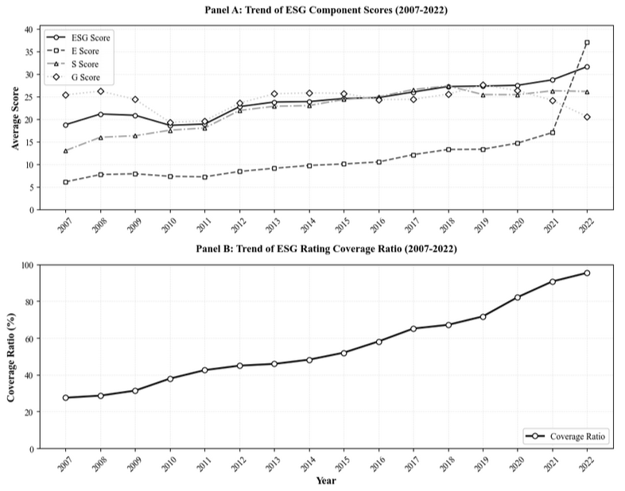
Panel B: Trend of ESG Rating Coverage Ratio (2007-2022)

Figure 2: ESG Rating Coverage Ratio by GICS Industry (2007–2022)

Panel A figure illustrates the ESG rating coverage ratio across 11 GICS Level-1 industries based on Wind industry classification as of February 2025. The coverage ratio is defined as the proportion of firms within each industry that have available ESG ratings in the Wind database during the sample period from 2005 to 2022. Real Estate and Energy exhibit the highest ESG coverage ratios, while Information Technology and Telecommunication Services show relatively lower coverage. The figure highlights substantial cross-industry variation in ESG data availability.

Panel B figure illustrates the evolution of ESG rating coverage ratios across 11 GICS Level-1 industries from 2005 to 2022, based on Wind industry classification as of February 2025. The coverage ratio is defined as the proportion of firms within each industry that have available ESG ratings in the Wind database in a given year. The figure shows that ESG coverage increased steadily across all industries dramatically increase around 2020, with Real Estate and Energy reaching nearly complete coverage by 2022, while Information Technology and Telecommunication Services exhibited relatively slower adoption, which is consistent with the ESG Disclosure Reform (2020). The coverage ratio drops to zero after 2022 due to incomplete or pending data updates.

ESG Rating Coverage Ratio by GICS Industry (2007–2022)
Panel A: ESG Rating Coverage Ratio by GICS Industry
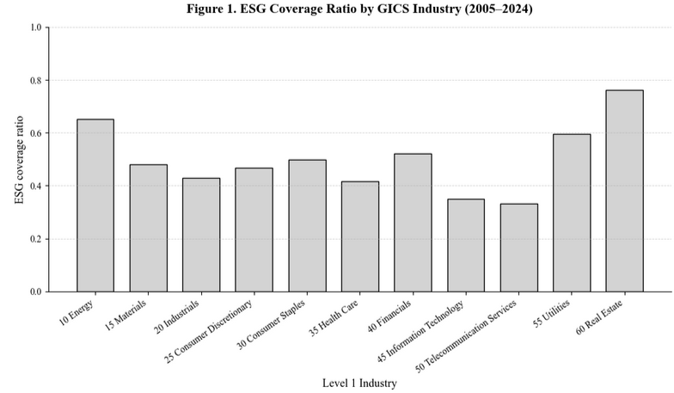
Panel B: ESG Rating Coverage Ratio by Industry (2007-2022)
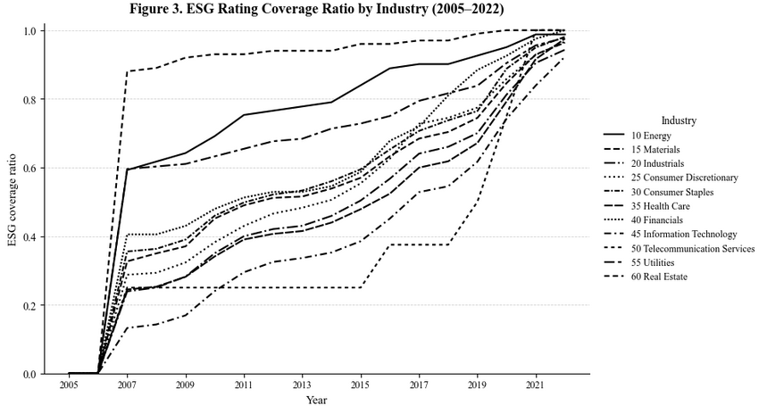

Figure 3. Average ESG Ratings by Industry (2007–2022)
This figure presents the average ESG rating by GICS Level-1 industry, based on the CNRDS database as of February 2025. Consumer Staples, Materials, and Health Care exhibit the highest average ESG scores, reflecting stronger sustainability disclosure and compliance practices. By contrast, Real Estate and Telecommunication Services show lower ESG performance, indicating slower progress in ESG adoption across these sectors.

Average ESG Ratings by Industry (2007–2022)
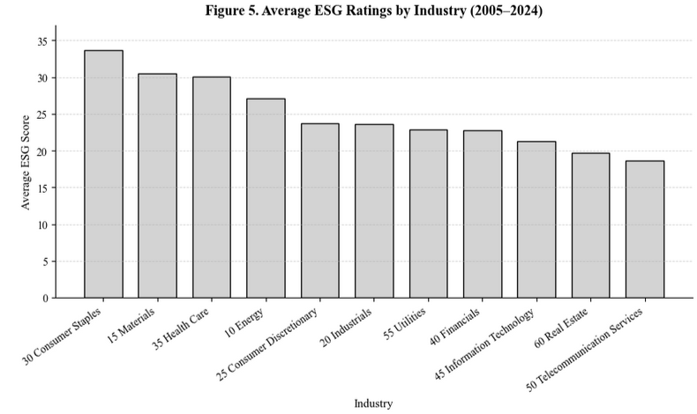

Figure 4. Annual Average ESG Ratings by Year (2007–2022)
This figure presents the annual average ESG ratings of all listed firms in the sample from 2007 to 2022, based on the Wind database as of February 2025. The overall upward trend indicates continuous improvement in ESG performance among Chinese listed firms, particularly after 2020, reflecting increased regulatory emphasis and market awareness of sustainability reporting.

Annual Average ESG Ratings by Year (2007–2022)
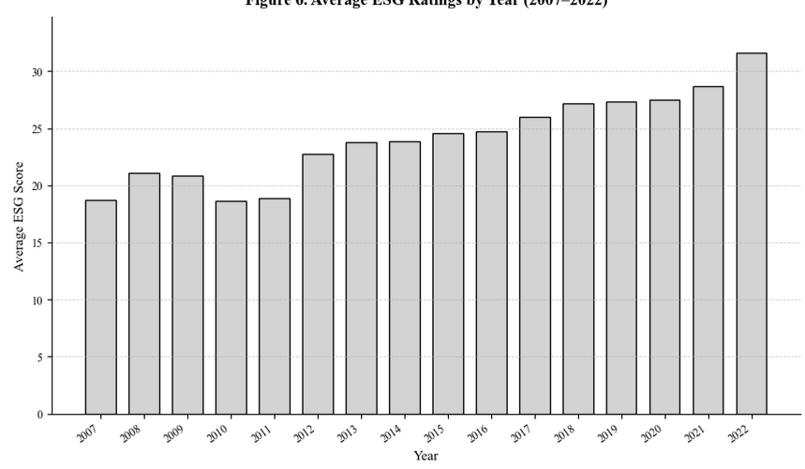

Figure 5. Industry-Level ESG Rating Trends (2007–2022).

This figure plots the time-series evolution of average ESG ratings across 11 GICS Level-1 industries based on Wind data. ESG ratings exhibit a broad upward trend over 2007–2022, reflecting the progressive strengthening of disclosure practices and the expanding adoption of sustainability reporting in China. Industries such as Consumer Staples, Materials, and Health Care consistently maintain the highest ESG scores, suggesting more mature reporting standards and structured governance frameworks.

By contrast, Real Estate and Telecommunication Services remain at the lower end of the distribution, with Real Estate showing pronounced year-to-year volatility—likely reflecting heightened regulatory scrutiny, leverage cycles, and uneven disclosure quality in the sector. Energy and Industrials also rise steadily but remain in the mid-range, consistent with gradual improvements driven by environmental compliance requirements.

Notably, most industries experience a visible acceleration in ESG score growth after 2015, coinciding with China’s green-finance policy rollout and the increasing integration of ESG considerations into capital market regulation. This temporal pattern highlights both cross-industry heterogeneity and the policy-driven nature of ESG adoption in the Chinese A-share market.

Industry-Level ESG Rating Trends
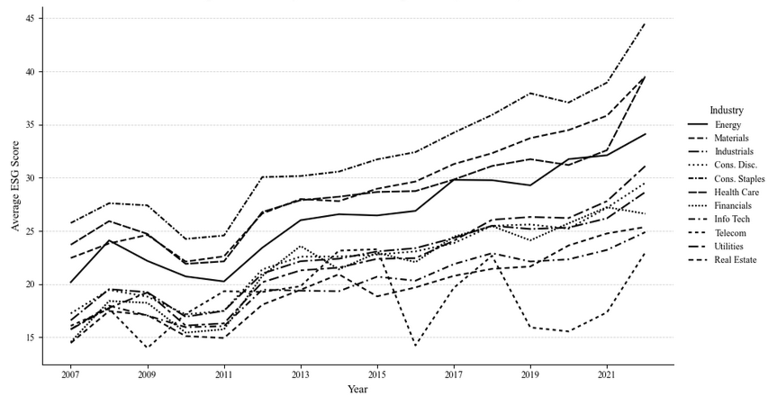

Figure 6. Average Industry-level E, S, and G Ratings (2007–2022)

This figure illustrates the average environmental (E), social (S), and governance (G) ratings by GICS Level-1 industries from 2007 to 2022, based on the Wind ESG database (as of February 2025).
Panel (A) reports the average Environmental (E) ratings, Panel (B) shows the average Social (S) ratings, and Panel (C) presents the average Governance (G) ratings.
Overall, Consumer Staples, Materials, and Health Care consistently achieve higher scores across dimensions, suggesting stronger ESG performance and disclosure. In contrast, Real Estate and Telecommunication Services exhibit lower averages, indicating slower ESG adoption in these sectors.

Average Industry-level E, S, and G Ratings (2007-2022)
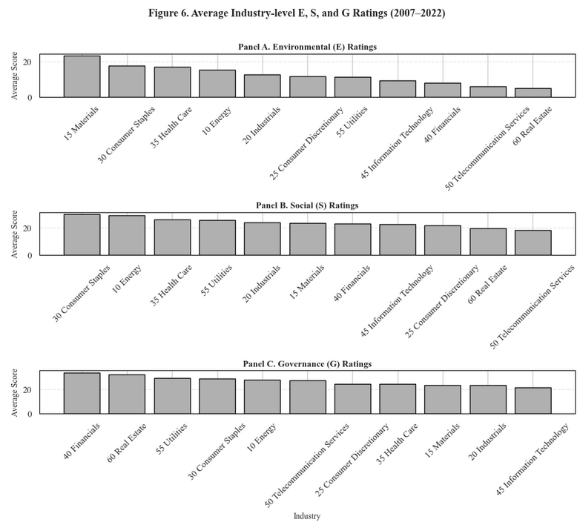

Figure 7. Industry-level Environmental (E) Ratings Trends (2007–2022)

This figure illustrates the time-series evolution of Environmental (E) ratings across 11 GICS Level-1 industries in China from 2007 to 2022, based on data from the Wind ESG database (as of February 2025).
The E ratings reflect firms’ performance in environmental management, emissions reduction, resource efficiency, and disclosure transparency.

Overall, all industries exhibit an upward trajectory in their Environmental (E) ratings, with a particularly sharp rise after 2020, coinciding with China’s national “carbon neutrality” pledge and the implementation of stricter ESG disclosure regulations.
The Materials and Consumer Staples industries show the most significant improvement, suggesting active adoption of sustainable production practices and stronger compliance with environmental reporting standards.
In contrast, sectors such as Telecommunication Services and Real Estate demonstrate relatively modest progress, indicating slower integration of environmental sustainability into their operational strategies.

E Rating of Industries (Yearly Trend)
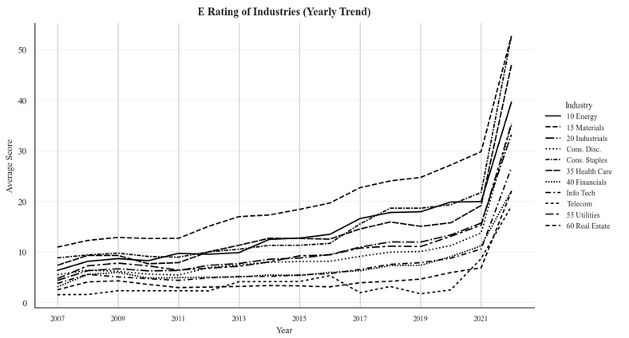

Figure 8. Industry-level Social (S) Rating Trends (2007–2022)

This figure presents the annual evolution of Social (S) ratings across 11 GICS Level-1 industries in China from 2007 to 2022, based on data from the Wind ESG database (as of February 2025). The S ratings evaluate firms’ performance in areas such as employee welfare, labor standards, community engagement, product responsibility, and social disclosure practices.

Overall, the Social (S) dimension shows a consistent upward trend across most industries, reflecting the strengthening of corporate social responsibility (CSR) frameworks and improved disclosure requirements in China.
The Consumer Staples and Energy sectors record the highest S scores, driven by enhanced labor protection policies and social sustainability initiatives, while Telecommunication Services and Real Estate remain at the lower end, suggesting slower progress in integrating social responsibility measures into their operations. The acceleration of S performance after 2015 aligns with the introduction of domestic CSR guidelines and the growing importance of human capital management in corporate governance reforms.

S Rating of Industries (Yearly Trend)
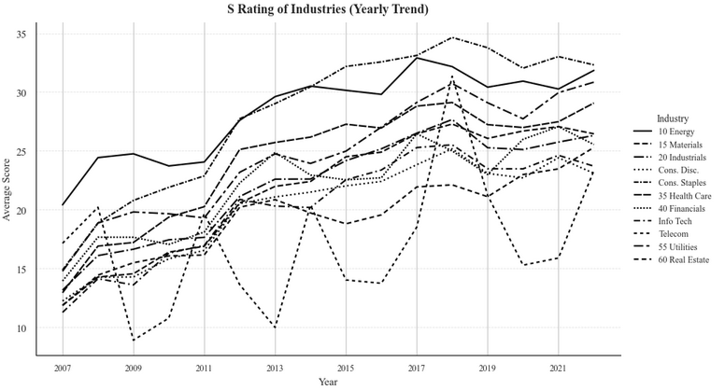

Figure 9. Industry-level Governance (G) Rating Trends (2007–2022)

This figure illustrates the annual evolution of Governance (G) ratings across 11 GICS Level-1 industries from 2007 to 2022.The Governance (G) score measures corporate board structure, management accountability, transparency, and shareholder protection practices.
Solid and dashed lines represent different industries’ average G scores by year, smoothed to highlight cross-industry variation and long-term governance trends.

The figure shows a moderate upward trend in governance quality across most industries from 2007 to 2020, consistent with the gradual institutionalization of ESG reporting and corporate governance reforms in China.
Industries such as Financials, Utilities, and Real Estate maintain relatively high and stable G ratings, indicating stronger internal control systems and greater compliance with governance codes. In contrast, Information Technology and Materials sectors display lower average G scores and greater volatility, reflecting less mature governance frameworks and potentially weaker regulatory oversight.

The decline observed after 2021 is largely attributed to data coverage limitations in the Wind ESG database, rather than a structural deterioration in governance quality.

G Rating of Industries (Yearly Trend)
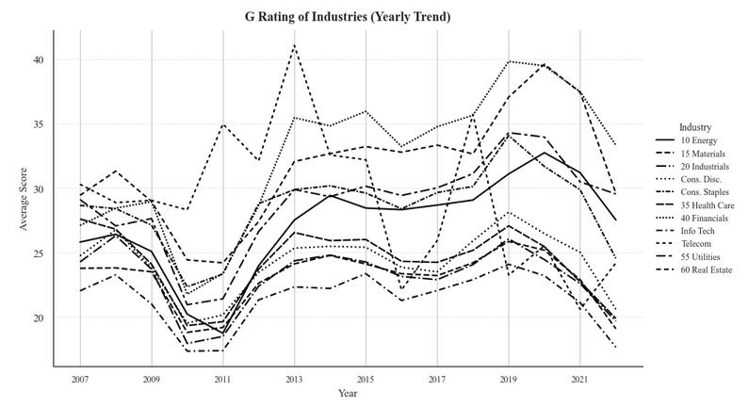

Figure 10: Distribution of E, S, and G Scores by Dimension

This figure visualizes the cross-sectional distribution of Environmental (E), Social (S), and Governance (G) ratings aggregated at the industry level. The distributions are estimated using violin plots based on firm-level average scores over the 2007–2022 period from the CNRDS dataset. The internal dashed lines indicate the first quartile, median, and third quartile of each distribution.

Distribution of E, S, and G Scores by Dimension
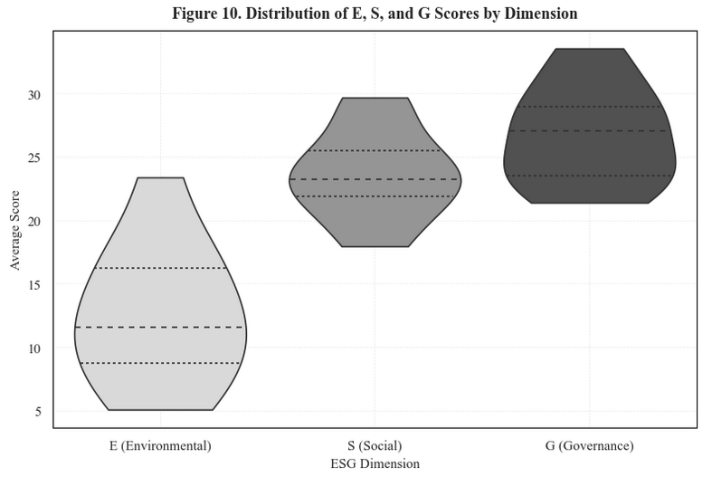

Figure 11. Quantile Plot of ESG Scores (E, S, G)

This figure compares the 25th, 50th, and 75th percentile values of firm-level ESG dimension scores, illustrating the cross-sectional distributional structure across the Environmental (E), Social (S), and Governance (G) components. Consistent with the quantile estimates reported in Table 13, the Social and Governance dimensions display substantially higher central and upper-quartile values than the Environmental dimension, indicating stronger disclosure depth and greater score dispersion for S and G.

The steep upward shift from E to S across all quantiles highlights that environmental performance remains the weakest and most unevenly reported dimension among Chinese firms. By contrast, the relatively tighter interquartile range between S and G suggests more uniform reporting standards and lower cross-sectional variability in these two pillars. Together, the quantile patterns reveal meaningful divergence in disclosure quality and score concentration across ESG dimensions.

Quantile Plot of ESG Scores (E, S, G)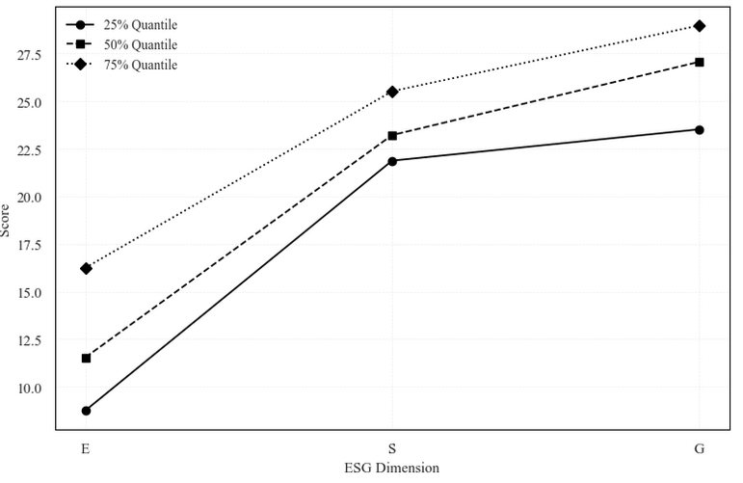

Figure 12. Spearman Rank and Kendall Rank Correlation (E, S, G)

Panel A (Figure A. Spearman Rank Correlation (E/S/G)) visualizes the Spearman rank correlation matrix across Environmental (E), Social (S), and Governance (G) dimensions at the industry level. The strong positive correlation between E and S (ρ = 0.76) indicates similar ranking patterns across environmental and social dimensions, whereas Governance (G) rankings show weaker or negative associations with the other two dimensions.

Panel B (Figure B. Kendall Rank Correlation (E/S/G)) shows the Kendall τ rank correlation matrix for the same dimensions. The results are consistent with the Spearman correlations, reinforcing the robustness of the E–S concordance and the relative independence of the G component.

Spearman Rank and Kendall Rank Correlation (E, S, G)
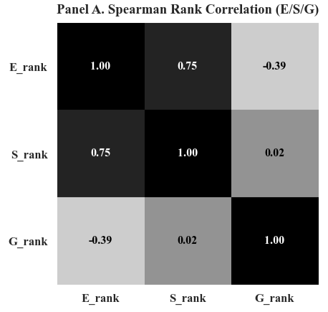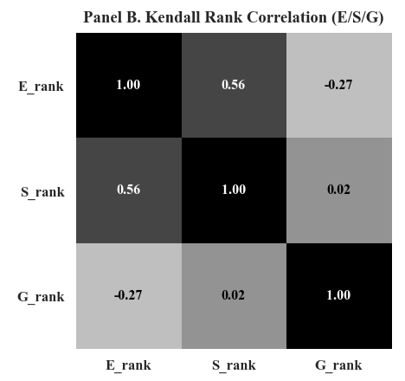

Figure 13. Data Availability Comparison: Firms With vs Without ESG Ratings

This figure presents the proportion of missing data for key financial variables, stratified by ESG rating coverage. The results reveal a stark disparity in data completeness between the two groups. Firms without ESG ratings exhibit near-total data absence, with 100% missing rates across all three financial metrics—market capitalization, price-to-book ratio, and daily returns. In contrast, firms covered by ESG ratings maintain high data integrity, with missing rates of only 2.2% for market capitalization and daily returns, and 36.3% for price-to-book ratios. This systematic pattern indicates that the absence of ESG ratings serves as a strong proxy for overall data unavailability, suggesting that non-ESG-rated firms either represent non-operational entities, have delisted status, or maintain minimal public disclosure. These findings underscore the presence of significant selection bias in ESG data coverage and highlight the importance of accounting for such systematic differences in empirical research.

Data Availability Comparison: Firms With vs Without ESG Ratings 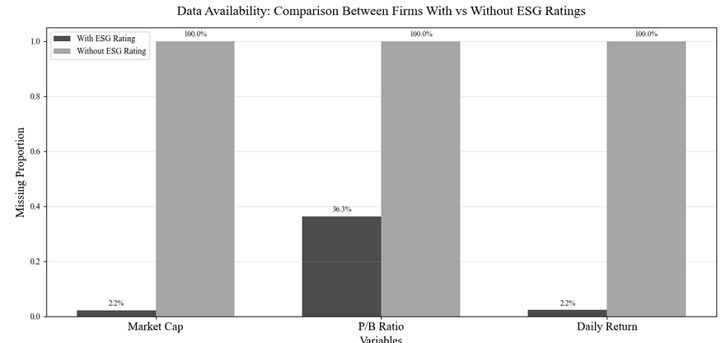

Figure 14. Annual and Cumulative Returns of High–Low (D1−D5) Portfolios, 2007–2022

Panel A plots annual excess returns (D1–D5) of ESG and its three sub-pillars (E, S, G). Positive values indicate that firms with higher ESG scores outperform low-ESG firms in that year. Panel B shows cumulative returns from annually compounded High–Low portfolios. The results reveal that governance (G) and environmental (E) dimensions exhibit persistent underperformance, while social (S) returns fluctuate around zero, suggesting heterogeneous and time-varying ESG premiums.

Annual and Cumulative Returns of High–Low (D1−D5) Portfolios, 2007–2022
Panel A. Annual Returns of High-Low (D1-D5) Portfolios
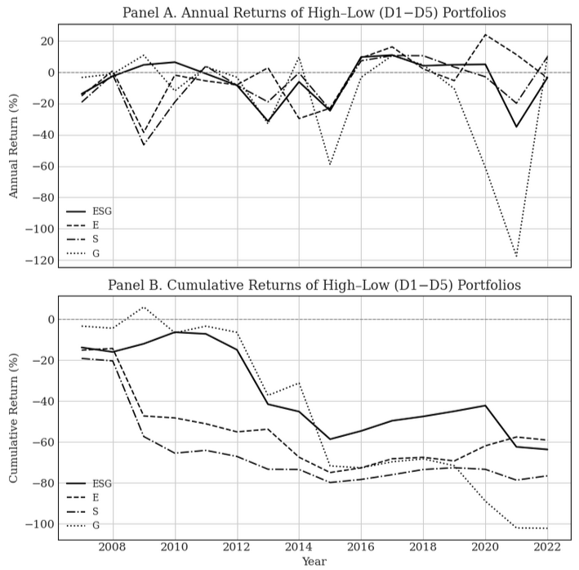
Panel B. Cumulative Returns of High-Low (D1-D5) Portfolios

Figure 15. Annual Volatility and Sharp Ratio of High–Low (D1−D5) Portfolios, 2007–2022

Panel A plots the annual return volatility of High–Low (D1–D5) portfolios constructed from ESG and its three sub-pillars (Environmental E, Social S, and Governance G) between 2007 and 2022. The volatility levels capture the risk dispersion of excess returns between the highest- and lowest-rated firms within each dimension. While all series exhibit time-varying volatility, the Governance (G) factor displays consistently higher volatility—particularly during 2013 and 2021—indicating that governance-related returns are more sensitive to market sentiment and structural shocks. In contrast, ESG-aggregate and E/S sub-portfolios show more moderate and stable volatility patterns.

Panel B shows the corresponding annual Sharpe ratios (rₓ = 0), measuring risk-adjusted performance of High–Low portfolios. Across the sample period, Sharpe ratios fluctuate substantially, with multiple years of negative values, suggesting that high-rated ESG firms underperform low-rated ones after accounting for volatility. Notably, the G pillar demonstrates the lowest and most volatile Sharpe ratios, driven by its larger downside swings, whereas E and S pillars occasionally deliver short-term positive risk-adjusted gains (e.g., 2016–2018). Overall, the results reveal heterogeneous and time-varying ESG premiums, where the governance and environmental dimensions dominate downside risks while the social pillar contributes transient improvements in portfolio efficiency.

Annual Volatility and Sharp Ratio of High–Low (D1−D5) Portfolios, 2007–2022
Panel A. Annual Volatility of High-Low (D1-D5) Portfolios
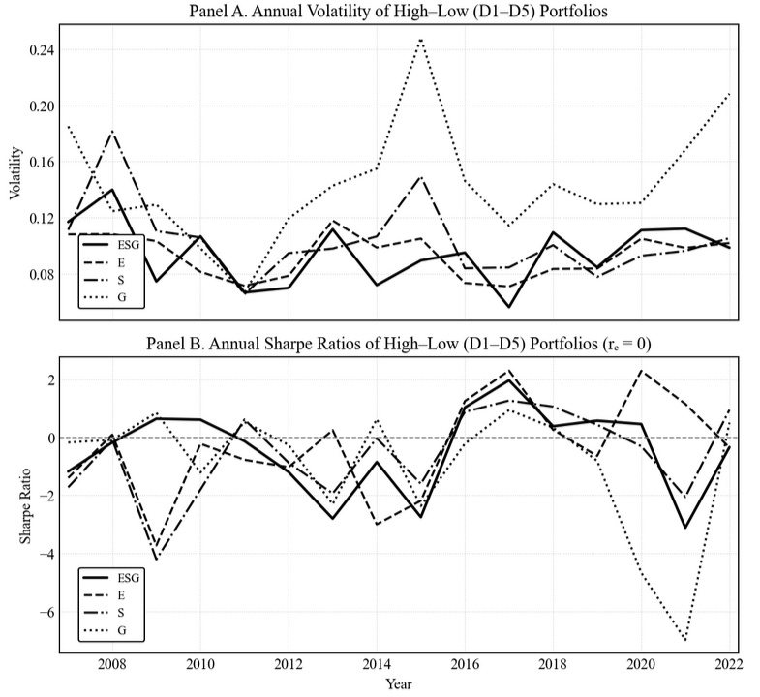
Panel B. Annual Sharp Ratios of High-Low (D1-D5) Portfolios (rₓ = 0)

Figure 16. Annual Turnover of High–Low (D1−D5) Portfolios, 2007–2022

This figure plots the annual turnover ratios of High–Low (D1–D5) portfolios constructed for the overall ESG score and its three sub-pillars (Environmental E, Social S, and Governance G) from 2008 to 2022. Turnover ratio measures the fraction of portfolio constituents replaced each year when rebalancing the long–short portfolios. A higher turnover ratio indicates greater portfolio reallocation intensity, often implying higher transaction costs and lower implement ability.

Among the four dimensions, the Governance (G) portfolio exhibits the highest and most volatile turnover, particularly after 2010, suggesting that governance-related firm characteristics change more frequently and are more sensitive to market sentiment. In contrast, the Environmental (E) portfolio maintains the lowest and most stable turnover, reflecting more persistent firm rankings in environmental scores. The Social (S) and aggregate ESG portfolios show moderate turnover dynamics over time, with slight increases during market stress periods such as 2020–2022. Overall, these patterns indicate heterogeneous portfolio stability across ESG pillars, consistent with the view that ESG components differ in persistence and information turnover.

Turnover Ratios of High-Low (D1-D5) Portfolios
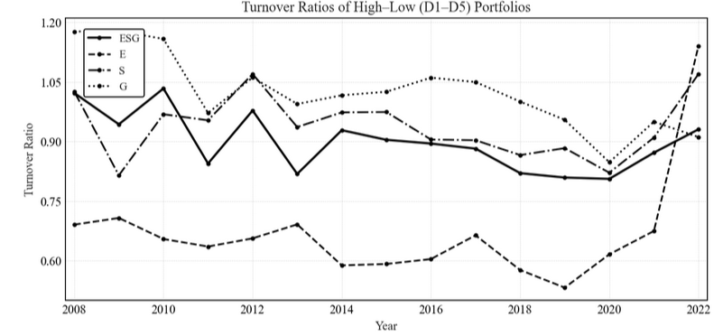

Figure 16. Correlation Heatmaps between ESG and Fama–French Five Factors

This figure illustrates the pairwise correlations between the constructed ESG-related High–Low (D10–D1) factor returns and the Fama–French five factors. Panel A shows the correlation of the overall ESG factor, while Panels B–D present the Environmental (E), Social (S), and Governance (G) sub-pillars, respectively.

Across all panels, ESG-related factors exhibit consistent patterns: high negative correlation with SMB (size), indicating that high-ESG portfolios tilt toward large-cap firms; and strong positive correlation with RMW (profitability), implying that ESG portfolios load heavily on profitable firms. Mild positive correlations with HML (value) suggest limited association with the value factor. Among all sub-pillars, the Governance (G) factor displays the largest correlations (|r| up to 0.63) with profitability and value, consistent with its stronger link to firm fundamentals. Darker shades represent stronger correlations (positive or negative). The heatmaps are based on value-weighted monthly High–Low portfolio returns from 2007 to 2022.

Correlation Heatmaps between ESG and Fama–French Five Factors 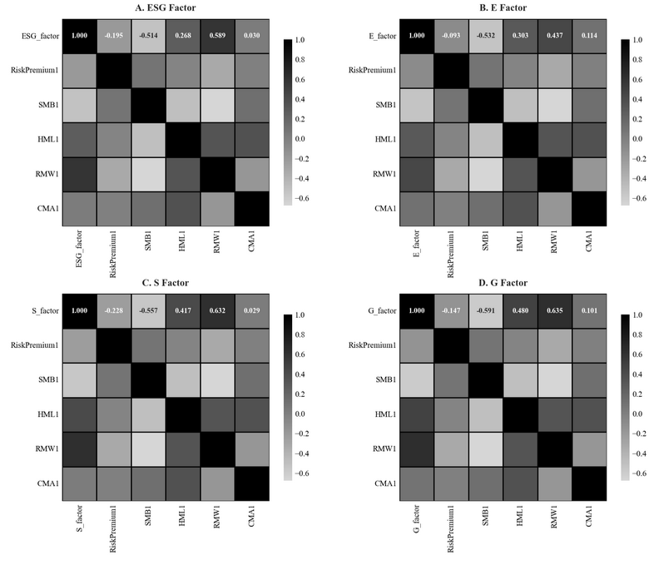

Figure 17. ESG Event Distribution and Market Response

Panel A reports the annual distribution of ESG-related events (upgrades, downgrades, and initiations) from 2007 to 2022. The steady rise in total counts indicates the rapid expansion of ESG coverage in China, particularly after 2018. Panel B presents the trend of ESG events by type. Upgrade events consistently exceed downgrades, reflecting continuous improvement in firms’ ESG performance. Initiations surge in 2010, 2016, and 2020, corresponding to key enhancements in ESG disclosure requirements. Panel C illustrates monthly portfolio returns around ESG events. Initiation events show the strongest and most volatile positive returns, implying higher information content. In contrast, upgrades and downgrades exhibit smaller, symmetric reactions, suggesting limited market sensitivity to incremental ESG score changes.

ESG Event Distribution and Market Response
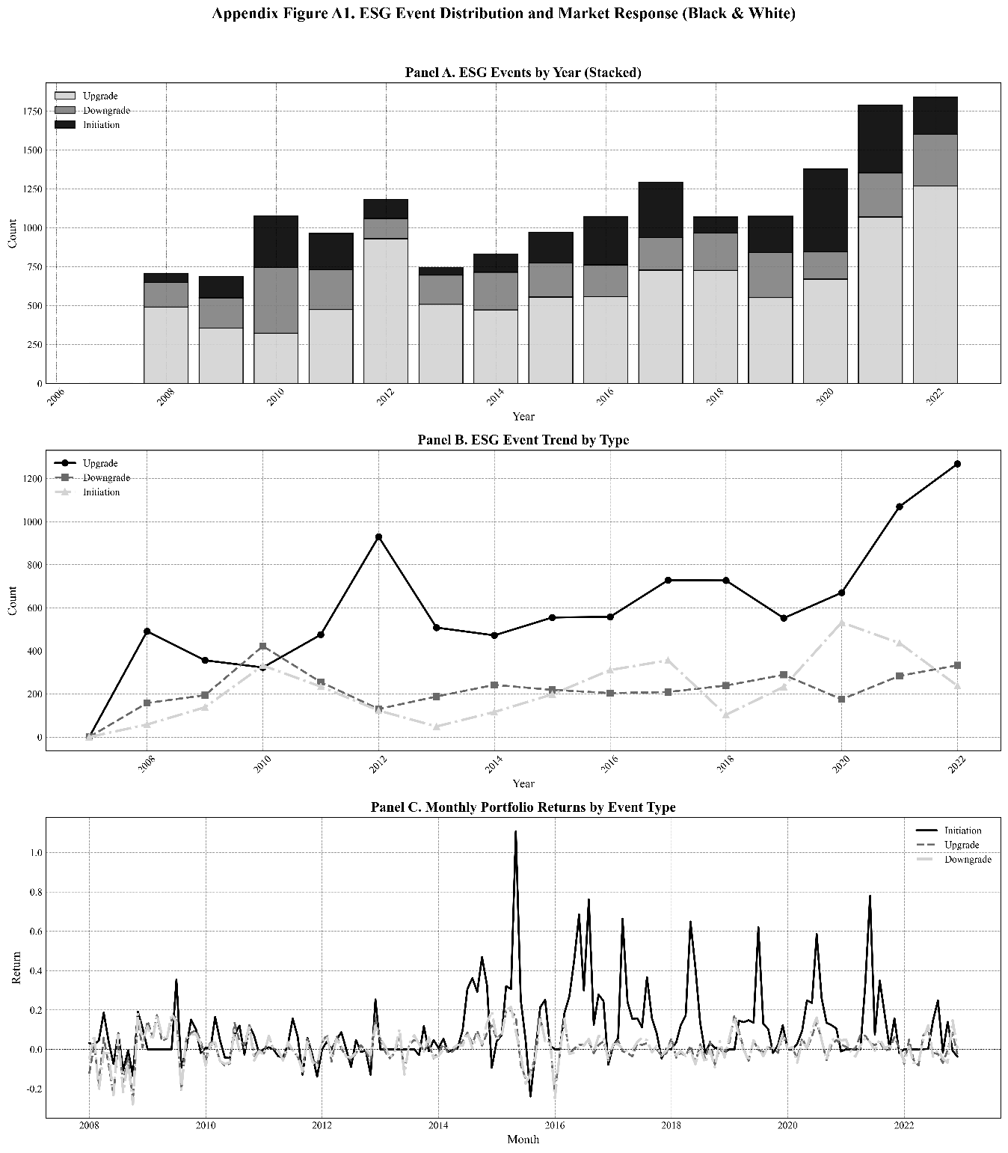

Figure 18. Monthly Realized Volatility: ESG H–L Portfolio vs. Major Market Indices

This figure plots the time-series of monthly realized volatility for the ESG high-minus-low (H–L) portfolio alongside three major Chinese stock indices—CSI 300, SSE Composite, and SZSE Component—from 2007 to 2022. The ESG H–L portfolio consistently exhibits lower volatility than the benchmark indices, indicating greater stability and weaker exposure to market-wide shocks. Volatility spikes observed during 2015–2016 and 2020 correspond to the stock market turbulence and the COVID-19 outbreak, respectively, but the ESG factor remained relatively resilient throughout these episodes, suggesting its defensive risk characteristics.

Monthly Realized Volatility: ESG H–L Portfolio vs. Major Market Indices 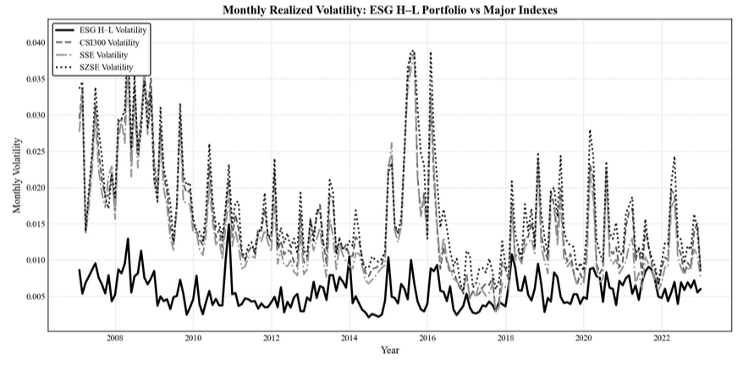

Figure 19. Heatmap of ESG Coverage by Industry and Year (2007–2022)

This figure presents a heatmap of ESG coverage ratios for all listed firms across 11 industries from 2007 to 2022. Darker shades indicate higher coverage, with values normalized between 0 and 1. The figure illustrates a clear two-phase evolution: (i) initial selective participation concentrated in energy-, resource-, and regulation-intensive sectors in the late 2000s, followed by (ii) rapid post-2015 diffusion across previously underrepresented industries, coinciding with the introduction of China’s Green Finance Guidelines and subsequent ESG disclosure reforms. By the early 2020s, ESG coverage converges across nearly all sectors, indicating the institutionalization of sustainability disclosure in China’s capital market.

Heatmap of ESG Coverage by Industry and Year (2007–2022)
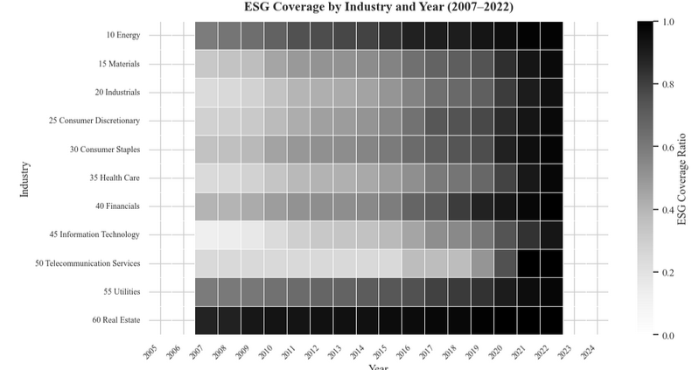

Figure 20. Rolling 5-Year Average of ESG High-Low Returns

The figure plots the five-year rolling average of annual ESG High–Low (D1 – D5) factor returns. The pattern reveals pronounced time variation: negative values in the early 2010s, a strong rebound around the 2016–2020 green finance expansion, and a subsequent decline after 2021. The episodic behavior suggests that ESG-related return premia in China are regime-dependent and closely aligned with shifts in regulatory intensity and policy attention.

Rolling 5-Year Average of ESG High-Low Returns
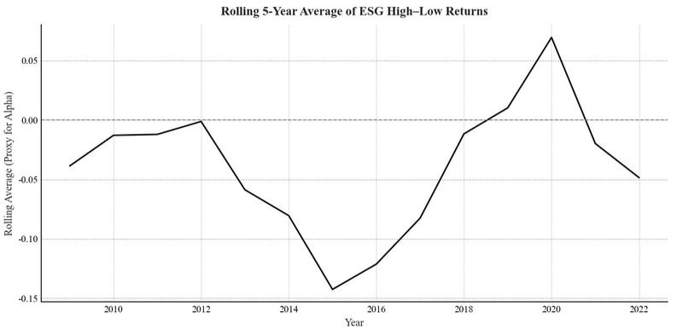

Figure 21. 24-Month Rolling Alpha of the Social (S) Factor with COVID-19 Policy Timeline

This figure plots the 24-month rolling alpha from Fama–French five-factor regressions for the Social (S) High–Low portfolio from 2017 to 2022, overlaid with key COVID-19 policy milestones—namely the outbreak (January 2020), emergency vaccine approval (July 2020), the beginning of the recovery phase (August 2020), the post-reopening transition (May 2021), and the termination of the Zero-COVID policy (December 2022). The rolling alpha turns sharply positive during the outbreak period, indicating a short-lived crisis-resilience premium for socially responsible firms. As the pandemic stabilizes, the rolling alpha declines and becomes negative in both the recovery and post-reopening phases, consistent with the regression results reported in figure. These dynamics illustrate the state-contingent and transitory nature of the S-factor premium—strengthening under acute macro uncertainty and reversing once market conditions normalize.

The Social (S) factor is plotted here because it is the only ESG pillar that exhibits a clear sign reversal across COVID-19 stages—positive alpha during the outbreak and negative alpha during the recovery and post-reopening phases—making it uniquely informative for visualizing the crisis-response dynamics documented in the regressions. Governance (G) and aggregate ESG factors show consistent underperformance across subperiods, and thus rolling-alpha plots provide limited additional interpretive value relative to the S-factor.

24-Month Rolling Alpha of Social (S) Factor with COVID-19 Policy Timeline
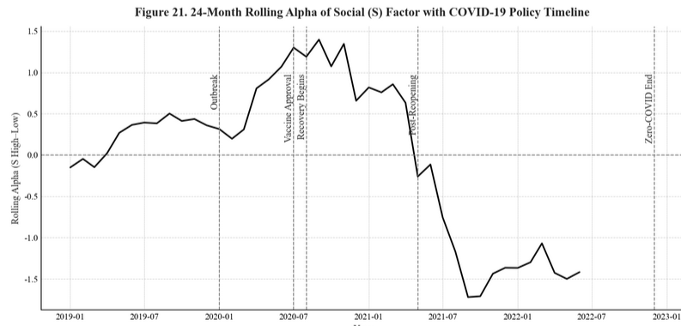

Figure 22. 24-Month Rolling Alpha of Governance (G) Factor with Policy & Housing Cycle Timeline

This figure plots the 24-month rolling alpha from Fama–French five-factor regressions for the Governance (G) High–Low portfolio between 2018 and 2023, overlaid with key policy and housing-market turning points, including the pre-crackdown baseline period (2018–2020), the implementation of the Three Red Lines leverage restriction (August 2020), the credit tightening associated with the Ant Group IPO suspension (late 2020–mid 2021), the first housing-market downturn (2021H2), the short-lived rebound in early 2022, and the renewed decline beginning in March 2022. Consistent with the regression results in Table 30, the rolling alpha is positive prior to the crackdown, turns sharply negative during the tightening phase, rebounds around the onset of the housing-price recovery, and declines again as credit conditions weaken. This nonmonotonic pattern indicates that the pricing of the G factor is highly sensitive to credit conditions and real estate capitalization dynamics, rather than to regulatory announcements alone.

The Governance (G) factor is plotted here because it is uniquely concentrated in property developers and financial institutions and therefore is the only ESG pillar that exhibits clear cyclical responses to both policy tightening and housing-market conditions. Unlike the Environmental and Social pillars, whose returns display limited sensitivity to leverage-driven shocks, the G factor consistently prices sectoral liquidity risk: it underperforms during credit contractions and housing downturns, and temporarily rebounds during easing episodes. As such, the rolling-alpha pattern visualized here provides direct evidence for the leverage-sensitive and state-contingent nature of governance-related premia documented in the regression analyses.

24-Month Rolling Alpha of Governance (G) Factor with Policy & Housing Cycle Timeline
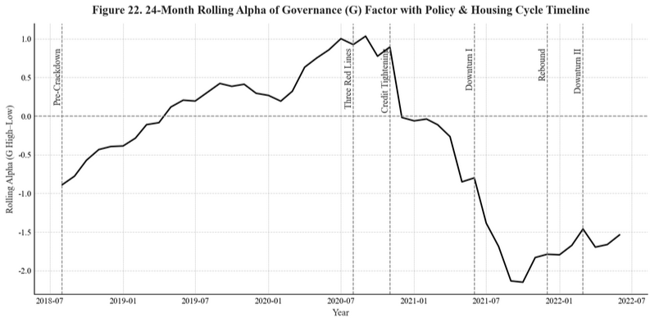

Figure 23. 24-Month Rolling Alpha of Environmental (E) Factor with Green Development Policy Timeline

This figure plots the 24-month rolling alpha from Fama–French five-factor regressions for the Environmental (E) High–Low portfolio from 2016 to 2022, overlaid with major green-development policy milestones in China. Key events include the baseline period before large-scale environmental policy reinforcement (2015–2017), the elevation of “ecological civilization” during the 19th National Congress (October 2017), the regulatory tightening that followed the First Plenary Session (March 2018), the late-cycle environmental rectification phase (2018–2019), the decline in new-energy-vehicle (NEV) sales during subsidy withdrawal (September–December 2019), the stabilization period after policy adjustments (2019–2020), the announcement of the “dual-carbon” targets (September 2020), and the subsequent stabilization phase (2021–2022). Consistent with the regression evidence in Table 31, the rolling alpha rises sharply during periods of strong policy promotion—such as the post-Congress environmental push (2017–2018) and the dual-carbon announcement (2020–2021)—indicating that the E factor delivers short-lived positive abnormal returns when policy support for green industries intensifies. In contrast, the rolling alpha turns negative or remains muted during subsidy withdrawal (2019) and in the post-2021 stabilization period, reflecting a normalization of valuations once policy novelty fades and fiscal incentives recede.

Only the Environmental (E) factor is plotted here because it is the ESG pillar most directly linked to China’s state-led green-development agenda and exhibits clear policy-cycle-dependent fluctuations. Unlike the Social factor, which responds primarily to crisis-driven sentiment, or the Governance factor, which reflects leverage-risk exposure, the E factor prices shifts in environmental policy emphasis, subsidy regimes, and carbon-neutrality initiatives. As such, the rolling-alpha pattern visualized here provides direct evidence that environmental-related premia in China are episodic, policy-backed, and highly sensitive to changes in national strategic priorities.

24-Month Rolling Alpha of Environmental (E) Factor with Green Development Policy Timeline
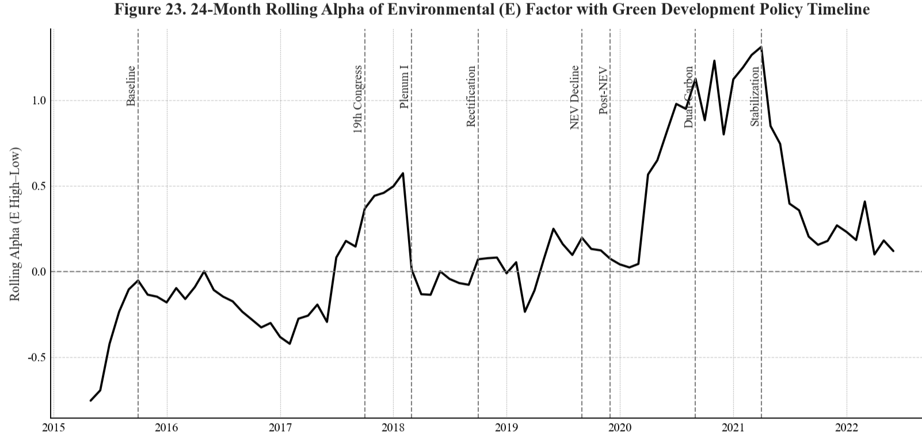

Figure 24. Cross-Database Comparison of ESG Ratings: CSMAR vs. CNRDS (2015–2020)

Panel A shows that raw ESG scores from CSMAR and CNRDS exhibit virtually no systematic relationship. The points form a wide, unstructured cloud with no visible linear pattern, reinforcing the low rank (ρ = 0.066) and level (r = 0.057) correlations. In Panel B, percentile normalization does not meaningfully improve alignment. If the two rating systems were consistent in relative ranking, the scatter would cluster around an upward-sloping 45° pattern; instead, the plot remains horizontally dispersed, indicating that firms ranked highly by one provider are not similarly ranked by the other.

These figures visually confirm a key empirical message: ESG disagreement in China is structural, persistent, and unaffected by normalization. Thus, the weak/negative ESG return patterns documented in the paper are unlikely to be artifacts of a particular scoring scale and instead reflect fundamental divergence in rating methodologies.

Cross-Database Comparison of ESG Ratings: CSMAR vs. CNRDS (2015–2020)
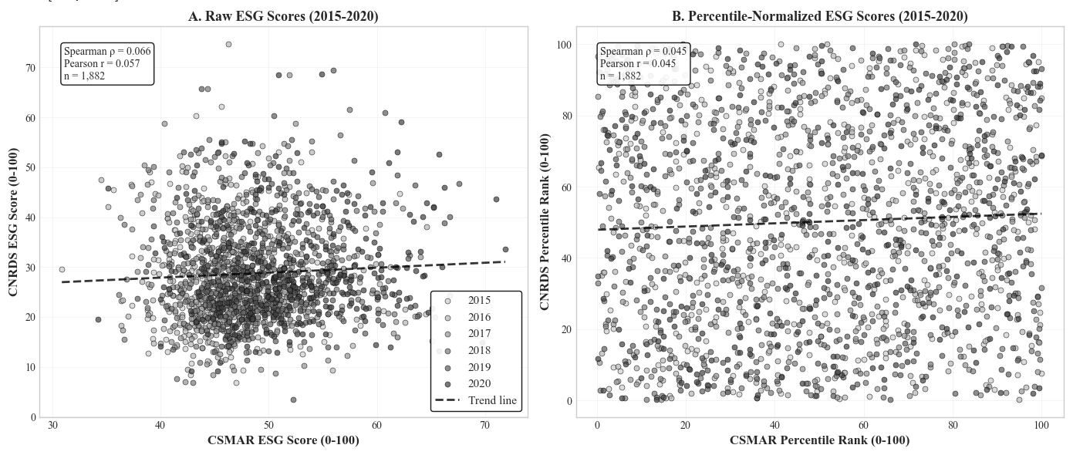

CNRDS (Chinese Research Data Services Platform, www.cnrds.com) is a leading domestic data provider supported by the National Natural Science Foundation of China (NSFC) and Tsinghua University, specializing in Chinese financial and ESG data.
CNRDS data collection involves manual verification and automated text-mining from multiple disclosure channels, ensuring both breadth and data quality across corporate filings and media reports.
MSCI ESG and Refinitiv ESG databases include only a partial subset of Chinese A-share firms, typically large-cap constituents of the MSCI China Index or cross-listed entities, thus limiting representativeness for the full A-share market.
CSMAR and Wind provide firm-level financial and market variables widely used in Chinese capital market research; merging follows firm code and fiscal year alignment procedures consistent with prior literature.
Winsorization at the 1st and 99th percentiles is standard in empirical finance to mitigate the effect of outliers (see Fama & French, 1993; Jegadeesh & Titman, 1993).
Table 2 – Time Trend of ESG Rating Coverage and Scores (2007–2022) reports the yearly ESG coverage ratio and mean ESG scores across all dimensions. ESG rating coverage increased substantially from 27.5% in 2007 to 95.4% in 2022, while the mean overall ESG score rose from 18.7 to 31.6 over the same period. Notably, the Environmental (E) score demonstrated the most significant growth, increasing from 6.1 to 37.1, reflecting heightened emphasis on environmental performance in recent years. Figure 1 plots this upward trend, showing inflection points in 2010 and 2020.
Table 3 – Annual ESG Rating Coverage Ratio by GICS Industry (2007–2022) and Table 5 – Average ESG Ratings by Industry (2007–2022) summarize cross-sectional heterogeneity. Consumer staples, health care, and materials record mean ESG scores above 30; telecommunication and real estate average below 20. Figure 3 and Figure 4 visualizes this dispersion.
Tables 8 – Average Industry-level E, S, G Ratings (2007–2022) show that the E dimension exhibits the widest spread (standard deviation = 5.52), followed by G (3.89) and S (3.57). This pattern indicates stronger regulatory heterogeneity in environmental performance.
Figure 1 – Temporal Evolution of ESG Performance and Coverage (2007-2022) plots ESG rating trajectories and key policy milestones, including the 2015 Green Finance Guidelines and the 2020 Disclosure Reform. The post-policy years show statistically significant upward shifts in mean ESG scores (p < 0.05).
The one-month Treasury bill yield data are obtained from the People’s Bank of China (PBoC) via the WIND Financial Terminal. The use of this rate follows standard Chinese market conventions in empirical asset-pricing research (e.g., Huang et al., 2020; Broadstock et al., 2021).
This definition follows standard practice in Fama and French (1993, 2015) and is consistent with volatility-based risk assessments in ESG portfolio studies (e.g., Broadstock et al., 2021).
Lower semi-deviation captures volatility conditional on negative excess returns, isolating downside risk from total variance. It has been widely used to measure downside exposure in asymmetric return distributions (Ang et al., 2006; Fu, 2009).
VaR is computed as the empirical quantile of portfolio returns at the 5% tail, representing the maximum expected loss with 95% confidence. All returns are standardized prior to quantile estimation.
Crash thresholds of -5%, -8%, and -10% are chosen to capture varying degrees of market stress, consistent with Kim, Li, and Zhang (2011) and Chen, Hong, and Stein (2001). The results are robust to alternative cutoffs.
The subperiod segmentation reflects major institutional and policy regimes in China’s capital markets, including the introduction of green finance initiatives (2015), the COVID-19 pandemic (2020), and the regulatory normalization phase (2022). This classification ensures that observed shifts in ESG returns correspond to meaningful macro-policy transitions rather than random fluctuations.
The use of HAC standard errors with a 12-month lag follows the convention in monthly-return studies (see Fama and French, 2015; Ang et al., 2006). Shorter lag structures (e.g., 6 or 9 months) produce qualitatively similar inferences, confirming the robustness of the specification.
The calendar-time portfolio approach mitigates event clustering bias that arises when multiple firms experience ESG-related announcements within the same month. It also accounts for overlapping holding periods, which are common in multi-firm event environments.
The 12-month post-event window balances the trade-off between capturing medium-term market reactions and avoiding excessive noise from unrelated price movements. Shorter (6-month) holding periods yield similar directional results but lower statistical power.
The inclusion of the five-factor model ensures comparability with global ESG-return studies while accounting for unique characteristics of the Chinese market, such as higher state-ownership concentration and sectoral regulation intensity.
These indices jointly represent over 90% of the total market capitalization of A-share listed firms, providing a comprehensive baseline for evaluating systematic risk exposure.
Alternative risk metrics, such as the Omega ratio and Conditional VaR, were also computed for robustness; results remained consistent and are available upon request.
This period coincides with China’s “Green Finance” policy rollout and the 2016 establishment of the Green Bond Endorsed Project Catalogue.
Empirical asset pricing literature notes that high turnover often undermines factor profitability due to implementation frictions; see Novy-Marx & Velikov, 2016, Journal of Financial Economics
See Fama & French, 2015, Journal of Financial Economics, for the definition of the five-factor model and the interpretation of RMW and CMA loadings
Footnote 5: See Pedersen, Fitzgibbons, & Pomorski, 2021, Journal of Financial Economics, for a global analysis of “Responsible Investing” factors and their time-varying exposures.
Pandemic segmentation follows the four institutional milestones defined by China’s epidemic and mobility policies (National Health Commission, 2020–2022).
These results align with Broadstock et al. (2021, Journal of International Financial Markets, Institutions & Money) and Pedersen et al. (2021, Journal of Financial Economics), who document time-varying ESG risk premia driven by market sentiment and policy uncertainty.
The governance factor’s sectoral concentration in property and finance follows Li, Liao, and Shen (2021), China Economic Review.
See China Index Academy, “China Real-Estate Market 2022 Summary & 2023 Outlook”, Sina Finance (2023-01-01).
The cyclical co-movement between leverage and valuation corresponds to the financial-accelerator frameworks of Brunnermeier and Koby (2018) and Kiyotaki and Moore (1997).
Similar cyclical responses of governance-related leverage shocks are documented in Chen, He, and Liu (2022), Journal of Financial Economics.
The segmentation of environmental policy phases follows Beijing News (2020) and Sina Finance (2023), which summarize the chronological evolution of China’s green-development agenda.
Krüger (2015), “Corporate Goodness and Shareholder Wealth,” Journal of Financial Economics, 115 (2): 304–329. The stronger initiation response observed in China likely reflects greater information asymmetry and lower baseline disclosure quality among firms newly entering ESG coverage.
See Report to the 19th National Congress of the CPC (October 18, 2017).
Constitutional Amendment of the People’s Republic of China, adopted March 11, 2018.
State Council Executive Meeting decision, March 31, 2020; see Beijing News (2020).
President Xi Jinping’s address at the 75th UN General Assembly, September 22, 2020, reaffirmed China’s “dual-carbon” targets (peak CO₂ by 2030, neutrality by 2060).

